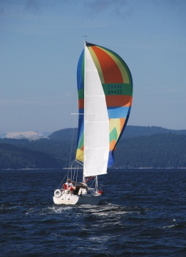
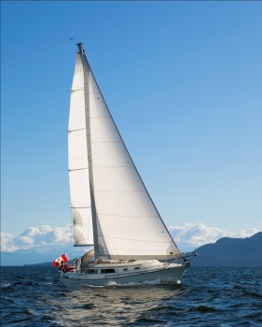
s/v Natasha
Engine replacement and hull repair
October 28th 2011 to Feb 28th, 2012 ^{(and beyond!)}

Carey & I (along with Dick & Marjory Cooksley) have owned “Natasha” since November of 2003 when we purchased her in Victoria BC. A very basic, neglected, and unmodified 1978 Islander Bahama 30 that was named “Folly”, this boat was sailed up from San Diego by her previous owner. Since our purchase “Natasha” has been transformed into a very comfortable cruiser. Virtually all of her gear, inside and out, has been replace or renewed.
At the time of purchase I knew that there were some bottom blisters visible through the anti-fouling paint. This was no different than our previous Islander Bahama 30, “Dreamer”. I also knew that the original raw-water cooled Volvo MD7A was close to 30 years old and, although running strongly, would need eventual replacement. With reliability issues becoming apparent last summer, the winter of 2012 was going to be the year for this work. Because of their limited use of the boat, Dick & Marjory decided to bow out of the boat partnership. They had difficulty justifying the expense of a new engine when they only used the boat two weeks in the summer. Now, as sole owners of the boat, the winter of 2011/12 would be the “project” winter. The tasks would include:
- Replace the Volvo MD7A with a Beta 20 sail-drive, including a new control panel.
- Replace the 20 gallon aluminum fuel tank.
- Re-wire the majority of the boat to comply with current ABYC standards.
- Rebuild the battery compartment to meet current ABYC standards.
- Install a new electrical panel to match the replaced wiring.
- Repair the bottom blisters and apply Interprotect 2000e barrier coat.
- Re-paint the bottom with International CSC antifouling.
- Re-paint the boot stripe with International Perfection paint.
- Remove the rudder and inspect/lubricate all cables/pulleys.
- Replace the propane locker with a system to comply with current ABYC standards.
- Replace the stern through-hulls with Marelon fittings, re-align the hoses.
- Prime and paint the stern & cockpit locker.
The project called for a haul-out at Canoe Cove Marina, Sidney BC, on Friday, October 28th with a completion date near the end of February 2012. Canoe Cove marina has a “boat yard” where owners can work on their own boats. March saw the dry land storage rates double into their “spring” rate, incentive to launch before the end of February.
Engine Replacement
For the engine replacement I looked at Yanmar, Volvo, Sole and Beta in a sail-drive configuration. After considerable research on the Internet, and with local distributors, the decision was made to go with a Beta 20.
The basic Beta 20 sail drive unit was priced at about $12,000 with the manufacturer usually gives a 10% discount at the winter boat shows. That’s a significant savings! But the nearest boat show wasn’t until February 2012 in Vancouver! The timing was off. I would have to work on Ben Gartside of Gartside Marine, the Canadian distributor for Beta, to see if we could move that up somewhat. My plan was to order the engine for a late December delivery. It would take until then to repair the bottom before applying the Interprotect 2000e barrier coat. In the meantime, work would commence on doing the electrical work, etc.
Saildrive
I have often been asked, “Why a sail-drive”? There are a number of reasons for that decision.
# 1 Noise and vibration mitigation. Even after replacing the engine mounts and adding sound insulation to the old Volvo MD7A I found the noise and vibration tolerable, but not ideal. I would have liked to install an Aquadrive system on the prop shaft. This system inserts a thrust bearing with constant velocity joint between the shaft and engine, allowing considerable latitude for engine movement without alignment problems. This, in turn, allows for more flexible engine mounts and less vibration transmitted to the hull. As I said, I would have liked to install this system, even with the new Beta engine on a shaft. However the engine compartment on an Islander 30 is simply too short for the engine and drive system. There wouldn’t be enough room without major reconfiguration. The new sail drive system allows for the optimum in mount flexibility, reducing transmitted vibration.
I also opted for the Beta 20 (instead of the 13 or 16hp) simply because three cylinders will inherently run smoother than two cylinders. I doubted that I would ever use all 20 hp (the Volvo was 13 hp at maximum cruising rpm, barely adequate for an 8,500lb boat).
#2 Ease of installation. The Beta 20 could have fit in the compartment with a shaft, but I would have had to re-configure the stuffing box, shaft and strut to accommodate the new engine, tasks that may have been beyond my skill level. The sail drive does not require any alignment and is quite simple to install. A sailing friend of mine, with an identical Bahama 30, had his Volvo professionally replaced with a 2 cyl Yanmar with a shaft drive. The engine cost him about $9,000, and it cost that much again for the installation once the rest of the drivetrain was replaced! I would rather put that money into the machinery than into the mechanic. In my particular installation I had to re-position bulkheads and cabinetry to get the bed to fit into the current engine compartment, but this was work I could do with my limited skills.
#3 Propeller size. The maximum size prop I could swing on the standard strut was 13” in diameter, limited by the proximity to the hull. Additional thrust from this size propeller would be difficult to obtain without cavitation. Going to a three bladed prop would induce considerably more drag under sail. An option would have been a three bladed folding or feathering propeller. However, finding the appropriate 13” diameter for that style of propeller was proving almost impossible and very expensive. With a sail drive I would have room to swing a 15” diameter propeller if necessary. As it was, the sail drive came with a 14” Gori two bladed folding prop which would give plenty of thrust with low drag.
Blister Repair
Another major component of this project was to repair hundreds of blisters visible through the bottom paint. I had already done this repair 20 years earlier on a sister ship (Dreamer) and was aware of the potential work involved. The intention was to strip off the anti-fouling paint, open the individual blisters, let the bottom dry out over the winter, repair the blisters with epoxy, and then apply Interprotect 2000e barrier coat before new antifouling paint.
Wiring
The third major component of this project was to re-wire the stern half of the boat. As installed at the factory, all the wiring for the port side of the boat went through the engine compartment, hanging over the engine. All the engine control wiring also went through this compartment. Over the years this wiring, along with the battery compartment under the quarter-berth, and electrical panel at the “nav station”, had become a warren’s nest of wiring as owners added and modified systems. Current wiring terminated in corroded fittings, or simply ended with no connections at all. It was time to replace and organize the wiring to ensure future safety. With the engine out of the way, this would be the perfect time to undertake that task.
This document is the log of work (and changes in direction) as the project progressed.
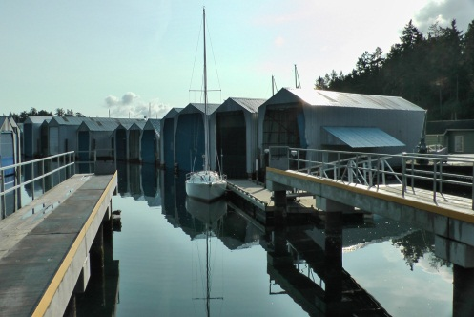
Thursday, Oct 27th
Although haul-out was scheduled for the following day, 28th of October, the weather forecast was for heavy rain for the Friday. I called up Canoe Cove Marina and they had an opening for a lift at 1230 on the 27th. The “Natasha” was ready, stripped down to a bare boat. Off I went on the last run of the Volvo! I powered over to Canoe Cove under calm, sunny skies and then waited at the Cafe while marina staff power washed the bottom, moved the boat from the Travel-Lift to the trailer, and then into the back part of the boat yard between two other boats. Once set into place I measured for tarps to enclose the hull/bottom and drove over to Sleggs Lumber Supplies to purchase them. I applied tape to both sides of the hull to prevent water from running down under the boat, forcing the water to drip off the hull at the tape first. Then I hung the tarps from the slotted toe-rail to enclose the bottom. I couldn’t cover the decks yet until the engine was out, I need to use the boom to hoist the engine up and out, over the side, and onto the ground.
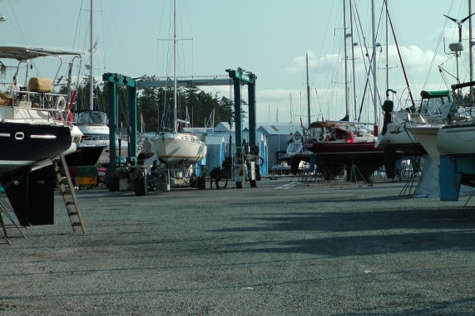

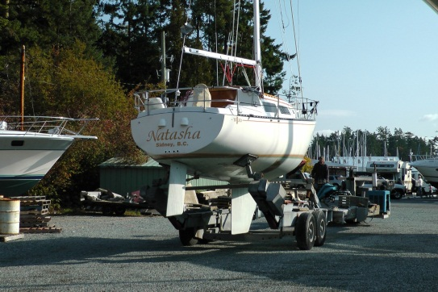
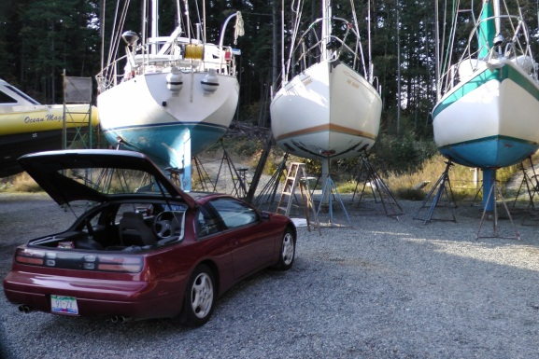

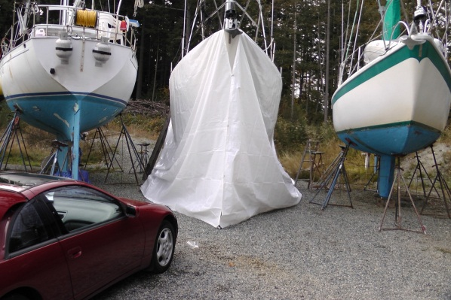

Friday, Oct 28th
The weather prediction was right, heavy rain all day! It was as wet under the boat as above! I had taped above the water line to get the water to drip off the hull and that had worked in some places and not in others. I had to move some of the tape. It was a soggy mess underneath.
I started the task of removing the engine, disconnecting as much as I could until I ran out of tools (which were at home). A bit soggy inside as well without the dodger up to protect the hatch. The rain just fell in. Despite all that, I applied a layer of Boat Bright Soy stripper to a dry section of the starboard side bottom paint, covering it with saran wrap as the instructions call for. The task of removing the bottom paint to get at the blisters was started. I would see the results the following day.

Saturday, Oct 29th
The engine came out and, although a bit nerve wracking, it went without a hitch. I experimented with 4-1 purchase off the boom for the heavy flywheel, transmission, and starter motor. That went well and so I went with the 6-1 purchase for the main block. A bit scary with that much weight dangling over the cockpit and then swinging out over the side. But down it went . The engine ended up under the boat and I would have to figure out a way of getting it home. The rest of the parts (except the transmission) were already there.
The saran wrap on the paint remover came off easily, but the bottom paint didn’t. I applied more with a fabric roller (instead of the foam one I used the day before, which disintegrated) and didn’t cover it this time.
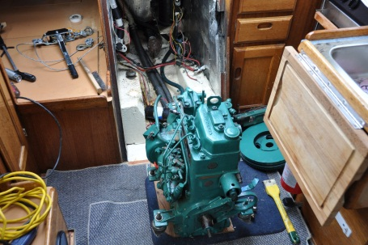
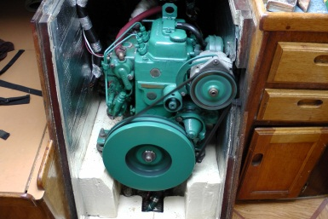

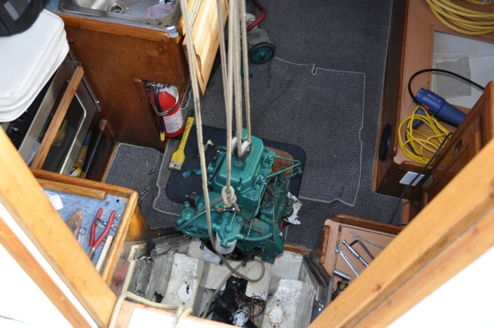

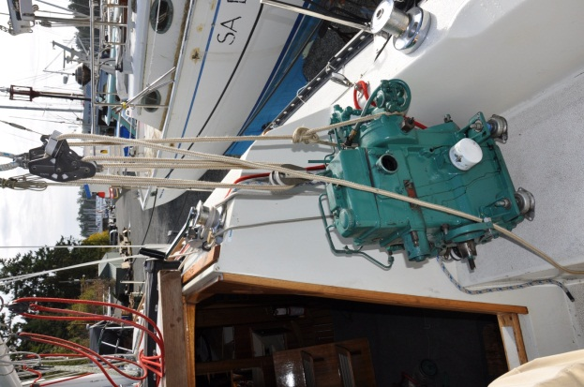

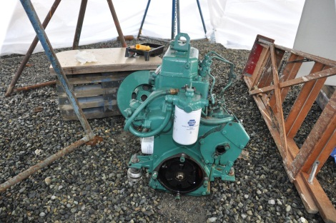

Monday, Oct 31st
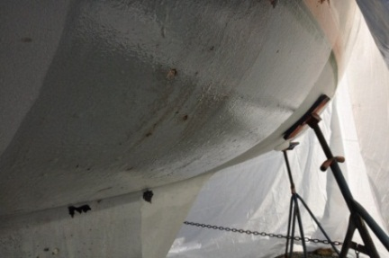
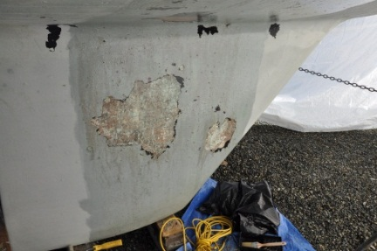
I got some work done, some good, some not so good. It was a sunny and warm day so that was part of the good stuff. The bottom paint remover wasn’t doing as well as I would have hoped. Although softening the paint somewhat, it still took a lot of effort with a scrapper to remove. I experimented with other options including sanding and heat-gun. The heat gun, although time consuming, was a lot easier on the arms. I would still have to sand afterwards but I would deal with that when I got to it. I managed to strip down part of the starboard side of the keel along with some of the hull above that area. The blisters were not nearly as bad as I thought either. The big ones were simply blisters in the anti-fouling paint.

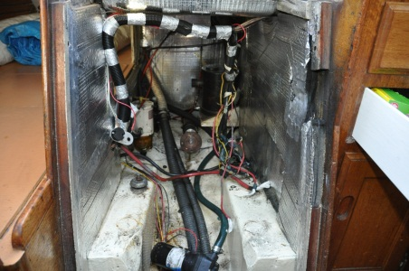
I started the clean-up of the engine room and cockpit locker as well. The instrument panel came out along with the propane tank and locker and everything associated to that. The wiring was all cut loose and I had to figure out what had to go and what needed to stay. All the engine parts were now at home except the block. I bought two more tarps and put them over the deck, tying them down and taping them into place. It would stay pretty dry under there. All in all; a successful day.
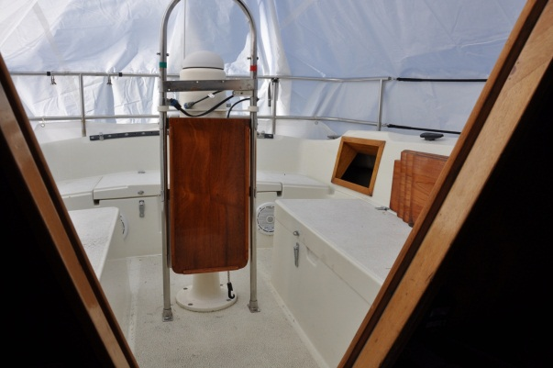
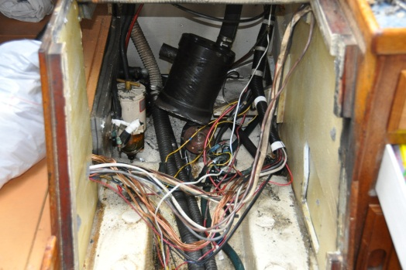

Friday, Nov 4th
Another day of working on the bottom and in the engine compartment. I did a bit more stripping with the heat gun. It was slow and tedious work. I applied two more patches of the soy stripper, hoping that it would speed the removal a bit. The following day would tell the story. The weather was cool so it would probably take more than one day for the stripper to do its’ job. You would think at $145 per gallon it would be more effective!
Then it was continue stripping out the engine room. Dirty work. The water lift exhaust was pulled out, all the wiring to the engine panel pulled out along with the engine stop cable, etc. There was lots to do. I needed a gear puller to get the coupling off the shaft. I took the head off the rudder post after disconnecting the cables. The shaft dropped about 8” until the quadrant hit the top of the stuffing box. The top bearing looks pretty good. The bottom one is a bit wobbly but I thought I would be able to graphite/epoxy that in place so I wouldn’t have to remove the rudder.
I ordered the Beta 20 from Gartside Marine Engines with a delivery date sometime late in December. Gartside Marine just happens to be the Canadian distributor for Beta, and he happens to be in Sidney about two blocks from where we live. I had also been dealing with Ben Gartside as a mechanic for years and knew him well. Convenient! The order was for a Beta 20 without the overpowering red paint, the deluxe “C” control panel and left hand Gori folding prop. The sail drive unit comes from the factory white, the Kabota engine comes from the factory blue, Beta turns everything red. I didn’t particularly want a red engine. The standard prop for this combination was a right-hand Gori folder. I wanted a left hand unit as I’ve always sailed with a left hand propeller. I’m used to the stern walking to starboard when in reverse. Walking to starboard in reverse was also perfect for entering my home slip.

Saturday, Nov 5th
The stripper hadn’t really started to work yet so the saran wrap was left on to keep it moist. I didn’t even try to remove any of the paint. I emptied the fuel tank (seemed to be an endless supply of fuel when trying to get rid of it!) with the vacuum oil change pump. I took all the hoses out of the back end of the boat, including all the drain hoses, bilge pump hoses and fuel tank filler hose. All were original and beyond their life expectancy. The fuel tank needed to come out to get at the drivetrain strut bolts and to install the new engine bed. I was hoping it may just slip out of the stern cockpit hatch. I knew it wouldn’t fit out the now empty engine compartment, was too wide.
In preparation for the task of sanding the entire bottom I purchased a pivoting pole sander head (aluminum) and nylon ties to make up the holder. The plan was to strap the Bosche power sander to the pole sander head and use the pole to support the weight of the sander. I would simply drive the sander around on the bottom while the pole would support its weight. I came up with this idea 20 years ago on the last Islander (Dreamer), it would work this time too.

Sunday, Nov 6th
Marc gave me a hand with his truck and we hauled the motor home. A bit heavy! We used a plank and 4 – 1 purchase to pull it up into the bed. Then when we got home we used the tree next to the driveway to lift it out and down onto a dolly. The plan was to advertise it on the Internet to see if a buyer could be found.
Then it was back to the boat to do some more scrapping of the bottom. I made up a holder for the Bosche sander out of ridged foam to cradle the top of the sander and attached it to the pole sanding head. I tried it on the hull and it works well. But the pole was too long! I would have to get a shorter boat-hook pole to get under the hull.
I also cut the fuel tank loose but it wouldn’t fit out the stern locker, the steering quadrant was in the way! The quadrant (aluminum on a stainless steel shaft) wouldn’t come off without destroying it. I would have to cut the tank up to get it out of the locker. I wasn’t certain that it would be necessary, the tank was in pretty good shape underneath, no corrosion at all. I would examine it more closely the following day. The strut bolts were now accessible, located as they were under the fuel tank that was now out of the way. The nuts came off fairly easily and the strut simply fell off. It was time to patch those four holes and saw off the stuffing box tube. I needed to repair all that before the fuel tank went back in, or a new one installed.

Monday, Nov 7th
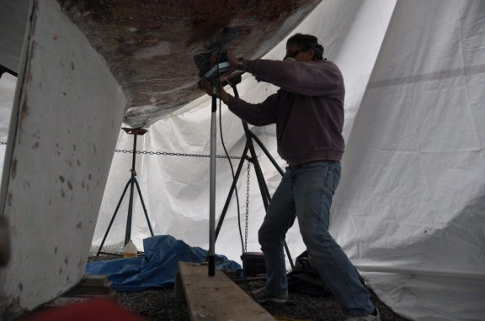
Back at the bottom. I had a new, shorter pole for the sander and, after scrapping off the patches of stripper from Saturday, I sanded everything I had done so far. Slow work, but not too hard physically. I applied more stripper fore and aft on the starboard side and that would be ready for removal on Wednesday. I had to get more rope to hold the tarp down with a 10 knot wind coming up the harbour.
I decided to leave the fuel tank in place, sealing up the holes for the strut first of course! The outside of the tank was in great shape and there wasn’t any internal corrosion that I could see. That would save about $300.00 for a new tank.
As I wouldn’t have room for the fuel gauge outside at the new Beta control panel I planned to re-build the nav station breaker panel. The intention was to include a Linklite battery monitor and fuel gauge there. I would get a sheet of brass from Industrial Metal Warehouse and polish it up myself, drill all the holes and then take it in for etching. Should be good.
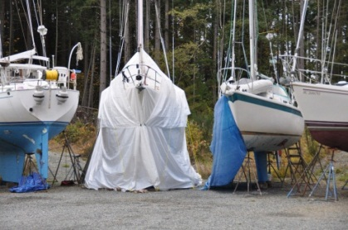
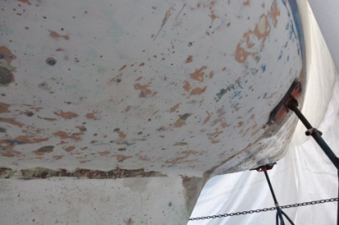
I checked with Gartside about the prop size. Ben was of the opinion that the standard 14 x 8 folding Gori prop would get me 6 knots at 3000 rpm. Maximum continuous rpm for the Beta 20 is 3600.

Tuesday, Nov 8th
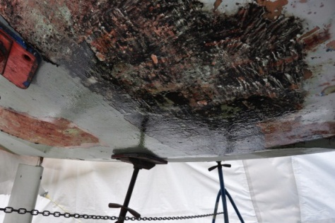
It actually warmed up for a change, up to 13C (55 f) at home with a light cloud cover. Very pleasant to work in. I purchased a Dremel power scrapper to see how it would work on removing the bottom paint. Not as good as I had hoped. I suspected that I will be doing the entire bottom manually! Arrgh! I scrapped some more on the starboard side at the bow and stern using a one inch putty knife and the heat gun. The bow was relatively easy, the stern quarter not so much. The original black anti-fouling paint was stuck on very hard. I scape off the white CSC anti-fouling that I put on last year, then put another layer of stripper on. I would see how that peels off the following day. There was a relatively large patch at the starboard stern that peeled off fairly easily just with the heat gun. I was hoping to find more of that!
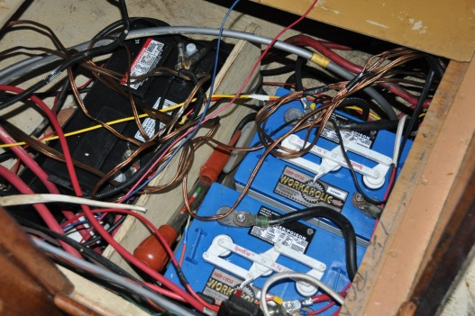
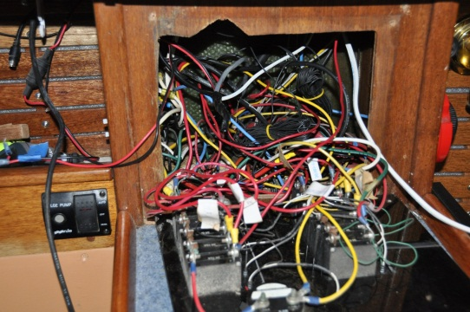
Then I moved inside and removed the fuel filter and hoses, the water raw water strainer and hoses, and pulled the 120 volt wiring out of the galley area. We never use that plug for anything anyway so why have it there. The challenge would be to move all the wiring from the engine room to the stern of the boat, just to get it out of the engine compartment. While I was at it I was going clean up the wiring in the battery box, as well as behind the panel. This is going to be difficult work, I’m not good with electrical wiring!
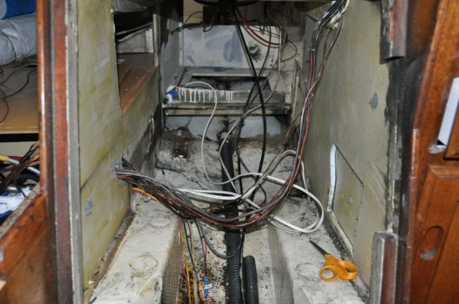

Thursday, Nov 10th
I managed to scrape most of the stripper I had applied the day before. A gooey mess! My coveralls were covered in it! Then on the port side I started near the bow with some loose stuff and, using the big scraper, managed to get almost everything off right back to the keel. Very nice! I applied more stripper to the waterline on that side, the thickest paint. Then I started on the port side of the keel with the heat gun and putty knife. And it took an hour but I did remove all the old paint!

Saturday, Nov 12th
The paint remover under the stern was a gooey mess and really didn’t help all that much. I carried on with just the heat gun and it was just as fast (or slow!). The work was a bit depressing after a while, dull and mind-numbing. But I was making progress. The stern was just about done and I was up to the trailing edge of the keel on the port side. It was time to start some sanding again.

Monday, Nov 14th
A day of bottom stripping…..but I was almost done!! I completed almost the entire port side outside of a patch at the stern and the keel. I suspected that the thin white layer I could see on the bottom was a previous barrier coat, the pink smooth surface underneath was the bonding coat. I continued sanding to see what was underneath.
I checked in with Gartside to ensure that the engine had been ordered from the factory. It had been. Ben was still reviewing the specs for the correct prop size. The new one was supposed to be 14 x 8. The old Campbell Sailor prop was 13 x 8. The way I figured it:
MD7A was a 1.91:1 ratio to the prop. At max engine rpm of 2600 the 13 x 8 prop was turning 1361 rpm for 6 knots
Beta 20 was a 2.15:1 ratio to the prop. At engine rpm of 2600 the 14 x 8 prop would be turning at 1209 rpm. That should be close to 6 knots.
I sent an e-mail to Ben with this information.

Nov 15th, Tuesday
Ben replied to the e-mail that Beta has responded to his query about the right prop and they were suggesting 14 x 9. Ben agreed, and I agreed whole heartedly. I thought this would get us 6 knots at about 2,500 rpm (max torque). Max cruise RPM for the Beta is 3,600, 80% of that is 2,800 rpm. Just about right to get 6.2 - 3 at 2,800 rpm.
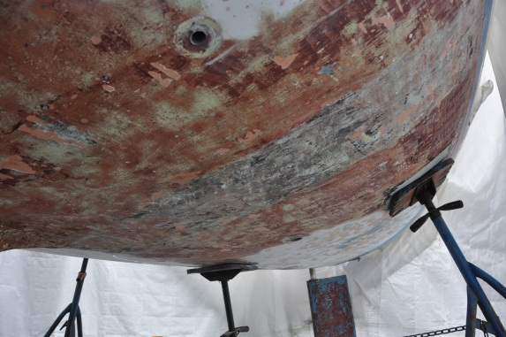
There was frost under a clear sky when I arrived at the boat. I managed to peel off the last of the bottom paint along the port side waterline and started on sanding at the stern of the boat. It was going well. The pole and sander bracket were working out well although the sander transmission was sounding a bit rocky. I was hoping it would last to the finish. The epoxy plug I had put in for the old knotmeter/sounder transducer two years ago was soft! I heated it up with the heat gun and pulled it out. It was like very sticky taffy. Fortunately, the fiberglass mat on the inside was good and solid.
I also put a layer of paint remover on the rudder. I tried using the heat gun for a small section on the rudder but there were too many layers of paint on that unit.

Saturday, Nov 20th
I spent most of the day sanding the bottom (again). I stripped off the paint on the rudder and then started sanding the bottom from the starboard side stern quarter to the bow and half way back along the port side. It was a bit chilly near the end of the day with the ice that fell off the tarp never melting.
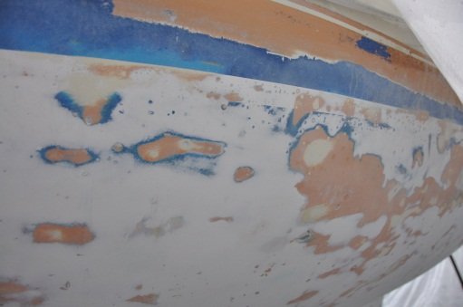
At this point I thought I had figured out what had happened to the bottom prior to our purchase. It looked like someone in the past had repaired the original hull blistering. The repair had held well with very little re-blistering. Then a barrier coat of some type was applied, perhaps simply gelcoat (once this material heats up it becomes very flexible, not like an epoxy barrier coat). All of the blisters visible since our purchase were in this top layer! There were very few that had penetrated into the original gel coat. In some places this barrier coat was very thin and easy to remove by sanding. Other places it was much thicker and a bit more difficult. So what would I do?!? As there were very few blisters in the original gel coat did I forgo adding a barrier coat? If I did go with a barrier coat, did I need to remove all of the current barrier coat? In some places where the barrier coat was very thin the edges started to peal away from the original gelcoat underneath. Was this just the start of a general peal-up. If I apply Interprotect 2000E would that cause the “barrier coat” to disintegrate? Too many questions, not enough knowledge.

Monday, Nov 21st
I had good intentions for more work, but found the tarp covering the cockpit had blown over the side due to the vicious wind storm overnight and in the morning. Between wind and rain I managed to reposition the tarp. As the cockpit drains have been removed all the rain that fell overnight drained into the sump. With no bilge pump it was all still there! More wind and rain anticipated for that evening.
Wednesday, Nov 23rd
It was a relatively good day down at the yard. I spent the first 1 ½ hrs refastening the tarp in a bunch of corners. I had some clips along with “Hurricane Tape” to make repairs. I was hoping the storm predicated for that evening didn’t rip it all apart again.
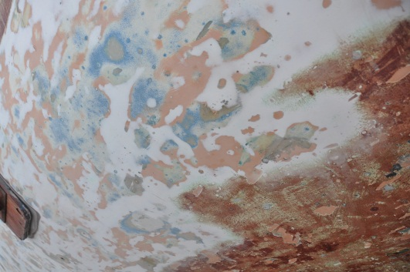
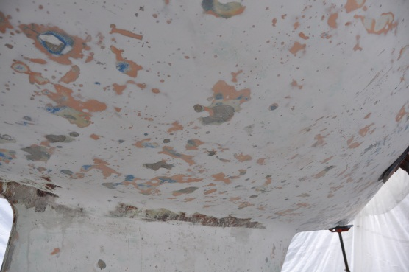
I sanded the port side of the keel and re-sanded the starboard side as well. Then I started on the rudder before giving up for the day. I had Matt from Blackline Yacht Repair come over to take a look at the bottom for an opinion. I’d had time to think about what had gone on and Matt came to the same conclusions. Someone in the past had applied a barrier coat over the original gelcoat after completing a blister repair job. Although there were a few new blisters that penetrated the original gelcoat, the vast majority of the new blisters were in the barrier coat. Matt recommended against applying a barrier coat to a 30 year old hull, saying that after that many years in the water whatever resin voids were original in the hull had already blistered and had been dealt with. Any applied barrier coat had the potential of re-blistering. The original blister repairs in the original gelcoat look like they were holding just fine. It was highly unlikely that there would be further blistering. There were a handful more but nothing drastic. I decided to sand the bottom smooth, fair out the small pockets created by the remaining barrier coat and the additional blisters, then apply anti-fouling paint! This would save a lot of work and probably close to a $1,000 in barrier coat! If any kind of weather holds for December I would be done the bottom by the New Year.
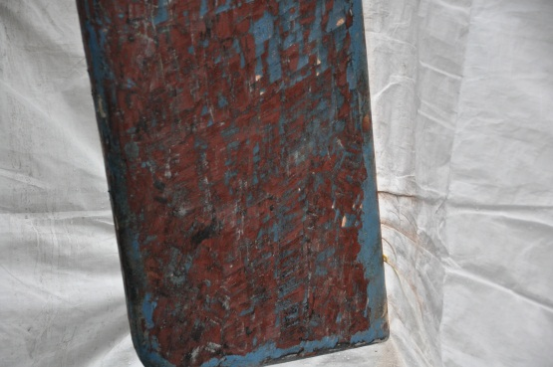
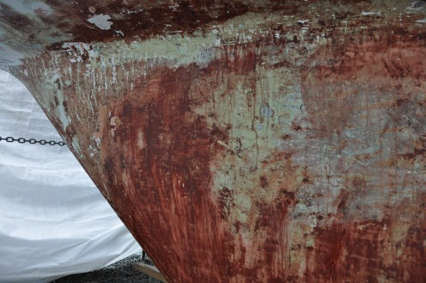

Friday, Nov 25th
A bit more time repairing wind damage to the tarps after another storm blew through overnight. It had been blowing a good 40 knots in Sidney Channel and it seemed that strong at the boat as well. I released some of the ropes to the stands during the windstorm, afraid the tarps were going to pull the stands out from under the boat. One of the neighbouring boats had had that happen. A few of mine were loose but at least I didn’t lose any completely.
I did a bit more sanding on the port side aft of the keel. I estimated about 3 more hours of sanding and the primary sanding would be done. Then it would be time to fair the hull with epoxy.

Monday, Nov 28th
Finished the initial bottom sanding!! Finally! And it’s a good thing too. The Bosch sander sounded like it was on its last legs! The transmission was squealing like a stuck pig. I was hoping it would last a few more weeks until I finish applying epoxy to the blisters and sanding again. We had some pretty vicious wind storms come through but the tarps (with all their repairs) seemed to be hanging in there.
I also sanded the entire waterline down to the original blue bonding coat. The rest of the bottom was as smooth as I could make it. I had to open up the suspected blisters that had penetrated the fiberglass and allow them to dry out. Then it would be epoxy time. In the mean time I needed to paint the waterline with cream coloured Interlux Perfection to match the hull color before applying the tan color as a boot stripe

Tuesday, Nov 29th
I cleaned up, sanded and taped the waterline in preparation of a two part epoxy primer. I had to be ready for a reasonably warm day (I needed 10c/50f). The macerator through-hull was right in the middle of the boot strip so it had to come out. I had to cut it off from the inside as the bronze gate valve and mushroom fitting wouldn’t come apart anymore. I also took out the four plastic stern through-hulls so that I could paint in the tan boot stripe. I planned on raising the boot stripe 1 inch so that the boot stripe paint wouldn’t get fouled all the time. The old stripe was right at the waterline with the paint attracting growth. I was using Interlux Perfection (pearl white) to paint the entire boot stripe area before applying the tan of the actual boot stripe.

Wednesday, Dec 7th
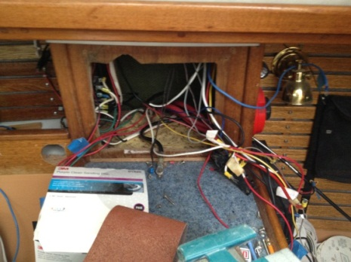
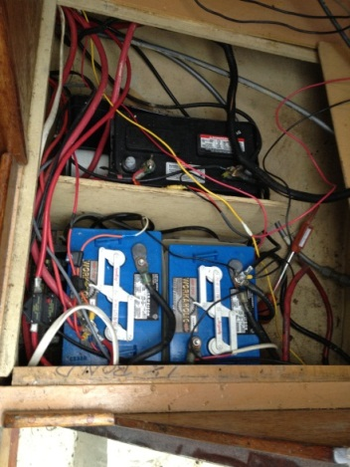
I started the task of re-wiring the stern of the boat, ripping out all sorts of wiring that was very questionable. I removed all the wiring from the engine room, cutting the bundle after labelling it.

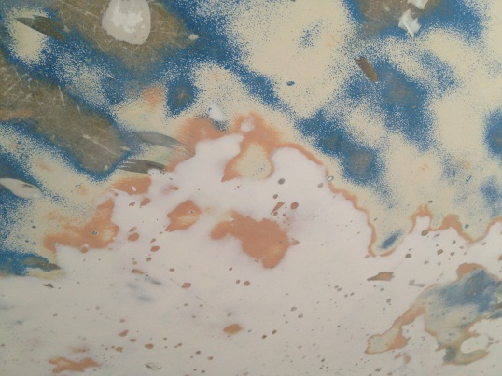
The weather wasn’t all that bad so I also started the re-sanding of the bottom as well. I had decided that it was going to be just as much work (and with better results) to sand off the previously applied barrier coat as opposed to trying to fair out the hills and valleys of that material. I started in the starboard rear quarter and worked my way forward. It was going quite well but the sander was really sounding ominous. There was far too much noise from the gear box(?) bearing area and the engine was labouring, really slowing down! It wasn’t a good sign. It was time for a replacement.
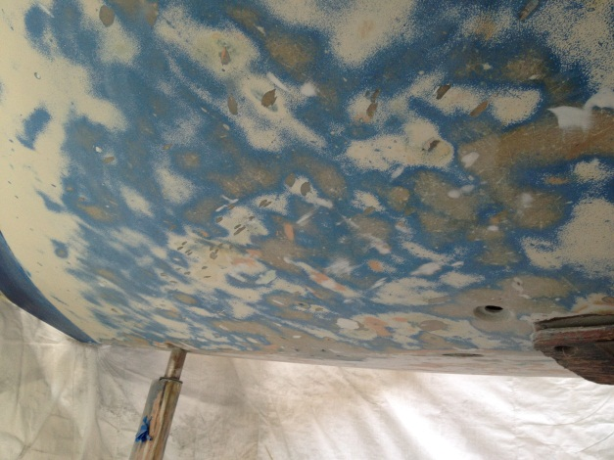
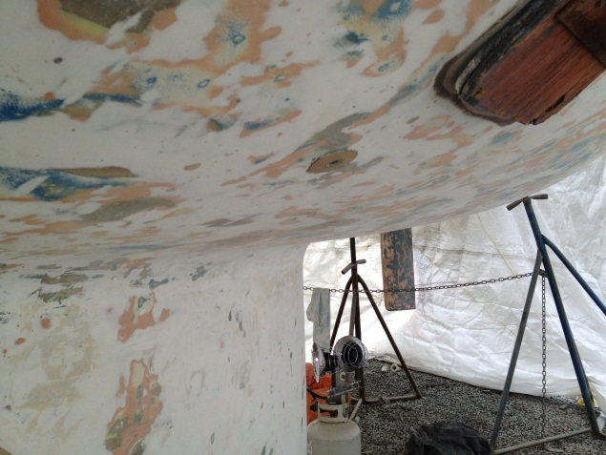

Thursday, Dec 8th
Well, the sander did die. It wouldn’t even turn over! I took the Bosch apart in the morning and it was definitely the lower bearing that was all jammed. I could barely turn it over with my hand. I drove over to Sleggs Lumber Supplies to see if they had another one in stock. They had three at the Langford store (a 45 minute drive away) that could be transferred to the Sidney store the following week. So, no sanding. I did a bit more work on stripping the wiring out (it was going to be fun putting it all back together!) before tackling the engine beds!
Trepidation! How was I going to get them out?! It ended up being a bit easier than I thought. Each bed had two 3 x 12” pieces of mahogany screwed together (no glue, thank heavens!) and then tabbed to the hull on the inside edge only. They were attached to the hull on what looks like an epoxy bed and stapled to the cabinetry, again without glue! That may have caused a few of the rattles that were so annoying under power! Using a crow bar and hammer I managed to bang and pull both beds out! I sheeted off the cabin with plastic to minimize the dust and then went at it with a grinder and the belt sander.
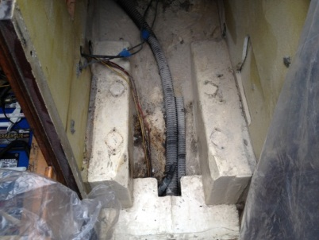
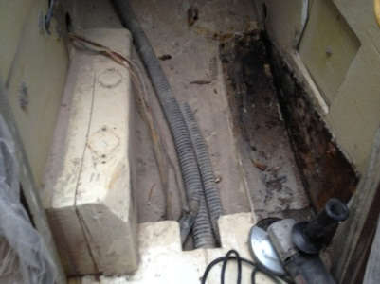
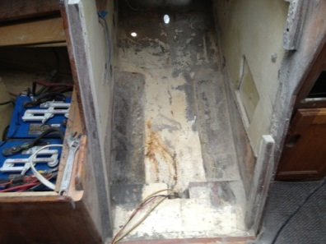

Friday, Dec 9th
First thing in the morning I had driven all the way to Sleggs in Langford to pick up a new Bosch sander only to find that they had shipped them all to Sidney! Some people simply didn’t listen! I purchased the display model as I wasn’t going to risk getting back to Sidney and not finding one ready. I used the new sander to continue removing the old barrier coat. Long, noisy and dusty work.
I also managed to get the first coat of two part epoxy primer on the waterline. It was about 7C (45 f) with no wind. I turned on the 30,000 btu propane heater under the boat and had no problem getting the temperature up to over 10C (50 f) in no time. I mixed up the two part primer and rolled it on in just a few minutes. I placed balloons between the stern and the tarp to keep the tarp off the fresh paint. The stern was the only area of the boat where the tarp came into contact with the hull at the boot strip. That worked very well.
Then it was into the boat and measuring for the engine bed. I confirmed that it wasn’t good news. The engine room was measured at 22” wide. The Beta engine bed data indicated 23 ¾ wide! The sides wouldn’t really be a problem, I could cut the walls and angle them out into space that we didn’t use under the quarter-berth to starboard and galley to port. I knew that I had to do that anyway as there certainly wouldn’t be enough room to glass the new engine bed to the hull without removing the cabinetry. I was going to wait until I got the engine bed mounted to re-glass the cabinetry so I could match angles and still get sound insulation into the extra space.

Saturday, Dec 10th
It was another cool, clear day (7c, 45 F) today and I had the heat turned on again. The epoxy primer had not set up yet (probably because of the cold night) so no further patching or painting. Down to sanding again! I finished the port quarter and made it most of the way to the leading edge of the keel on that side.
I’ve concluded that the water-lift muffler is not going to fit in the engine compartment like the smaller one did with the old Volvo. My plans to move it towards the stern and take up room with a new, smaller fuel tank would also not work out as I was going to keep the original fuel tank. I tentatively planned to build a locker inside the port side cockpit locker to hold the muffler, not an ideal solution as it would really cut down on available space in that locker.

Wednesday, Dec 14th
A minor change of plans from Saturday, a better idea dreamed up as I fell asleep. I could keep the original fuel tank in its’ original position and move the new water-lift muffler under the port side cockpit “T”. It would fit nicely and not be in the way. Excellent! Unfortunately, it would be outside of the engine compartment and all the associated sound insulation. The impact of that will be determined later.
I finished sanding on the port side near the bow and started on the starboard side from the bow to almost the leading edge of the keel. That meant I only had the starboard side midsection to go!
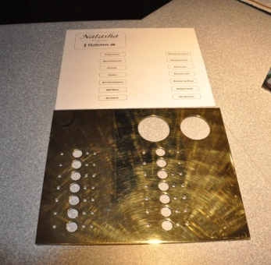
I finished polishing the brass electrical panel starting with coarse emery cloth all the way down to brass polish. I was going to take it to the engravers the following day along with the paper example of the labelling that I wanted.

Friday, Dec 15th
Another day of sanding, but I was almost done down to the original gel coat! About time! I was planning on giving the boot stripe another coat of epoxy primer but there was just enough of a breeze blowing that the tarp moved around and prohibited that from happening. All I had left for sanding was the keel and keel root.
A bit of a hiccup with the instrument panel. Custom Rubber Stamp in Victoria indicated they couldn’t engrave the brass, but could stamp it. That change was given the OK.

Saturday, Dec 16th
I managed to sand and put another coat of epoxy primer on the boot-stripe. It was looking pretty good. Then it was into the boat to clear out the battery compartment. I had to move the cabinetry between the battery and the engine compartment so that the engine bed would fit, so everything came out of the battery compartment. The original factory plywood subfloor was poorly constructed and starting to rot so it was a good thing it was being replaced.
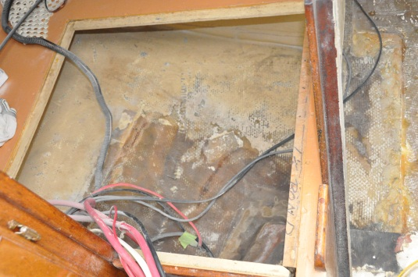

Monday, Dec 19th
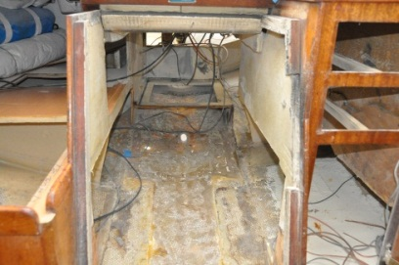
It was a pretty good day with reasonably warm (9c, 48 f) temperatures so it was pleasant to work outside. There was just a bit too much of a breeze to put the last coat of primer on the boot stripe with the light wind pushing the tarps against the boot stripe area of the hull.
I tackled the last major challenge (I hope) that I had approached with trepidation; the removal of the engine compartment bulkheads. It actually went quite well. A lot of work with the circular saw, jig saw, grinder, and belt sander! I went through two cutting wheels on the grinder and had to pick up more sanding belts for the sander, but it’s done! There was plenty of room to put the engine bed in now.
I picked up a dual-battery box from Waypoint Marine and it fit the compartment very nicely. Both deep cycle 6 volt house batteries fit into the single box. The starter battery was over 10 years old and needed replacement. It was to sit in its’ own box just astern of the house batteries. I purchased plywood so I could start with the battery platforms. One sheet would also do both new bulkheads for the compartment as well. As usual during a boat project, the interior looked like a construction site!

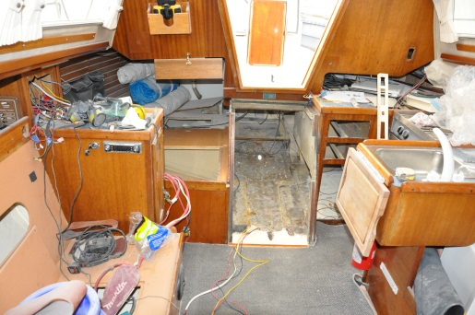
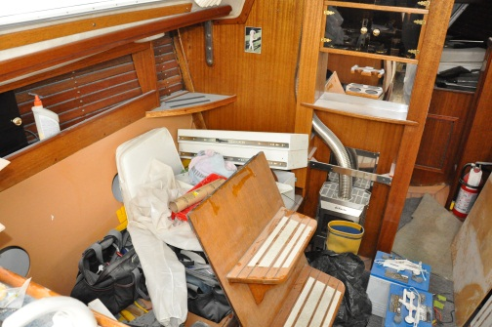

Tuesday, Dec 20th
I was down at the boat for about an hour, putting the last coat of primer on the boot stripe. Up to 10c (50f) with no wind, perfect! I left the propane heater on under the boat to help with the curing process.
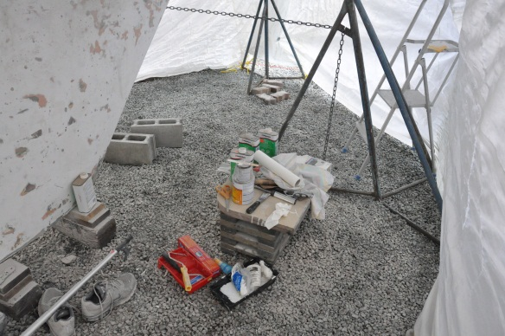
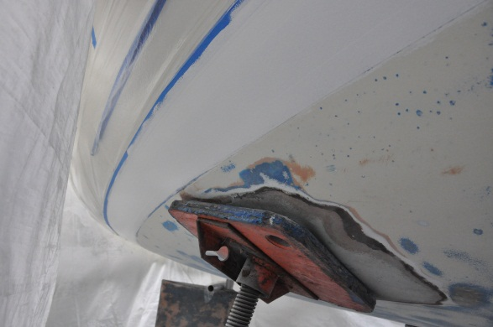

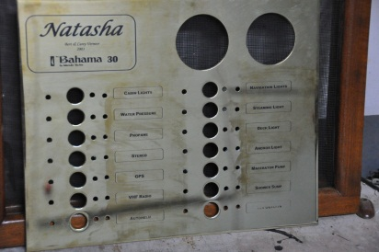
Wednesday, Dec 21st
I picked up the brass electrical panel and found it to be a severe disappointment. Poorly done and poorly finished. I went to buff it up to remove fingerprints and smudges, using liquid brass polish, and it simply removed the lettering! I needed to do some more research on how to make this work. There were labels available from BlueSea and I was leaning that way.

Thursday, Dec 22nd
I was a bit cold for painting although I had planned on doing that. When I got to the boat I found the propane tank empty and the hull cold. I had figured that the propane would go a couple of days on the low setting. I guess that’s with one burner only! Oh well, the primer was nice and hard so I was able to sand the boot stripe in preparation for the finish paint. I would have to wait for warmer weather and get more propane!
Then it was into the boat and work on the battery compartment. I had the main support for the battery box roughed out so I trimmed that to fit. Then I measured and cut templates for the starter battery box. I had to cut the hatch a bit to be able to take the lid off the battery box for routine maintenance. I routed the wiring for the pedestal GPS signal and power through the edges of the engine and battery compartments. The wiring for the bilge pumps was re-routed into the battery compartment direct from the bilge, I wouldn’t have to see them in the engine room. I also managed to prime the upper edges of the battery compartment so that I could finish them with International bilge coat paint by the end of the week. I could then start installing all the electrical equipment without waiting for the completion of the whole battery compartment, including the wall between the battery and engine compartments.

Friday, Dec 23rd
The wind never stopped completely, just enough to move the tarps with occasional higher gusts. No painting the boot stripe. There was a front coming through with rain and warmer (8c, 46 f) temperatures and wind. So, back to working on the inside. Would you believe I built the starter battery platform from the cardboard template, but upside down! Damn! Another “Duh” moment. I epoxied the house battery platform into place after giving the upper edges of the compartment the first of the bilge coat paint coats.
Speaking of the engine bed, the engine and sail-drive unit had arrived at Gartside without the engine bed! Beta had left it out of the order! Hard to believe! But the right instrument panel came, the leg, engine and prop. Of course, the engine was red, not like the factory Kubota blue I asked for. Oh well, that could soon be corrected. I also picked up the Centek exhaust water separator as well as the water-lift muffler.
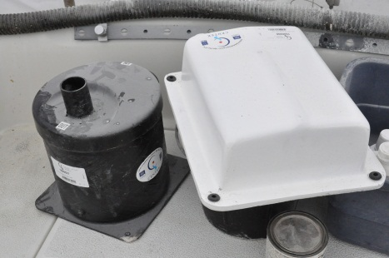
I figured out where the water separator was going to go and measured for a mounting platform. It was bigger than I thought it would be, but would fit behind the engine control panel. I picked up a galvanic isolator for the shore power system from Waypoint Marine Supplies and figured out where I was going to install that. I started the installation of the new shore power plug (Smart Plug) but the isolator needed to be installed first. I also rebuilt the starter battery box support (right side up) so I could glass that in. The project was coming along slowly, but surely. It was Christmas Eve the next day and a break would be appropriate!

Saturday, Dec 24th
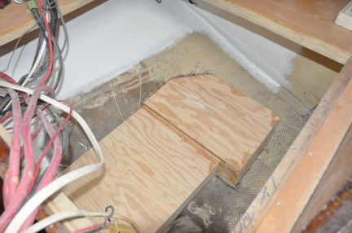
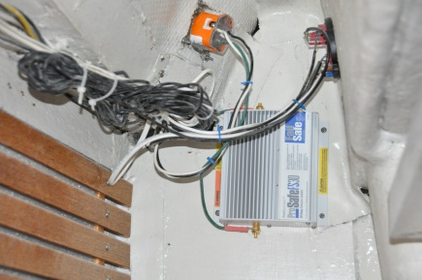
A somewhat mixed day, success-wise. I epoxied the start battery base and gave both that compartment and the one to the rear of that a coat of bilge white. That went well. I managed to install the new shore power cord socket (Smart Plug) along with the galvanic isolator. That also went well. I used a grinding disk to sand out the area in the cockpit locker that the water separator was going to be mounted, applying a coat of primer on the base I wanted to mount it on. I would be able to epoxy that into place after the Christmas break. I then sanded out the entire cockpit locker in preparation for a coat of primer.
Then the rain stopped, the sun came out and the wind died. Could I get a coat of epoxy finish on the boot stripe, finally? I went home and got the paint, mixed it up carefully and waited the required 20 minute pot time. The boot stripe was rubbed down with the proper solvent and the temperature under the tarp was well over 10c (50f), the minimum required. I started to roll on the Interlux Perfection and it fish-eyed immediately! A bit disconcerting! It was only a very small area that fish-eyed and I repaired that immediately. The remainder of the application on the boot stripe was good. It was still sticky two hours later but no wind had come up to push the tarp into it.
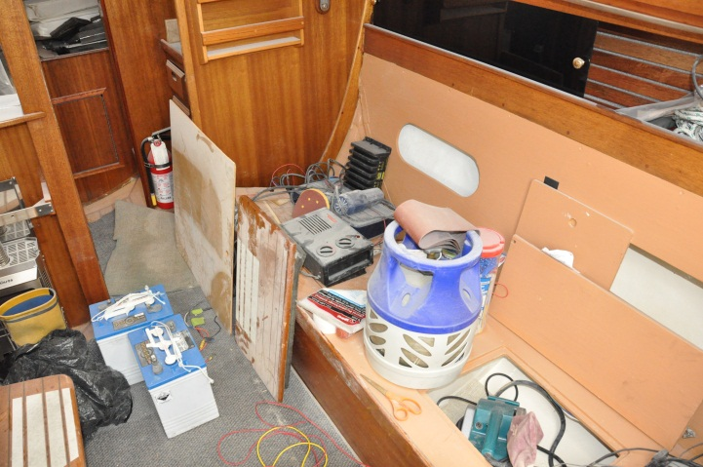
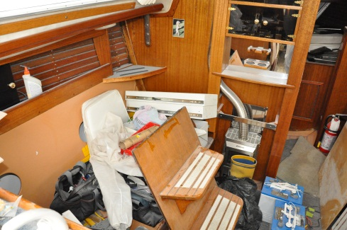
Thursday, Dec 29th
After the Christmas break I epoxied the water separator mount into the cockpit locker and applied glass and resin to the battery platform. I also used some of the epoxy (with fairing compound) to fair out some of the small depressions in the hull from previous blister repairs . Not as many as I would have thought when I was originally sanding.
Friday, Dec 30th
Just a few minutes on the boat, priming the battery platform and the cockpit locker.

Tuesday, Jan 3rd
It had been raining hard all day! Still warm enough though, about 10c (50c) which was very nice to work in. I started the bottom anti-fouling painting on the patches where I wanted to move the hull supports. I needed to move the rear-center support soon as it was where the sail-drive unit would come through the hull. I wanted to get at least 4 – 5 coats of bottom paint on the patches first. I glassed matt on the old engine holes through the hull, the water intake and stuffing box tube (now ground flush). The strut patch under the fuel tank had five layers of glass on it and should be sealed. The holes are not that big in the first place and the 4 – 5 layers should be more than adequate. Then I would need to epoxy the hull from underneath to fair out the holes. The glassing went well. I also put a coat of bilge coat on the battery platform. I wanted to paint the cockpit locker but had to order the paint from Waypoint. I want to tint that paint to match the original hull color.
I also dropped by Gartside Marine Engines to check on the prop rotation. Ben confirmed that it’s a left hand prop. He didn’t know when the engine bed was arriving but said it would be before the 15th of January. I picked up the control panel so that I could prepare the backing plate to fit as a replacement for the current teak panel.

Wednesday, Jan 4th
The fiberglassing from the day before worked out well, good and dry. I started the fairing out of the bottom of the hull where the old engine holes were. I ground out the holes to allow for a feathering to the hull and started filling with epoxy and matt glass. It was too windy to put a second coat of anti-fouling on the bottom paint patches. I did put the last coat of bilge paint in the battery compartment and put the first coat in the cockpit locker.

Thursday, Jan 5th
I put a second coat of bilge coat on the cockpit locker (upper half) so I can get the port side wiring started. I also wanted to mount the water separator for the exhaust system. The epoxy in the engine room holes was hard so I was able to sand it and put a second coat to fair it out. That would be sandable the next day. I also put a second coat of bottom paint on the stand patches.

Friday, Jan 6th
A mixed day working on the boat. The epoxy on the hull had hardened nicely. And it was fair too! I sanded it down. I also applied a coat of bottom paint to the stern patches as well as the others.
Then it was into the stern locker to clean it up. I moved the fuel tank back into place temporarily and vacuumed all the dust out of the stern locker. Then into the locker with the grinder and sander to remove all the old paint and prep for the new. I was getting too old for those tight places! Anyway, it was all cleaned out, vacuumed out and primed. I removed the old manual bilge pump as the surface seal was leaking into the locker. The outside diaphragm was torn, allowing rain water to roll off the cockpit seat and into the locker. I wanted to see if I could find parts, or a replacement pump with the same footprint. I also want to make an ABS plastic support for the autohelm rudder sensor. The plywood one that I had originally built didn’t quite stand up to the abuse of the stern locker!
Then I tried to glass the three layers of matt into the engine compartment. This was an area two feet by three feet, covering the entire hull in that compartment. The idea was to ensure that all the old through hull holes were securely sealed and to even out the sole for the new engine bed. I had the mat all ready and mixed up all the resin I had. I soon figured out that I didn’t have nearly enough! I walked over to the shop at Canoe Cove Marina to get some more and they don’t sell any! Time was too short to drive anywhere to get more and seeing I was only half done I had to rip it all out, stuff it all into the garbage bag and into the dumpster. I couldn’t afford to have only half of the sheet harden up! I would have to be better prepared next time!

Saturday, Jan 7th
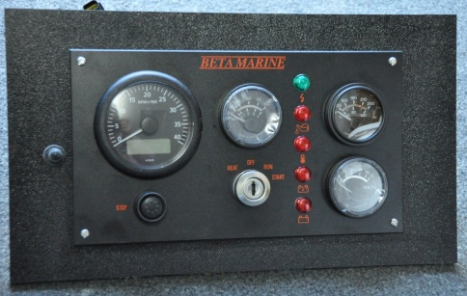
A good day’s work on the boat, despite the crappy rain and about 7c (47f). I started in the garage with the table saw, cutting the trim for the battery compartment out of hardwood, the air intake for the engine compartment out of plywood, and the auto-pilot rudder angle holder out of ABS plastic. I also built the ABS plastic backing plate for the new engine control panel in the cockpit. Then it was down to the boat to do some painting in the lazerette locker. I finished the first coat and then started work on the bottom again. I sanded and added another coat of bottom paint to the patches for the stands. I also painted the rudder with anti-fouling. Then it was continue on with fairing the hull and keel. I sanded down both sides of the keel again, fairing out the old barrier coat and then adding epoxy to the dips. By then it was getting dark out and time to quit.

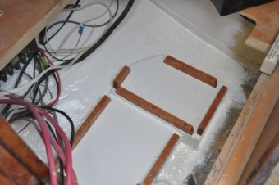
Monday, Jan 9th
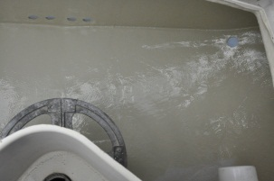
Another pretty good day at the salt mine! I managed to get the trim completed on the battery compartment and put a second coat of bilge paint in the stern locker. Then it was under the boat again with a sander, smoothing out the epoxy I applied on Saturday. It was good and hard this time and sanded out very nicely. It was warm today (about 11c, 53 f) and I was hoping to get a second coat on the boot stripe, but the wind would just never go away! The tarp just kept moving, slowly, but moving. I mixed up some epoxy for some more filling and also put another coat of bottom paint on the patches and rudder. Then I noticed that the wind had finally stopped. I turned the propane heat back on and mixed up a batch! Of course, I had to wait the 20 minutes for it to set and then rolled it on. I left the propane on for the night. It would run out of gas sometime around midnight as the temperature dropped with the clear skies, but the paint would be dry to the touch by then and good to go.
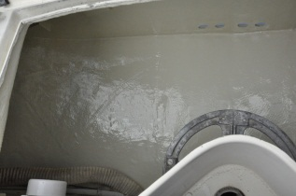

Wednesday, Jan 11th
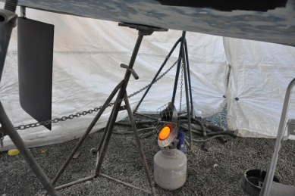
I didn’t spend a lot of time at the boat but got a few things done. I had removed the manual bilge pump from the stern locker as the handle diaphragm was ruptured, allowing rain water to roll off the stern seat into the lazerette locker. I was hoping to get a simple replacement for the diaphragm but didn’t think that was likely for a 30+ year old pump. I couldn’t believe it when I learned that Whale still makes them, along with a nice cream coloured cover!
I took the bottom boot stripe masking tape off and it came away cleanly. The paint looked very good and was hard. I taped it up for the tan trim paint. Although it was supposed to be fairly cold for the following day at least there wouldn’t be any wind and I had the propane heater (as soon as I got more propane!). I put a first coat of brown on the stern so I could get the through-hulls in the following week. I also put three more layers of fiberglass matt over the shaft hole and water through-hull for the engine, the task I had messed up previously. There were only two layers there and I figured that may not be enough!
I also sold the Volvo MD7A engine to a guy who lives in Vermont and bought a boat in LA. He wanted the manifold mailed to him and was willing to pay the $800 for the whole engine just to get the manifold. He was expecting to pick up the rest of the engine later in the spring.

Thursday, Jan 12th
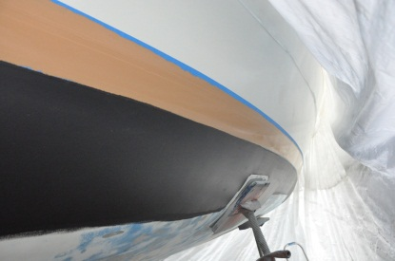
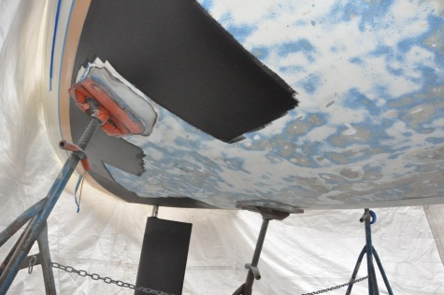
A pretty good day down at Canoe Cove. Although it was cold out it was also sunny, and did warm up. First thing in the morning I drove into Victoria to pick up a hand cart / trolley to hold the sail-drive leg and, eventually, the engine. I also picked up two bottles of propane as I was right out. Then, after dropping by Waypoint Marine to pick up various parts, it was down to the boat. I turned the propane heat on under the boat and start stripping the top edge of the boot stripe tape off. Then I re-tape the top and bottom of the stripe along with the little accent stripe. A bit of sanding and a wipe down and I was ready to paint with Sundown Buff, the color of the boot stripe. That took the better part of the afternoon! I managed to get the temperature up to over 10c (50f) at both stern and bow with the heater. It only took a few minutes (after all that preparation) to actually apply the paint. I simply rolled it on. The not-quite-perfect rolled finish is something I could live with. It is, after all, a boot stripe! I left the heater on for the afternoon and the one burner on for the night. I also wiped down the top edge of the bottom at the boot stripe (the white part) so that I could apply bottom paint.

I also went by Gartside Marine Engines and picked up the sail drive leg. It’s a bit heavy to lift (about 90 lbs), but I can carry it. I took it home in the car and built a stand onto the new cart and placed the leg on it. I started the process of painting the top white and sealing the immersed half with epoxy. The epoxy, Interprotect 2000E, is on order at Waypoint and the immersed part of the leg will require about five coats.

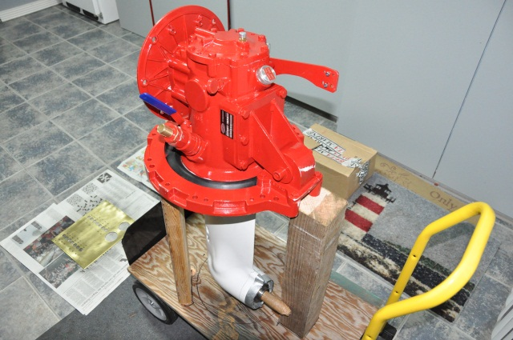
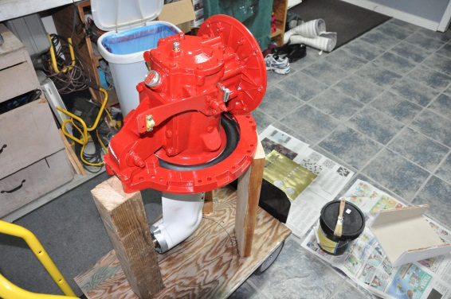

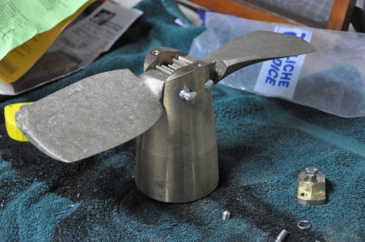

Friday, Jan 13th
A rather cold, cloudy day with a threat of snow for the weekend. I managed to get another coat of Sundown Buff boot stripe paint on along with another coat of anti-fouling bottom paint at the water line. I mixed up a bit of epoxy and searched the hull for more holes and dips I didn’t catch the other times. The new manual bilge pump cover (very nice) was installed.
At home I worked on the electrical panel. After the disappointment of the stamped-on lettering I stripped all the lettering off. I re-polished the brass and put clear-coat lacquer on to seal the finish. I had purchased the Blue Sea labels for the panel and, to make up the boat name on the panel, I created a sticker on the computer and used Avery See-Through Label paper. I reversed the colors so that it’s black with clear lettering. It looked pretty good.

Saturday, Jan 14th
A good day. The weather stayed nice all day and I managed to get some things done. The boot stripe was just fine with two coats of paint, no need to risk a third. The forecast was for snow in the evening with a few flakes around during the day. The wind was forecast to be NW so I didn’t want to risk the tarp against the paint. It’s cold as well. I bought another 20 lbs of propane but I thought I would have had difficulty getting the temperature under the boat over 10c (50f). The anti-fouling paint didn’t have that restriction and I painted the rest of the bottom with CSC after sanding off the last remaining epoxy patches.
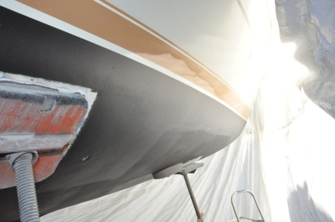
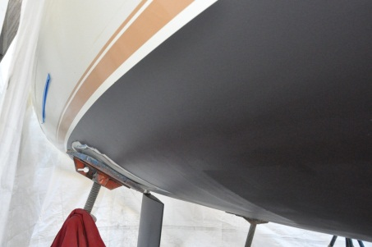
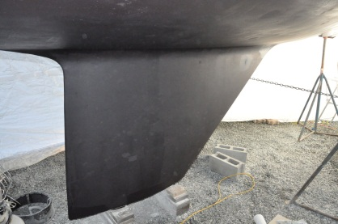

I felt so pleased with my progress that I treated myself to lunch at the cafe. Once clear I went home and started work on the sail drive leg, taping off the fittings I didn’t want painted white. I rolled the cart into the garage (heat on in the garage) and started to paint, taking breaks between coats to watch a very entertaining Saint Louise / San Francisco football playoff game.
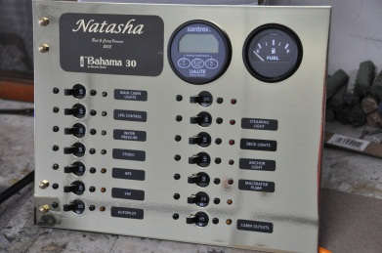
Sunday, Jan 15th
Assembled the electrical breaker panel today and it looks very nice, almost professional!
It was sunny and cold out, down to -5c (23f) overnight. The Vancouver area and the Fraser Valley received plenty of snow. On the premise that I may have had to take the bus to the marina in the near future (no snow tires on the Nissan!) I brought the rest of the bottom paint to the boat. I wanted to put another coat of CSC on the bottom and get the center rear support moved out of the way for the leg. I needed to grind that area clear and fill any blisters that may be under there.
I’ve also had a change in plan for the stern through-hulls to ensure that the boat passes the survey. I ordered five Marelon barbed 1 ½” through-hulls. The originals are simply plastic and at replacement condition. I would get a reducer for the 2” exhaust, down to 1 ½”. The exhaust cooling water would be coming out of one of the 1 ½” through-hulls. The exhaust gasses out of the other. No need for a 2” through-hull. I would have to “buddy-up” some of the bilge pump plumbing so I wouldn’t have to drill more holes through the hull. Considering the bilge pumps (2) have 1” hoses it wouldn’t be much of a problem to feed them into a 1 ½” though-hull.
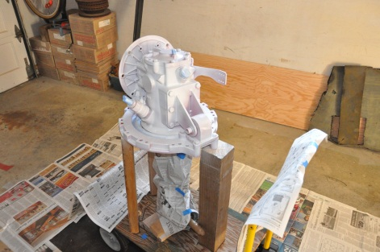
I also stripped the masking tape off the sail-drive and applied the first of 5 – 6 (maybe more) coats of primer to the lower leg. I had contacted the experts at International Paints and, if I wanted to use Interprotect 2000E on the leg, I would have to strip the leg down to metal first. I couldn’t apply the barrier coat over ordinary enamel paint. One of the options was to use Interlux underwater primer, multiple coats, and then bottom paint. That seems to be a logical option. This application was to reduce the likelihood of damage to the leg and potential for galvanic corrosion if the aluminum is exposed to salt water.

Monday, Jan 16th
It was cold out in the morning and I soon had the propane heat on under the boat. With a snowfall warning posted I hoped to get at least one coat of CSC on the bottom before the white stuff forced me out of Canoe Cove (no snow tires, steep hill). I got marina staff to move the one centre support so I could strip the old paint off right where the leg would come through. I also managed to lubricate the rudder post and I slid the rudder back up into position. That worked out well without any difficulty. Then it was on to painting the entire bottom for the second coat of CSC. That worked out to four coats at the waterline and two elsewhere (except the patches) and I still had a gallon and a half left. I would be able to get three more coats on the entire bottom. At about noon I poked my head out from under the tarps and it was snowing hard! And it was sticking! That was it, I was gone. At home I finished the little piece I have built as an air intake for the engine compartment and put the fourth coat of primer on the bottom of the leg. It stopped snowing early in the afternoon and most of it melted quickly, but the snowfall warning was still in effect. Oh, and the engine bed, due on the 15th, hadn’t arrived yet!

Monday, Jan 23rd
It had been pretty cold for the week. I hadn’t been able to get to Canoe Cove to get any work done! The engine bed still hadn’t arrived and Ben Gartside had been busy at the Toronto Boat Show for the entire week, out of communication.
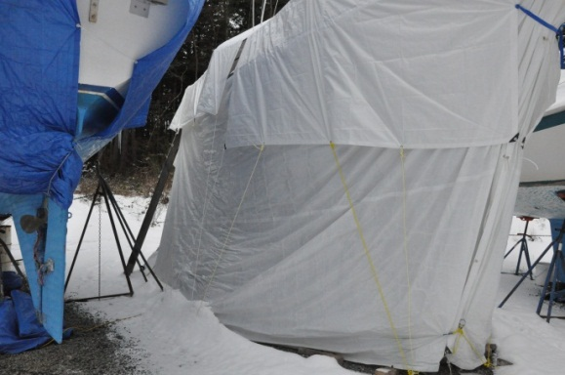
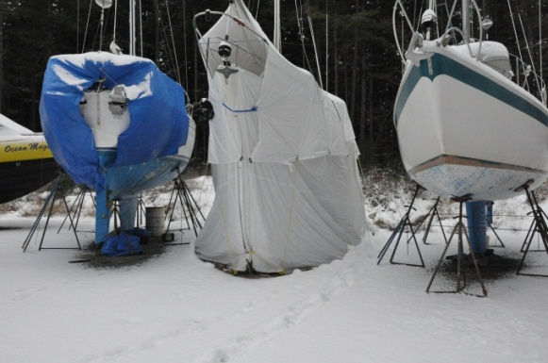

Tuesday, Jan 24th
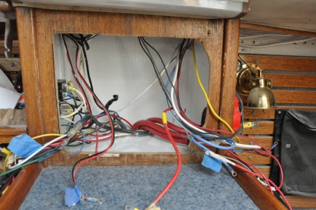
Not a particularly productive day. The wind was howling and the rain pounding, so only inside work (and not much of that!). The tarps were threatening to rip away and the boat shaking on the stands. But I did hard-wire the on-board Guest battery charger into the battery compartment, installed the negative buss bar, installed the new light over the galley, worked on the auto-helm holder, disassembled and lubricate the steering pulleys, and re-install the steering cables. I also painted the inside of the electrical panel box white so it’s easier to see into.

Wednesday, Jan 25th
A reasonably good day at Canoe Cove. Although the rain pelted down in the morning and early afternoon there was very little wind. When the rain stopped so did the wind. I managed to get a third coat of CSC on the rest of the bottom, the propane heat on under the boat. I worked inside as well. I reconnected the steering system along with the auto-helm rudder indicator, re-connect some of the wiring on both the port and starboard sides, and figured out what wires did what. I also figured out how much extra wire I would need to move the wiring from the engine room to around the stern.
I spoke to Ben Gartside about the water sensor (between the two rubber seals on the drive) and a lack of the sensor head. Also, no place for the sensor warning light/sound on the engine instrument panel(?). Obviously he had not installed one of these units before because he had to inquire with England. The bottom fairing rubber pad was also missing from the box (perhaps didn’t come with the package (!?)). The engine bed was on its way according to Beta but there was no indication of a delivery date locally. Beta ships all its engines air freight worldwide and for the Sidney area it would go England to Vancouver, the ground freight to Sidney.

Thursday, Jan 26th
A good day on the boat, and the weather finally improved as well. Overnight we suffered another fierce wind storm with power outages throughout the area. Finally some sunshine and warm temperatures during the day though.
I got the staff at Canoe Cove to finally move the remaining stands so I could get to the rest of the patches. Back to scraping, sanding and painting, just for a smaller area! I got that all done and applied the first coat of bottom paint. I also brought the electrical panel down to the boat and found that I had to cut the original opening substantially to get it to fit. It would be much easier to get my hands into that compartment to work on the wiring in future. But that’s all I had time for! I slapped another coat of white paint into the compartment and called it a day.
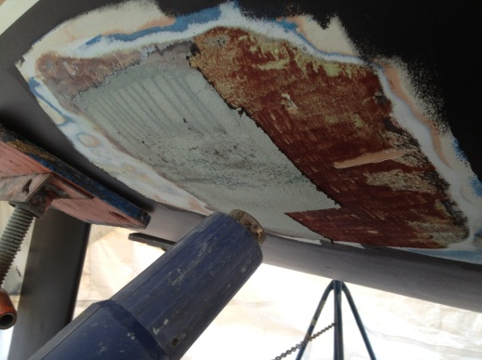
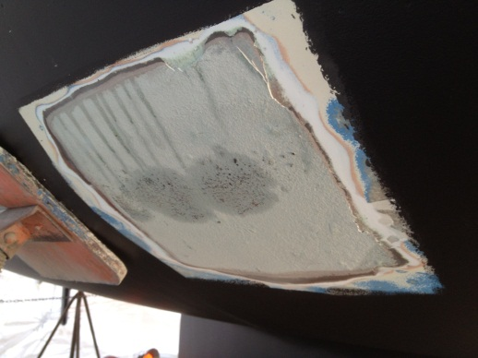

Friday, Jan 27th
Another very nice day to be working on the boat. Sunny with about 7c (46 f) most of the day after a bit of frost first thing in the morning. I applied a second coat of CSC to the patches and then worked on the wiring for the rest of the afternoon. That’s coming along nicely with the wire loom from the port side lead along the back of the cockpit locker and over to the starboard side. New wiring for the propane system and the port side 12v socket was also added. Labelling and attaching to the negative bus bar, etc. etc.

Saturday, Jan 28th
Lightly sanded the entire bottom (not that it was all too rough anyway) and put on a third coat of CSC bottom paint on the patches. I was ready to apply two more coats over the entire bottom and that would be a done job! Then it was on to the inside and the re-wiring job again. I temporarily installed the new electrical panel (I had the wrong fasteners. I wanted to use brass screws on the hinges but opted for stainless steel bolts and nuts instead, more strength). Then it was sorting through all the wiring, crimping on the ends, and attaching them to the panel. I re-routed a bunch of negative wire from behind the panel to run to the buss bar under the quarter berth. I also installed a small buss bar for local grounds behind the panel.
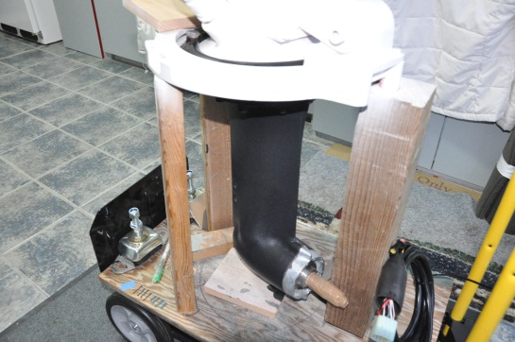
At home I put the first and second coats of aluminum friendly anti- fouling paint (Aqua Guard Alumi-Kote) on the sail-drive leg after 9 layers of underwater primer. Pretty foul smelling stuff, but supposed to be safe on the aluminum leg.
I didn’t think the end of February for a launch date was realistic anymore. The engine bed still hadn’t arrived!

Monday, Jan 30th
A good day at the boat. I put the second from last coat of CSC on the bottom and had enough left in the can for one more coat. The bottom was turning out quite nice and smooth. I made the mistake of not bringing a fresh roller and had to buy one at Canoe Cove. It had a REAL short nap so it took quite a while to do the entire bottom. Then it was back to working on the wiring. The electrical panel was installed properly and most of the wiring connected. I picked up a Group 29 Interstate deep cycle battery as a “starter battery” and put it in place. Then it was sorting out the battery cables and putting the proper ends on the right lengths to make them fit. Running back and forth to Waypoint cut the afternoon short (they close at 1600hrs this time of year).
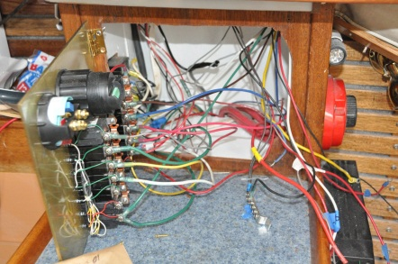
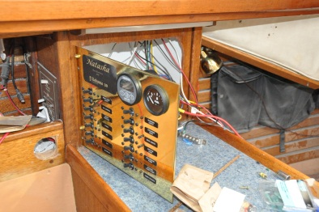
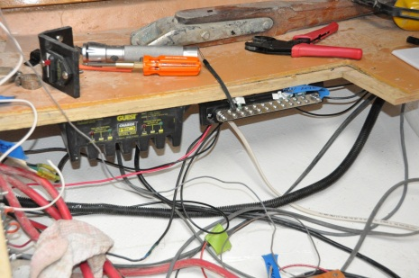

Wednesday, Feb 1st
I put the last coat of CSC on the entire bottom today, finally finished with that job. Then it was back into the electrics. With the cables prepared on Monday I hooked up the new Group 29 starter battery. Power in the boat! Finally! And it worked out fairly well too. With a few minor adjustments I had all the lights back up and running, water pump, and almost all the other circuits were live. I wired the fuel gauge back to the tank and then started on the bilge pumps. No luck yet, I suspected the float switch was toast. The stereo wouldn’t come on either and I didn’t have time to sort that out.

Friday, Feb 3rd
The engine bed had arrived! Finally!! Only six weeks late, but had arrived. It weighed in at about 30 lbs and appeared to have all the parts that were required. I took it down to the boat to see if it would fit into the compartment without further deconstruction, and it did! Good thing! I had to rotate it vertically to get it into the compartment, then to horizontal once was past the step. Of course, now I had to prepare it for installation. A planned trip to visit friends in Palm Desert was going to delay that fitting.
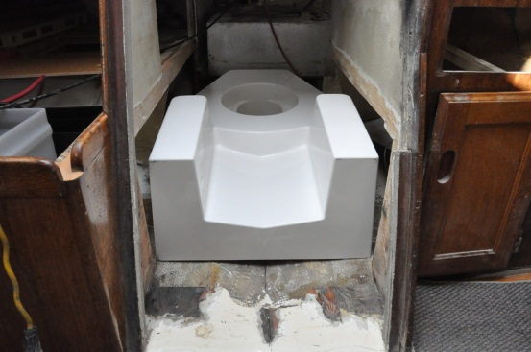
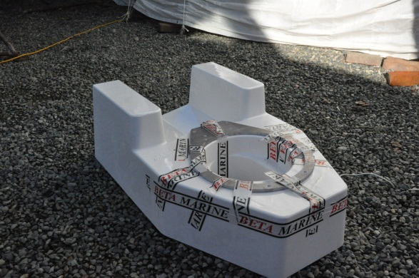

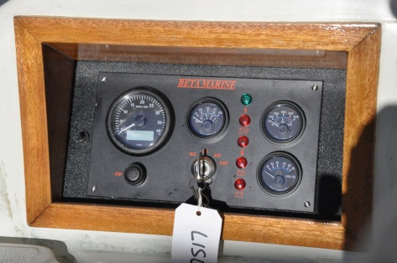
Working at the boat I installed all the stern Marelon through-hulls along with the bronze through-hull for the macerator pump. I also worked on the wiring, finishing some details. I managed to get the stereo working (!) and installed the engine control panel. It was a beautifully warm day and I even pulled the cockpit tarp back to allow some sun into the boat! It hit 15c (60 f) in mid-afternoon. The air cooled down rapidly once the sun started to slide to the horizon though.
Planning for my return from Palm Springs included the mounting of the sail-drive onto the bed, transport the engine from Gartside Marine Engines and mount it on the same bed, bolt them together, and then drill all the required holes to attach both to the bed. Then take it all apart so that I could epoxy the aluminum plate required for securing the leg to the bed and glass it into place. Once that was done the bed goes down to the boat and, with a saw and sander, shape the platform into the hull. Then, finally, get Blackline Marine to glass the platform into the boat. As I was running out of time for the end of February, I was planning on launching the boat as soon as the leg was in and towing the boat back to the marina. Dry land storage rates doubled at the beginning of March! I could do the bulkhead/cabinetry work with the boat back in the water with no time restraints at that point. Once the engine compartment was complete I would tow it over to Gartside Marine Engines and have the engine lowered in. That was the revised plan anyway!
Monday, February 13th
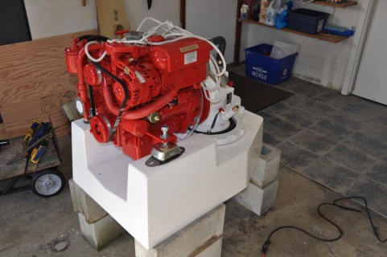
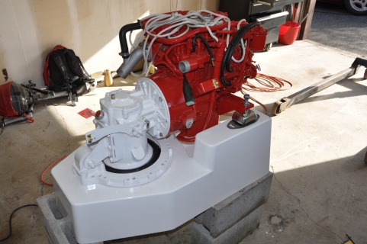
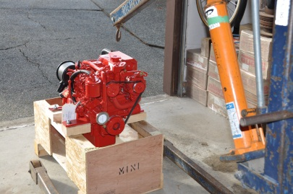
After a very pleasant break in Palm Desert I was back to work on the engine installation. I arranged for the Beta 20 to be delivered to the house from Gartside Marine. Then it was over to Richlock Rentals to rent an engine lift and transport that home. Once the engine arrived, the first step was to bolt the engine and leg together so I could align the unit on the bed to drill the mounting holes. There were multiple holes for the sail-drive let and four holes for the two forward engine mounts. Getting the two halves of this unit together was a challenge! There isn’t much in the way of wiggle room in aligning the shaft and leg! It took a while but I got it done. Then it was a matter of lining the engine/leg onto the bed (there was actually quite a bit of room to manoeuvre where the engine and leg were going to lineup!). Once that was done I marked the holes for the leg as well as the two front engine mounts. Then I had to disassemble the engine/leg, remove both from the bed and start drilling all the holes. The front engine mount holes had to be drilled through the fiberglass bed and stainless steel insert, then tapped with 10 mm course thread. The holes for the leg mount were easier, just through fibreglass. Once the holes were drilled then I had to flip the bed over and epoxy the pre-drilled/tapped aluminum ring onto the underside of the bed. I used West System with epoxy adhesive filler to attach the aluminum to the bed, then used pure epoxy with glass matt overtop. That would hold it (it was only temporary, to hold the ring to the bed while the bolts were being applied).
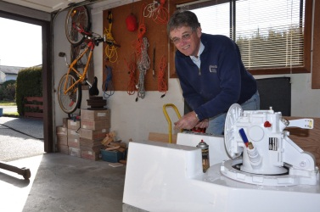
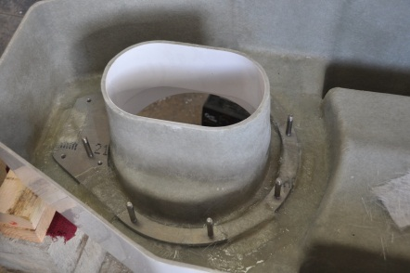

I also started the process of stripping the engine for repainting to white. When Beta painted it red they simply sprayed everything, hoses, wires, etc. I wanted it to look a bit more professional.

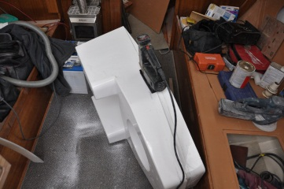
Tuesday, February 14th
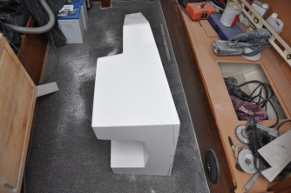
Well, the day of the big cut! I hauled the engine bed to the boat and spent most of the day fitting it to the hull. It did, in fact, take most of the day! I cut the bed down a little bit at a time to ensure that I didn’t cut too much off at once. Yet, I wanted the engine as low on the mount as I could make it while still allowing a secure surface for glassing the bed to the hull. The bed was 10” tall at the rear and I would need a minimum of 4” for glassing. I used the jig saw and the belt sander to shape and smooth it out. That created a hell of a dust storm inside the cabin because I wasn’t going to haul that thing up and down the ladder! Once I got the basic shape down to where I wanted it (trim five inches off the rear, then shape it to fit the shallow “v” of the hull), I had to sand all the gelcoat off the bottom edge of the bed so that the bonding fibreglass would have a good hold between the bed and the hull (most important!). I had Matt at Blackline Marine down to the boat first thing in the morning and basically followed his directions.
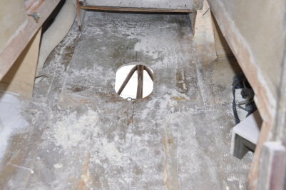
Once the shaping was done and I was satisfied with the fit I used the jig saw to cut the big hole in the hull! I had to do a bit of trimming around the hole to make a perfect fit for the bed. I then used epoxy to bond the bed to the hull in anticipation of the glassing. Matt came over to inspect and approved. He would have someone do the glass work on the Thursday. Perfect! End of another hard working day. I was starting to feel a bit old!

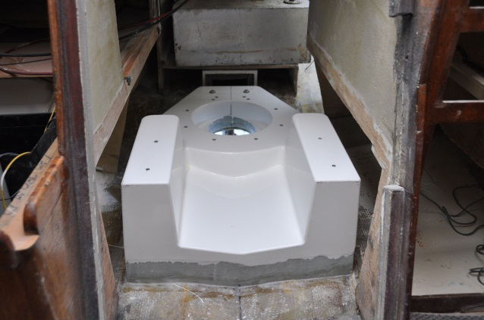
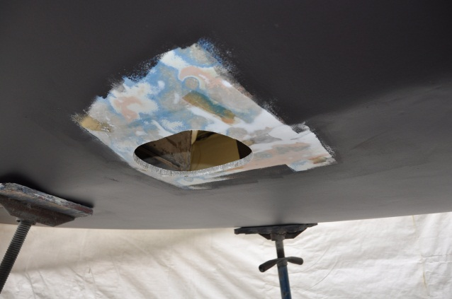

Friday, February 17th
I went down to the boat on Friday and found a worker from Blackline just starting to glass in the bed on the inside. The outside (bottom) had been glassed in the day before. No work on the boat for me.
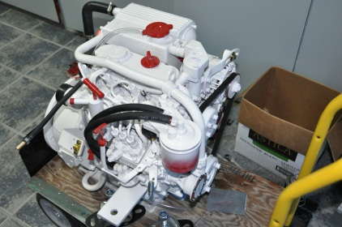
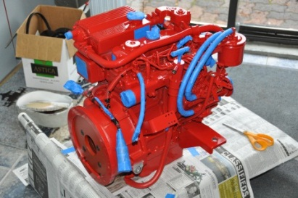
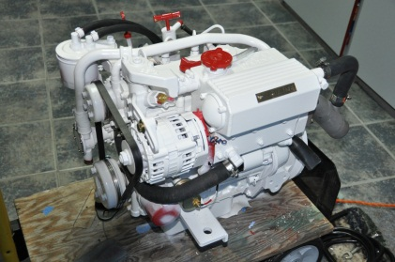

Back at home I continued with the engine itself. After removing or masking everything that I didn’t want painted white, I sprayed two coats of white engine enamel on everything that was still exposed.

Saturday, February 18th
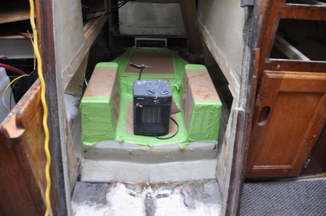
I was down to the boat first thing in the morning and found that the bed glassing by Blackline was obviously not finished yet, there was tape and masking paper all over it along with a Blackline heater on board. So, no work on the engine compartment. The fairing of the bed through-hull glassing was fabulous! It looked like it had been there since production. I was very impressed. As I didn’t want to disturb the professional work, I started cleaning and organizing, vacuuming out all the dust from the bed installation. In anticipation of the marine survey on the following Thursday I re-installed the VHF and GPS along with some of the other stuff that had been stored up in the attic for the winter. I installed the macerator through-hull. All that took most of the day. I also put a few more coats of paint on the engine.
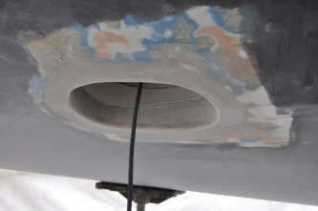

Sunday, Feb 19th
I worked on the #1 bilge pump wiring, got it fixed up again. The #2 pump should have worked, but the RULE float switch was broken (again). They seem to work about two years before they crap out. I purchased another and it worked again. I fitted the closing mechanism for the electrical panel and it worked just fine. A bit more cleaning and vacuuming and the day was done. I put the last two coats of white paint on the engine at home and moved the engine back into the tool room.
Monday, Feb 20th
A good day on the boat. Despite the forecast that called for partly sunny in the afternoon, the reality was showers on and off all day! I was back down at the boat by 1030hrs with the sail-drive leg in the back of the car.
It was still dry out so I pulled all the bottom tarps off along with the top bow one. I rolled them all up and fired them into the car. Matt indicated that Blackline was finished with the glassing job if I wanted to sand out the edges. No problem with that!
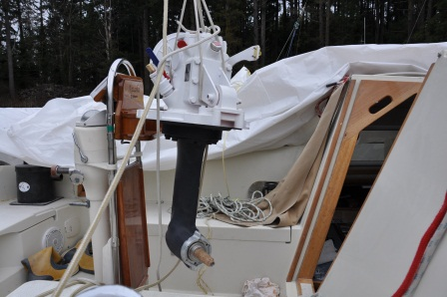
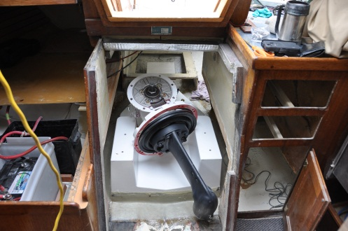
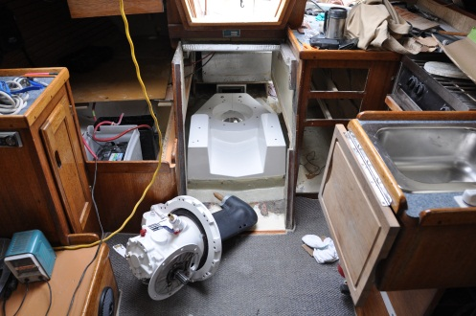
I rigged up the four-to-one tackle from the boom and lifted the sail-drive leg into the cabin. It sounds so simple and quick in one sentence! A whole lot of trepidation! It took a little effort just to get it out of the car! Anyway, once in the cabin I moved the fuel tank out of the way and edged the leg over the engine bed. I was in and out of the cabin and cockpit locker, back and forth, fitting it an inch at a time. As I suspected, the leg wasn’t going to drop into the bed, it was too tall! I was off in my measurements by about 1 inch. The top of the engine/transmission mating plate was up against the cockpit sole as I tried to tip the leg into the bed. Fortunately, all I had to do was remove the mating plate to get it to drop! Halleluiah! It was in! Then it was lining it up and bolting it down.

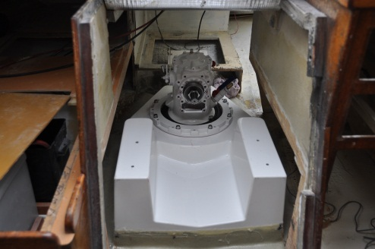
I found a sheet of 1/8th rubber at Beacon Auto (surprise!) and cut it to fit as a fairing piece under the boat. Neither the bed for the engine had come with this particular piece. I tried using 3M 5200 to bond the rubber to the hull but that didn’t work. The stickiness was just not enough to keep it from falling off. I was running out of time and would try again with epoxy the following day.
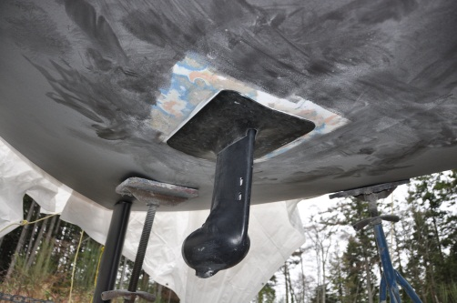
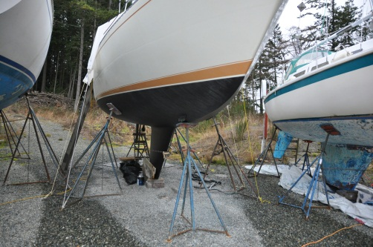

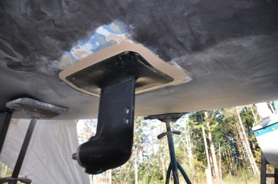
Tuesday, February 21st
A short day on the boat. I affixed the rubber cover for the sail drive to the hull using West System epoxy and adhesive filler, real sticky stuff. Then faired it out with West System epoxy with fairing filler. It looked good.
I also installed the drain hoses for the cockpit through-hulls and re-attached the fuel level sender to the fuel tank. That was about all the time I had. The forecast for the following week was snow!

Wednesday, February 22nd
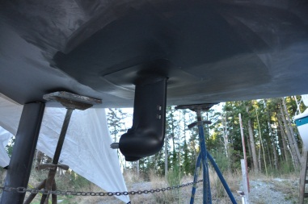
Hull polishing time! I needed to polish the topsides, and it was much easier on dry land than from a dinghy in the water. I spent the afternoon polishing the starboard side of the hull, bow to stern, with a power buffer. I also sanded the epoxy fairing around the sail drive leg and applied two coats of the aluminum friendly anti-fouling paint. It was sunny with a strong westerly wind keeping it cold. The forecast was a dropping temperature as the weekend approached.

Thursday, February 23rd
A long day at the boat, but not a whole lot to write about! I polished the port side of the hull and touched up the stern. I also put two more coats of bottom paint on the leg and rubber seal. I made arrangements to launch on Friday afternoon so that I could tie to the dock there overnight (Canoe Cove is closed on Sat/Sun) and then, with Peter’s help, move the boat using his dinghy and motor on Saturday (or Sunday if the weather didn’t cooperate on the Saturday). The dropping tide would help getting through Iroquois Pass to the marina until about 1400hrs.
Then I tried to install the propeller on the sail drive. Problems! The special nut wouldn’t fit on the shaft! The nut jammed after about a ¼ turn, like the threads weren’t the same. Perhaps a metric shaft (Italian made) with an imperial nut (British)? I went to Gartside and spoke with Keith who provided me with a thread measuring tool along with the right size tap and die set. Back down to the boat and I confirmed that both threads were the same, metric. So it was just more force that was needed, and now that I was comfortable with the knowledge of matching threads, more force was applied and everything bolted together. Good thing!
The rest of the time was spent cleaning up around the boat, getting rid of the tarp over the stern (cut and torn to pieces with the wind over the winter, into the recycle bin), and generally tidying up inside in anticipation of the survey the following day.
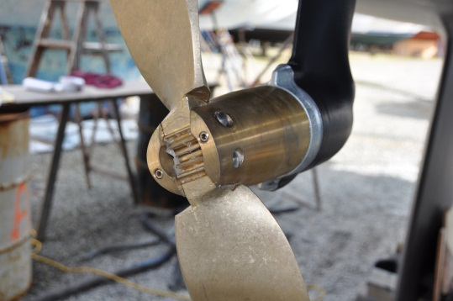
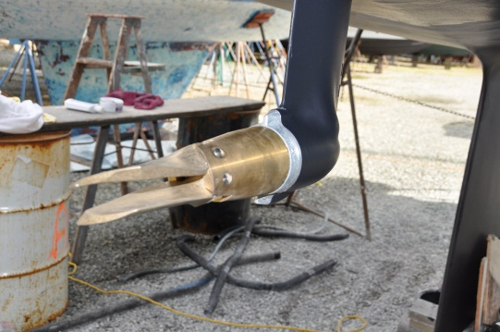

Friday, Feb 24th – Launch Day!
A nice day to launch the boat…..strong cold wind and heavy rain! Just perfect! It was snowing across the Strait in Vancouver!
Anyway, down to the boat at 0900 for the survey at 0930hrs. Nice day for a survey as well. Allen Benton of Total Boat Surveying came down and was suitably impressed with the boat. He really didn’t inspect all that much and was quite satisfied with what I’d done so far. He even approved the current propane installation! Perfect! I wouldn’t have to move the holder and purchase new, longer hoses!
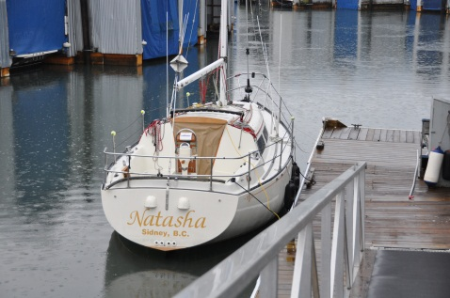
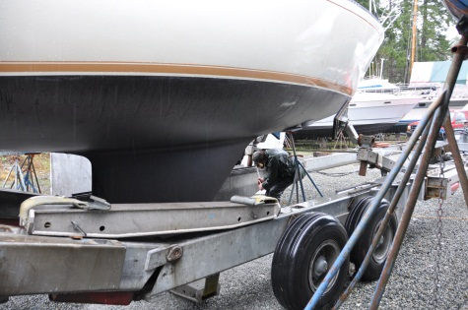
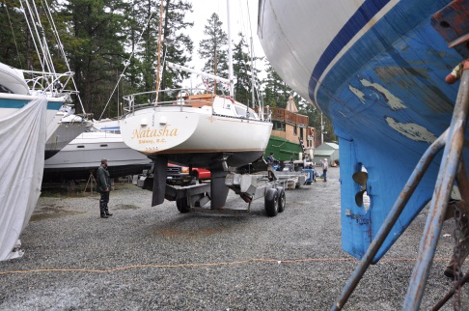
I paid for the launch and work done by Blackline (about $200 more than I expected, $1,150 once all the taxes were included). Then the boat-yard guys asked if I was ready, and I was. It took an hour to move from the stands to the water. And no leaks! The boat sat bow down by about 3”, no motor and all the stuff jammed into the v-berth I would guess. I tied her up to the dock for overnight in anticipation of Peter’s help with the move the following day.

Saturday, February 25th.
Boat moving day! The weather forecast was for strong NW winds and it was blowing hard enough in Georgia Strait to cancel some ferries (minimum of 40 knots for that to occur!). But we had no wind in Sidney and it wasn’t raining! Perfect! By 0900hrs I met Peter at his boat and, after some difficulty getting the Honda on his inflatable to shift into gear, we motored over to Canoe Cove on a falling tide. We strapped the dinghy to the port quarter and at low throttle managed 3 knots on the way back to North Saanich. By 1030 I was tied up and Peter on his way to do whatever he was doing the rest of the day.
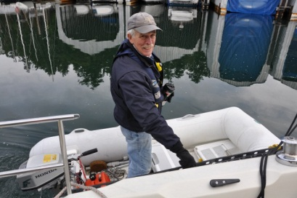
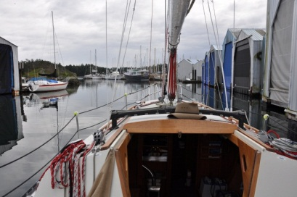

I cleaned up a bit, organized the deck and then went home for lunch with Carey in celebration. Back for the afternoon to scrub dust and dirt out of the cockpit, install the dodger (keep rain out of the open hatch) and install the new Smart plug onto the old power cord. I plugged the boat in and everything worked on the 110v circuit. Success! I flushed out the water tank and added a bit of fresh water so I would have something to drink again. The boat was still bow heavy and the cockpit water wouldn’t drain out the scuppers. I had to sponge out the water every time it rained.
Of course, it was a Saturday so lots of people walking along the dock. Everyone stopped to chat, the boat being back where it belongs. I worked out in my mind the details of how the new engine compartment was going to be built. That would start Monday morning!
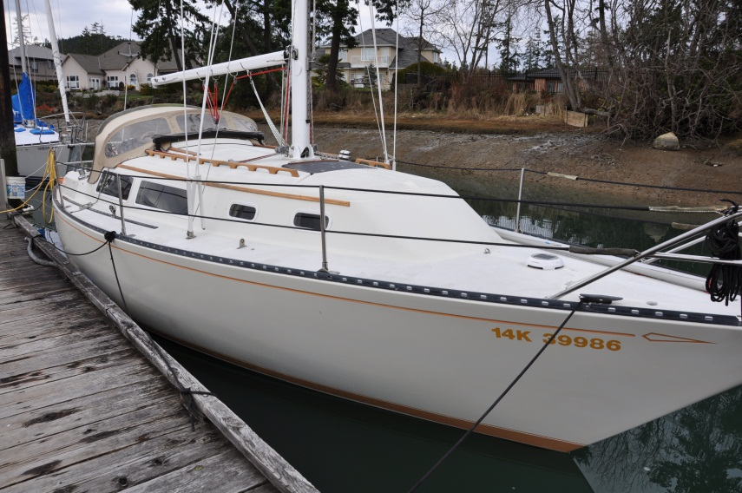

Monday, February 27th
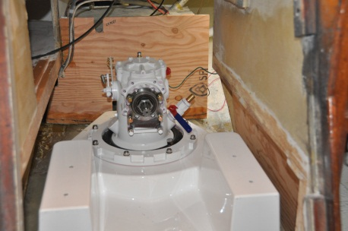
I started the process of re-building the engine compartment walls. It was a cold day with the frost never melting where it didn’t get sun. With the cockpit not draining properly the ice was a real problem. I threw a rag on it to get some traction. Then it was running between the boat and the table saw at home while I fitted and adjusted the plywood pieces. Of course, nothing was square or straight, so it all took time. I had the skill saw, sander, drills, and jigsaw all spread out on the dock, cutting and fitting. At the end of the day I had the rear bulkhead tabbed in along with the port side wall. The starboard side would have to wait until the rear bulkhead was properly glassed in. It had been cut and fitted, just waiting for the corner of the bulkhead to be properly fastened. Slow work.

Tuesday, February 28th
I did some more glassing of the stern and port side bulkheads after work. I was using 1” tape as the primary tab and then 3” tape over top. Power was out at the marina so it was cold aboard and I had to work with a flashlight.

Wednesday, Feb 29th
An hour of additional fiberglass taping after work today. It’s starting to look like a compartment again.

Friday, March 2nd
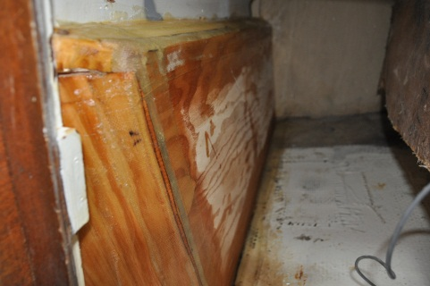
Another long day working on the boat. It was a day of cutting and fitting the remaining pieces of the engine compartment. The pieces that were causing a lot of work were figuring out how to seal the engine compartment from the cockpit locker, all the uneven surfaces and tapered angles. A few runs to the table saw and all the tools spread out on the dock while the sky threatened rain. I had to pick up another 40 ft of fiberglass tape, 20 ft of 1 ½ ” and 20 ft of 3”. By the end of the day all of that was gone and the compartment built! All the inside fiberglassing was done, I wanted another two layers of tape on the cockpit locker side, but I needed more tape.

Saturday, March 3rd
I headed down to the boat for some more fiberglass work and painting. I primed the inside of the engine compartment, the battery compartment and under the galley counter. Then put another20 ft of 3” tape on the outside of the box in the cockpit locker. That took me all of two hours.
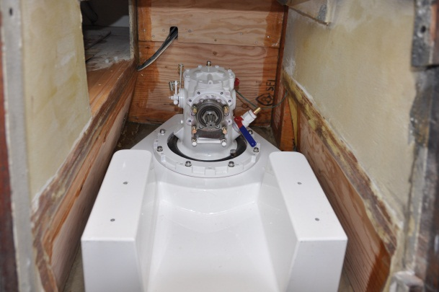
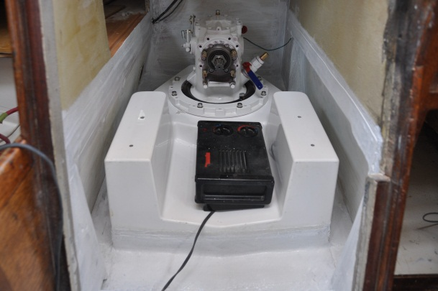

Sunday, March 4th
Nothing much exciting today. I put the first two coats of Silent Running, a sound absorbing finish, on the inside of the engine compartment, in the storage space under the galley counter, and on the cabinetry in the cockpit locker. This stuff was as difficult to apply as I remember from the last time and requires as many coats as there is paint available. It’s supposed to be sprayed on but that’s not possible under these circumstances. It was like lumpy porridge and doesn’t roll or brush nicely! I also applied the first coat of International Paints Bilge Coat to the exposed hull and woodwork inside the engine and battery compartments. I wanted to install the primary bilge pump in the battery compartment and hook the hoses up soon, but the painting had to be done first.

Monday, March 5th
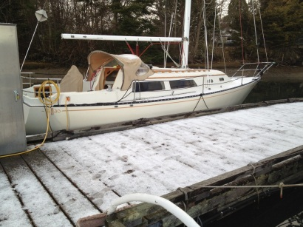
Two more coats of Silent Running on the inside of the engine compartment and under the galley. Although sunny out, it got quite cold. Silent Running only takes an hour to dry before another coat can be applied, but that only works if there is some heat. With no heat in the cockpit locker I could only get one coat on that woodwork. I had just finished in the locker when the dark cloud hovering overhead opened up and hail pounded down. Quite the show! A second coat of white paint on the exposed hull in the engine compartment and I was almost ready to start installing the bilge pump plumbing again. I also installed the primary bilge pump (a remote pump) into the battery compartment, ready for the hoses.

Tuesday, March 6th
I applied two more coats (and the last) of Silent Running in the engine compartment and under the galley, one more in the cockpit locker. There was enough left in the bucket that I can do a couple more coats in the cockpit locker, but that was about all. That gave me six coats where it counts and probably a dozen on the upper edges of the compartment. It was cold out but promising to warm up towards the weekend.

Wednesday, March 7th
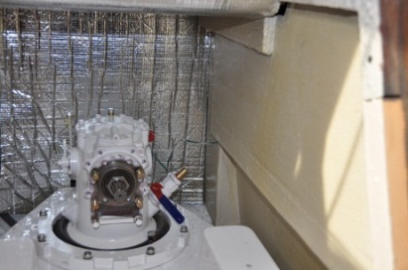
Time marches on. I installed most of the sound insulating material today with only a few small pieces to go. Two sheets of the foam/plastic 1” material would be more than enough and as I had most of one sheet from the last time, and purchased another complete sheet, I had just enough with the bits and pieces that I removed from the old compartment. Lots of contact cement as well.
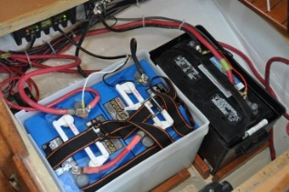
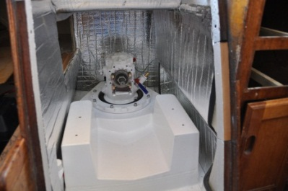

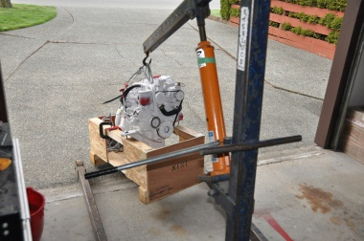
I also completed the installation of the batteries and battery charger. It all works and looks nicely cleaned up. I made arrangements to get the Beta engine back to Gartside Marine Engines so that it could be dropped into the boat the following day. Gartside had a dock-side crane for that purpose, better than risking the boom alongside our dock! I picked up the engine hoist from the rental shop and painted the bottom of the oil pan now that I could reach it. I put the wooden cradle back on as well and it was ready to go into the car for the ride to Gartside. Peter was going to help me get the boat over to Gartside at 1300hrs and back again. It was going to be a busy! The forecast was for sun and 10c (50 f) with rain the following day, hence the engine tomorrow!

Thursday, March 8th
The engine was aboard! All went well with an early start under sunny skies. I tried to load the engine into the car but it was obvious that it wasn’t going to fit. I couldn’t get the hoist under the hatch with the engine dangling down. Oh well, I suspected as much. I called up Ben Gartside just before 0800hrs, explained the problem and asked for assistance. He sent Keith and Gerry with the truck and by 0830 the engine was on its way back to Gartside Marine. As the engine lift wasn’t until the afternoon I finished most of the sound insulation installation and generally tidied up the interior. I took down the dodger to make room for the engine dropping down the hatch and turned the boat around at the slip so that we could tie the dinghy to the starboard side at the stern. By noon Peter was strapped alongside and we were making out way slowly out of the marina in a flat calm and high overcast. A careful docking at Gartside Marine and Gerry lowered the engine into the cabin in very short order. A short ride back to the marina and we were done by 1300hrs! That must be some sort of record!
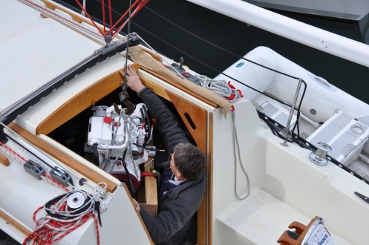
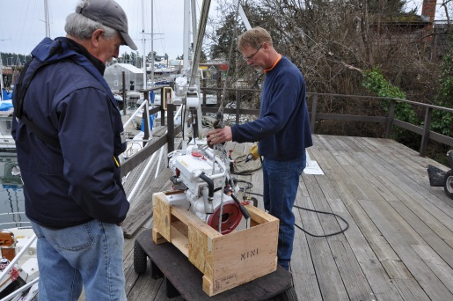

I quick trip home to pick up some stuff and back to the boat for the afternoon. I lifted the engine and took the shipping cradle off so I could move it in the cabin (slide it on the carpet).
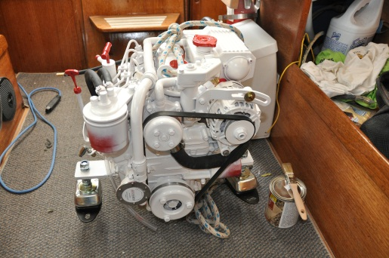

I then worked on getting the power cables through the wall from the battery compartment, the control cables through the rear bulkhead, and figured out how to get the service cable from the engine to the control panel (through the air box under the fuel tank!). I had to pick up some hoses and connect the fuel filler from the deck to the tank and installed the wiring to the fuel gauge. I had a whole list of pieces that I need to pick up or bring to the boat. The shifter cable needed to be moved up slightly, the angle from the bulkhead to the lever was too steep and caused some binding. I couldn’t lower the cable because the fuel tank was in the way. I had to make up a small bracket to raise the anchor point on the transmission.

Friday, March 9th
Another day, another few steps closer to getting all this done. It was getting somewhat tiresome! The end was getting closer though, it just seemed to be taking forever with small tasks mounting up on each other. Anyway, enough bitching. I made up the bracket extension for the transmission cable. I happen to have a small piece of 3/8th plate aluminum and cut / drilled it to fit. I got the cable installed and it worked. I installed the fuel tank filler hose and ground wire along with the fuel gauge sender / ground. I also sorted out the cockpit drains to the stern through-hulls, the exhaust separator water drain to the stern and the manual bilge pump to the through-hull. Some more hoses to connect and I would be ready to shove the engine into place.

Saturday, March 10th
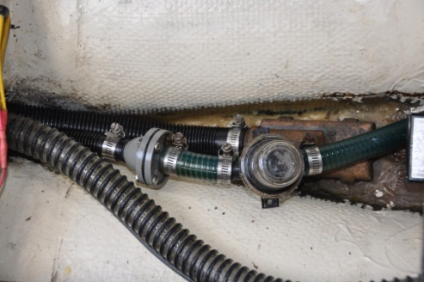
A reasonably warm, dry day right up to 1700hrs when the showers finally arrived. I started in the morning picking up 40 litres of diesel at the Chevron to put something in the fuel tank. I got that aboard without spilling a drop. Then I slid the Beta forward on the carpet to get it out of the way so I could get into the bilge. It was time to tackle the pumps and hoses before I could slide the Beta into its proper spot. The manual pump was hooked up in short order, new hoses, from the bronze pick-up through the engine compartment, under the fuel tank and up to the manual pump, then up to the gunnel and down and out the side through-hull. The #1 auto/switch electric was plumbed from the rear sump through the cabinetry into the battery compartment where the remote pump is located, then out the locker under the quarter berth into the lazerette locker. I needed an anti-syphon valve to complete that installation. The #2 auto pump is going to be plumbed like the #1 pump but with a 1 1/8th in hose instead of the ¾” hose. I had to get the hose yet. At least the bilge part is finished and I could close that up.
I built and glassed in a platform for the water lift muffler under the port side cockpit “T”. That, and the locker under the galley, was primed before I finished for the day. The cockpit stereo speakers were replaced with new ones, successfully wired in. The wiring to the port side cabin speaker was also sorted out and the entire system worked again.
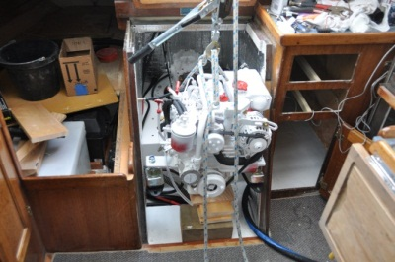
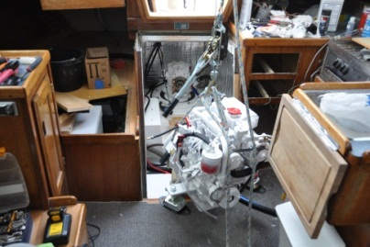
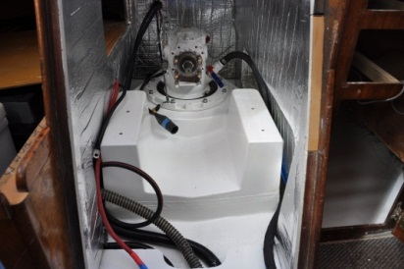
Then it was figuring out how to get the engine onto the bed and connected to the leg. I built up a platform of lumber so that once the engine was lifted with the come-along / beam over the cockpit hatch to the right height for the bed, I could slide it back onto the bed. That didn’t cause any problems and all went very smoothly. Then the alignment reared its ugly head again. I tried a few times to simply wiggle it into place without success. Considering how difficult it was in the garage when I prepped the two parts for the bed on the 13th of February, this would be the most difficult part of the entire reconstruction. It was late in the day and I want a fresh start the following Monday. The plan was to get a series of 10mm bolts of reducing length and align the bolt holes in small steps. That should work. All in all, not a bad day!

Monday, March 12th
Not much of a chance to work on the boat. It was the wind storm of the year! By 0800hrs in the morning the gusts were up to 61 knots at Kelp Reef about 4 miles away, 80+ knots up at Merry Island! I was down to the marina securing ripped jibs and tying up boats. There were three boats up on the rocks, one on the beach in front of the Yacht Club. By noon I was back at home throwing wet clothes into the dryer and trying to warm up. By 1400hrs it was flat calm and raining hard!
I went back down to the boat to try line up the engine / sail-drive unit. I even went and got a mechanic’s mirror on a stick to have a look at the alignment. Still no luck. Frustration was beginning to set in. I called up Gartside to arrange for assistance the following day. I knew when professional help was required.

Tuesday, March 13th
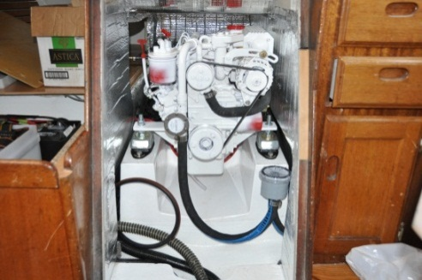
The engine was finally in, attached to the sail-drive unit, and bolted together! Ben came down in the morning just after 0900hrs and it took the two of us about 15 minutes to wiggle it into position. He told me that I had the leg tilted down just a bit and the two surfaces weren’t lining up perfectly. I plugged in the wiring harness and the water hoses and powered up the control panel. The alarms worked! Then I bumped the starter and the engine turned over! Now I just had to wait for the exhaust elbow to arrive, hopefully near the end of the week. In explanation, the standard Beta exhaust riser comes out horizontally from the manifold with the water injection point on the downward slope, just like it’s supposed to be. However, for that to work the water-lift muffler input side has to be at a level below that of the exhaust exit with a continual downward slope in the hose, otherwise the water in the hose will simply drain back into the engine when it is shut down. Not a good thing. Beta produces an “optional” exhaust elbow that rises 6” before the water injection point. This is what I needed. Ben had one in stock back in January when we examined the engine and I mentioned that I would need it. However he sold it to another customer! If I’d known they were that hard to get I would have taken possession of it then! As it stands now it will be next week at the earliest before the elbow arrives.
I painted the cockpit locker with the tinted bilge paint so the water-lift muffler could be installed over the weekend. The old carpet finally went into the garbage and I cleaned out the bilge of all stray water. I still had some time left so I started installation of the Link Lite system, routing and connecting some of the wiring to the electrical panel. Without the wiring instructions on hand I wasn’t about to plug it in.

Friday, March 16th
Not a particularly successful day on Natasha. Not a whole lot went right! I learned from Ben Gartside that the exhaust elbow was still in England and would probably be shipped on Monday, here on the Friday if all went well through customs.
I went down to the boat figure out the throttle control for the Beta. I discovered that the linkage was backwards from the Volvo! Who would have thought it! And I couldn’t reverse the leavers in the pedestal, there was just not enough room. So now I had to set up a system to reverse the push cable to a pull cable. Another headache to solve! And the fuel gauge refused to work in the new electrical panel in the cabin. I even tried the old one without success. More problems to sort out!

Saturday, March 17th
I figured out how I was going to get the linkage for the throttle to work. Kobelt makes a device specifically for that, about 18” long. The Kobelt reversing gear would be mounted over the fuel tank on an ABS plastic platform that I would attach to the quarter-berth wall. I would need a three foot Morse type cable as an extension directly from the reversing linkage to the throttle linkage.
With a great deal of effort I connected the water-lift muffler with the water separator using the required two inch diameter reinforced hose. It wasn’t easy to stretch the steel reinforced hose over the 2 1/8” fittings! I also figured out the bilge pump hoses and picked up all the necessary hoses and hardware.

Sunday, March 18th
The weather was pretty spectacular with clear blue skies and warm sun, it must have been about 20 c (70 f) on deck so I decided to work on the brightwork. I’m still waiting for the exhaust elbow so there isn’t much to do at the moment. I had stripped all the teak last fall so it was bare for the winter with just a coat of oil on it. I could tell where the rain got through the split in the cover for the winter, far dirtier and greyer. Anyway, I sanded it all down and applied a coat of Deks Olje D1. I will be able to apply Deks Olje D2 for the gloss finish as the weather warms up. Looks very good again and it wasn’t nearly as much work as having to strip it down this time of year! Then I got into the hoses for the pumps again, drilling through lockers to run the last hose for the secondary bilge pump to the stern. I also got some of the connectors in so the manual pump is operational again. A few steps closer…..

Monday, March 19th
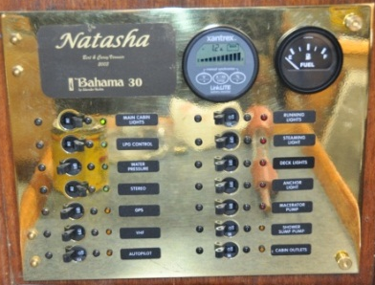
A pretty good day down at the boat. I finished up the plumbing for the bilge pumps and engine exhaust. The stern locker was just about finished. I also sorted out the fuel gauge problem. The fuel gauge wasn’t working with the wiring I had installed for it so I tried going direct to the power source. That didn’t work. I tried the old gauge, and that didn’t work either. Something was not quite right. I pulled the sender out of the fuel tank (always a very messy job with the sealant!) and simply connected the sender to the gauge, to power and ground and it worked like it was supposed to! So, why wouldn’t it work with the wiring I had installed? A light bulb came one! I had grounded the fuel gauge to the fuel tank as I would normally do. The fuel tank was grounded to the fuel filler, like it was supposed to be. But I never grounded the tank or filler to the batteries! Hello? I re-installed all the wiring and gauges and it all worked. Another “duh” moment!
It was only about 7C (47 f) with a 15 knot SW wind lowering the apparent to close to freezing. The first day of spring eh?
Tuesday, March 20th
Not a whole lot of work on the boat, the weather was simply too miserable. A whole series of storm cells moved through the area with high winds, rain and hail, and only about 4c! I ended up cleaning up a bit, taking the curtains home for a wash (lots of construction dust), taking the quarter-berth cushion to the boat and generally tidying up a bit. There was no working out in the cockpit! The weather is supposed to improve in the coming weekend, warming up a bit with sunshine.

Friday, March 23rd
The weather was really crappy, the series of storm front just kept marching through! I dropped by Gartside to figure out where my exhaust riser and Kobelt engine control were. He told me that the exhaust riser and moisture sensor were in Vancouver (arrived from England) and would probably be here on the following Tuesday. Kolbet engine controls (Surrey, BC) had told him that they didn’t have any in stock and would have to build one! It would be a few weeks! Arrgh! So, nothing I could do on the engine till I could get the parts. I went down there and continued the general clean-up process. Still lots and lots of dust all over the boat so I spent the morning vacuuming and cleaning up. Late in the afternoon the weather cleared somewhat and I was able to put the first coat of Deks Olje D2 on the outside teak.

Sunday, March 25th
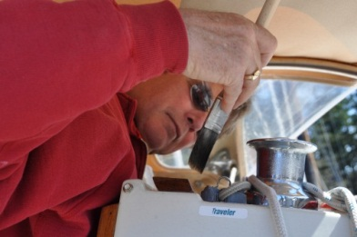
Our granddaughter Natasha visited for Spring Break so I wasn’t going to get a lot done! I picked her from Vancouver on the ferry and we spent part of the afternoon putting the second coat of Deks Olje D2 on the teak. I gave her the camera and told her to take photos. She actually came out with some pretty good ones!

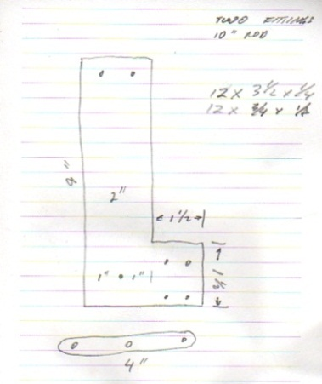
I figured out the “cable transfer unit” for the throttle cable. Having looked up the commercially available Kobelt 2123 (which is 23” long overall and would have to be mounted overtop of the fuel tank) I suspect this unit would be in the $250.00 range. It would also require a 3 ft cable extension. Having a look at the engine I figured out how to make my own unit that would be about 9” long and cost next to nothing! I designed it on paper and picked up the aluminum bar from the Metal Supermarket on Keating Cross Rd. And it would all fit inside the engine compartment! Much better.

Monday, March 26th
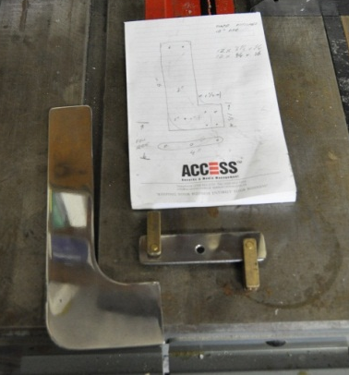
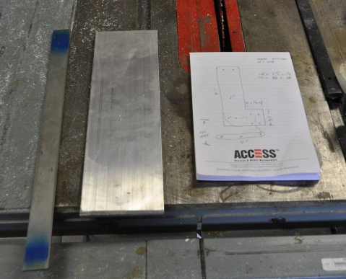
Both good and bad news. Again! I picked up a 12” section of ¼ x 3“ aluminum bar and a 12” section of 1/8” x 1” stainless bar for the engine controls. I spent the rest of the morning fabricating the required parts. I picked up the cable ends at Gartside, they had them in stock.
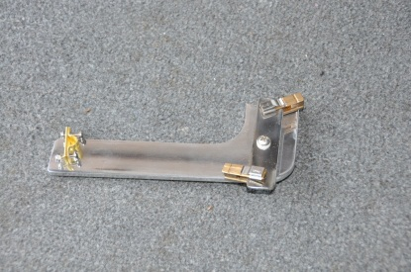

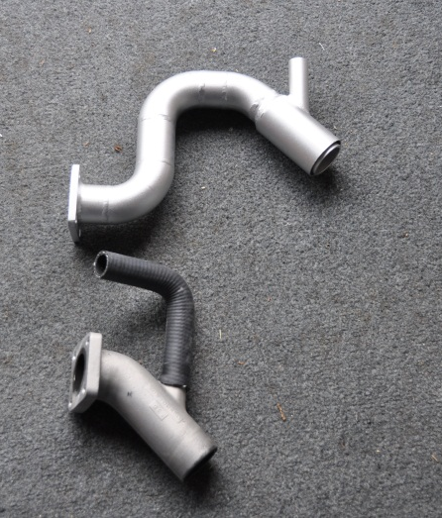
I received a call that my exhaust elbow and moisture sensor finally came in at Gartside Marine so I hustled down there to pick them up. The exhaust elbow looked tall, like a section had been added to the middle of it. I took it to the boat and discovered (like I suspected) that it’s too tall! Argh!! It would have to be cut down a bit to make it fit. I took it back to Gartside Marine and they would do the custom fabrication. At least I had the part!

Thursday, March 28th
Just a quick trip down to the boat after work and I installed most of the throttle linkage onto the engine and measured/cut/threaded the last link leading up to the throttle itself. It looks like it will work just fine.

Saturday, March 31st
A short morning on the boat. The exhaust elbow, customized by Gartside, was installed, the cooling water hose attached. The exhaust hose would have to go out the side of the engine compartment, not out the stern. Going out the stern would require going over top of the fuel tank. The level of the top of the fuel tank would make the hose rise a bit before dropping to the water-lift muffler. That could not happen as the water in the hose at shut-down would drain back into the engine.

Sunday, April 1st
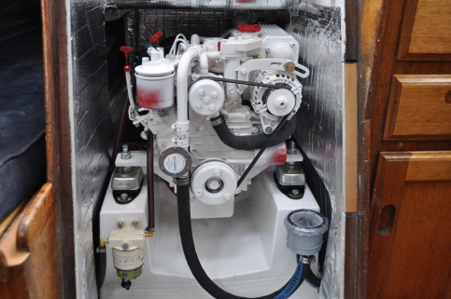
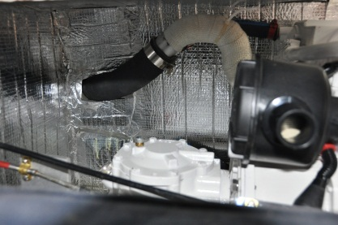
She was running!! Only a month late, but she was running! I got to the boat by 0830hrs, time to try and get the exhaust hose connected between the engine and the muffler. Time to drill a hole through the nice sound deadening box I built! It actually all went fairly quickly, drill the 2” hole and then use the jig saw to open it up enough to allow the 2” hose through the side of the box. The hose was just long enough to fit, three feet, with not an inch to spare! Once that was connected, and the water hose connected, it was time to try the starter. I cranked it over but no start! I didn’t really expect it to start because of the fuel delivery issue I hadn’t sorted out yet. I couldn’t get the secondary fuel filter to purge properly and I suspected that there was air in the fuel line. After some fiddling with the primary fuel pump hand lever I finally got fuel to the top vent of the filter. Then it was simply purge the high pressure pump and crank the engine again. After a few coughs the engine caught and started running! I dashed below to check on water in-flow, climbed into the cockpit to check the exhaust. The engine ran for about five minutes and then I shut it down to check all the fluid levels, topping up the water in the heat exchanger and oil in the engine. Then I ran it again for a while, idling smoothly at 900 rpm. I put it into forward and reverse gear (leavers in the right direction!) while tied to the dock. I found an oil leak in the oil pressure switch and a water leak at the hoses of the water pump. Fixed those. Also found that the water hose connecting the heat exchanger to the exhaust kept creeping off the hose fitting. I ended up using a nylon tie to hold it in place along with a clamp. I would have to use some gasket glue to hold it in place permanently. It’s a bit of a design flaw in that there is no ridge on the nipple for the hose clamp to tighten over.

I was back to the boat after lunch and the skies, having temporarily cleared in the morning, had clouded over again with a threat of rain. I turned the engine on again as a light rain started to sprinkle down. Off I went at low speed, out into the bay and then into the light chop in a NE wind. From idle to 2500 rpm and back down again a few times. I measured the speed against the noise most of the way out to Sidney Island and back again. It was cold with a large dropping tide. The exhaust (gases) tended to spit up against the transom with the exhaust through-hull under water when the stern squats with speed. I would have to make some modifications, probably moving it back to the port through-hull. Otherwise it was quite uneventful. The engine ran nicely, very low vibrations and low noise, about what I expected. There was a ticking noise when the engine went into gear, forward and reverse, which sounded like a card in the spokes of a bicycle wheel. It didn’t sound like it belonged! Not much noise from the muffler system though, certainly not enough to install any further insulation around the piping in the cockpit lockers.

Monday, April 2nd
Ben Gartside came down to the boat and signed-off on the installation. He approved all aspects of the installation and noted the throttle linkage was loose. I fixed that with longer bolts and lock washers in addition to the nylon lock nuts. I also put some Goop on the hose barb from the heat exchanger to the exhaust hose to keep that hose from sliding off. The ticking noise was apparently “normal” for the transmission under light load. It disappears under increased RPM and Ben would be checking with Beta to confirm. All else was working fine.
The only item still to deal with is the exhaust. I want to move it back to the port side quarter through-hull and think I will build two custom fittings for that, connected by a short hose for flexibility. No hurry though.

Easter weekend cruise
After successfully putting 10 hours on the Beta over a four day weekend cruise through the Gulf Islands (forced motoring - varying engine speed, not over 3000 RPM, etc. - even though there was wind, just to get some hours on it!) I made some observations.
- Although the motor smoked at start-up the first few times, by the end of the weekend the starting was clean. I have to assume that was part of the break-in process.

- The ticking of the transmission/sail-drive unit when put in gear was very obvious and, in my opinion, not acceptable. I made a sound recording and sent that to Gartside Marine for their action. Ben has since forwarded that sound file to the factory in England.

- The boat speed / engine RPM was about what I expected. Although I have not taken the engine to its maximum cruising speed yet, I expect to get about 6.4 knots when I do. At 2,500 to 2,700 RPM a speed of almost 6 knots is attainable.

- Thrust at low RPM is good and the two bladed Gori prop is working well. There is virtually no prop-walk in reverse, the boat simply goes back straight (a bit un-nerving!). I now have to recalculate my low speed coast-to-a-stop distances. The fixed prop drag is gone and the boat seems to drift forever before coming to a stop. As I frequently sail into my slip at the marina (as well as sailing to marine park mooring buoys and anchoring spots), this new stopping distance is a revelation on how much drag a fixed prop produces at low speed.

- The engine noise/vibration from idle to cruising speed is as hoped for. At full cruise (6 knots) a conversation can be held in the cockpit in a normal tone of voice. Wind and water noise is more obvious than the engine. This is a good thing! Yes, the engine is still obvious, but it’s no longer front and centre of how we communicate under power. A fellow sailor walked by the dock the other day and asked how the project was coming along. Jokingly, I told him the exhaust elbow was still in shipping and I expected it next week some time. We commiserated on out- of-our- control delays and how it affected our sailing time. Then he realized the engine was running! Yes, it is that quiet! From about amidships forward the engine cannot be heard running amid the normal outdoor noise at the dock. I deem that to be a success.
Lessons Learned
1. Life goes on despite the project timetable. Don’t get dependent upon the time table.
2. Don’t depend on required parts arriving as promised.
3. The project will always take longer, and cost more, than planned for.
4. Be prepared to deviate from the “plan” as dictated by what you find as work progresses.

Now it’s time to go sailing!!

