Cruising Desolation Sound 2014
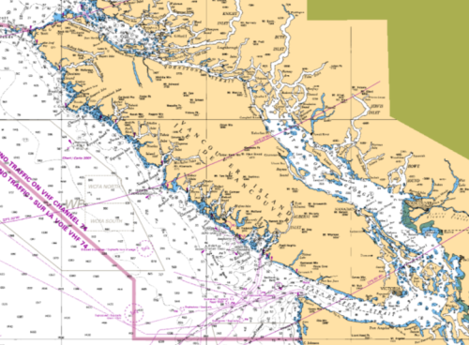
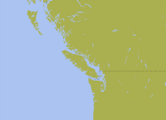

Vancouver

Sidney

Overview Chart Link Victoria
Desolation Sound is a relatively small body of water that is encompassed in the Discovery Island group at the north end of Georgia Strait. When boaters discuss “going to Desolation” they generally mean the entire Discovery group, part of that being the actual Desolation Sound. The Sound is serviced by the town of Campbell River to the west (Discovery Passage), Lund to the south (Thulin Passage) and two general stores in the middle (Squirrel Cove on Cortes Island and Refuge Cove on West Redonda Island). Cell phone reception is somewhat mixed once surrounded by the tall mountains in the Discovery group. Outside of the spectacular scenery, the main attraction to boaters are the pristine waters that reach the mid 20s c (70s f) in summer. The cold ocean water rushing down through Johnston Strait meets the water flooding up from Georgia Strait in Desolations Sound. With significant depths, these waters simply rise and fall in the 15+ foot tides with insignificant horizontal movement. The hot summer sun warms up the top layer to bathtub temperatures! The water flooding past Campbell River could be 10c (50f), even at the height of summer. Yet, 5 miles away at Cortes Island the water temperature could be 22c (72f), quite a difference.
From the Vancouver area, as well as the south end of Vancouver Island (Victoria), getting to Desolation Sound is as simple as sailing up Georgia Strait. Of course, nothing is really that “simple”. Boaters leaving from Vancouver generally tend to stay on the mainland side of the strait, travelling past the Sunshine Coast in Georgia Strait to Malaspina Strait that separates Texada Island and the mainland. There are numerous anchorages, docks and supply towns along the way. Boaters from the southern end of Vancouver Island have to decide on travelling north along the Island side, where there are few safe anchorages, or crossing the strait to the mainland side. Most opt for crossing the strait for a more leisurely passage along the scenic mainland side.
Either side, the winds and currents tend to be the same. The predominant winds are from the northwest in settled summer weather, from the southeast in unsettled weather. Summer winds favor northwesterlyies. Currents flood northbound, ebb southbound. Woe is the sailor who sets sail against a strong northwesterly with a full flood current. The same could be said for strong southeasterlies against a large ebb tide. The seas will be short, sharp and very uncomfortable! It’s prudent to plan ahead.
In the summer of 2014 Carey & I travelled up to Desolation Sound for the first time in many years, and the first time in 30+ years at the height of the summer cruising season. We’ve been to Desolation many times, but usually in the spring before the summer crowds arrived. But our granddaughter, Natasha, is an avid swimmer and wanted to experience the warm summer waters, not the colder waters of spring. So it was off to what was expected to be a busy, peak season experience.
About The Boat
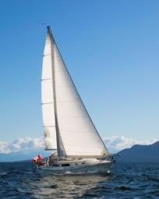
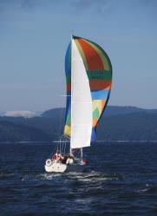
“Natasha”, named after our granddaughter, is a 1978 Islander Bahama 30 originally named “Folly”. She was sailed from San Diego to Victoria by her previous owner where Carey & I purchased her in 2003. We have been upgrading her ever since. She is probably better than new at this stage with the latest addition being a new Beta 20 diesel installation in 2012. See http://islander36.org/Natasha engine 2012.docx for a document about the engine installation, electrical upgrade and blister repair.
About Us
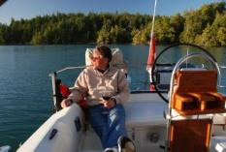
Carey & I have been actively cruising British Columbia waters for over 30 years, starting with a Balboa 20, moving up to an O’Day 25 for eight years and then our first Islander 30, “Dreamer”. Many early summers were spent sailing up to Desolation Sound and all points along the way. Our daughter, Nicky, grew up sailing with us. Now our granddaughter, Natasha, is following in her footsteps.
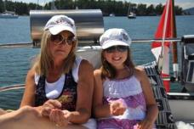

Table of Destinations
Thu | July 24th | Pirates Cove, DeCourcey Is. | Sat | Aug 9th | Squirrel Cove, Cortes Is
Fri | July 25th | Newcastle Island, Nanaimo | Sun | Aug 10th | Teakern Arm, Rendonda Is
Sat | July 26th | Pender Harbour | Mon | Aug 11th | Refuge Cove, Rendonda Is
Sun | July 27th | Hardy Island | Tue | Aug 12th | Gorge Harbour, Cortes Is
Mon | July 28th | Sturt Bay, Texada Island | Wed | Aug 13th | Gorge Harbour, Cortes Is
Tue | July 29th | Lund | Thu | Aug 14th | Rebecca Spit, Quadra Is
Wed | July 30th | Gorge Harbour, Cortes Island | Fri | Aug 15th | Campbell River
Thu | July 31st | Campbell River | Sat | Aug 16th | Campbell River
Sun | Aug 3rd | Gorge Harbour, Cortes Island | Sun | Aug 17th | Sturt Bay, Texada Is
Mon | Aug 4th | Roscoe Bay, Rendonda Island | Mon | Aug 18th | Smugglers Cove
Tue | Aug 5th | Roscoe Bay, Rendonda Island | Tue | Aug 19th | Newcastle Is
Wed | Aug 6th | Tenedos Bay | Wed | Aug 20th | Nanaimo
Thu | Aug 7th | Tenedos Bay | Thu | Aug 21st | Montague Harbour
Fri | Aug 8th | Lund | Fri | Aug 22nd | Portland Island
 |  |  | Sat | Aug 23rd | Home

Thursday | July 24 | Pirates Cove | Fulford Harbour
Chart 1 |  |  | 0222 | 3.0
 |  |  | 1010 | 0.7
 |  |  | 1822 | 3.1
 |  |  | 2304 | 2.7

Powering 2 hrs Sailing 7 hrs Distance 34 nm.
2040hrs Tied up at Rick Berry’s slip in a very busy Pirates Cove. Typical for the summer, not a whole lot of room to anchor, especially coming in late like I did. But I’m secure for the night and the dinner dishes are put away. The skies are part cloudy with what may be a red sunset looming. There is still a bit of a NE breeze out in the channel, but nothing in here. The glass of wine is delectable and the anchored boats are quiet. Surprisingly, most are sailboats.
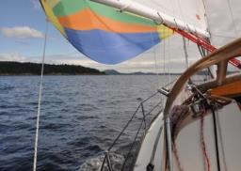
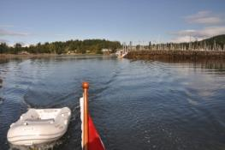
This morning I walked to the boat from home, carrying nothing but the laptop and iPad in my small backpack. I loaded the boat up yesterday just before the rain settled in for the day. I would have left yesterday if there was even a hint of wind, but there wasn’t. Carey & I had dinner at the Yacht Club last night and called it an early night. Arrival at the boat this morning saw the skies start to brighten to the west. The forecast was for clearing skies and strong NW winds. By 0900hrs I was powering out of the marina, headed for John Pass against the last of the ebb. A big flood was to follow and I wanted to catch that as far as the wind would go. There wasn’t much wind through Swartz Bay and I tried to sail just outside of Stranger Pass but gave up on that as the ebb carried me back. The power was on until about 1030 abeam of Kanaka Bluff. A light SW wind from Portland Island got the main and jib into action and I sailed off towards Beaver Point. A short time later the spinnaker was raised as BC Ferries and numerous boats of all kinds powered past. The rain yesterday kept boaters in place and everyone was moving this morning.
By 1115hrs I was screaming past Beaver Point on a tight reach with the spinnaker pole against the forestay, just making the corner. The current was neutral with plenty of boats moving about. I managed to sail between the Channel Islands as the skies brightened and the sun managed to get out from behind the clouds. I raised Born Free on the VHF, he was headed for Montague Harbour for the day after coming through Dodd Narrows on the big ebb. He’s on his way back to the marina.
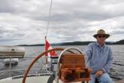
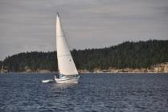
Once into the north end of Captain’s Passage the wind evaporated and the spinnaker had to come down. For the next hour or so the wind switched around to almost every point on the compass. Sailing was a challenge! A steadier wind finally developed from the NE of all directions. A close reach all the way up Trincommalli Channel! I reached Poulier Pass at about 1500hrs still on a reach, everything from 2.5 to 6.5 knots in the rising and falling wind. Although the clouds had moved back in, the wind was nice and warm. Just north of Poulier the wind backed enough that the spinnaker went back up with a great run all the way to Playdes Island. The light breeze kept filling in ahead of me, rippling the water. Then the wind went from SE to North in less than a minute. I had a real struggle to get the spinnaker down off the mast and spreaders. The jib came back out and the sailing continued, hard on the wind right to the mouth of Pirates Cove, DeCourcey Island. Very nice! I came across an Ericson 32 sailing south and took a few photos. The skipper answered the VHF and I got his e-mail. I will send the photos to SVPEMA@gmail.com. I arrived at Pirates Cove at 1730hrs to find the anchorage packed! Not a whole lot of room to anchor.

Pirates Cove is a very popular provincial marine park on DeCourcey Island at the north end of the Gulf Islands. There is no access to the island other than by boat. The majority of the island is privately owned with summer cabins peeking out of the forest. The relatively small anchorage is protected by a rocky reef that’s exposed at low tide, framing a very narrow, shallow entrance. The soft mud bottom in shallow water can cause your anchor, chain and rode to produce quite the stink when brought up on deck. Stern tying is the norm
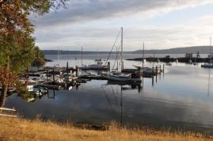
A boating buddy I know has a summer cabin on the island and with it, a slip at the private marina. I called him up on his cell phone and he directed me to his slip. He was at home in Sidney and I’m now tied up in his spot. Tomorrow I’m planning to catch the flood early afternoon though Dodd Narrows to get to Nanaimo.

Friday | Jul 25 |  | Newcastle | Fulford Harbour |  | Dodd Narrow
Chart 2 |  |  |  | 0307 | 3.0 | 0323 | 0634 | -6.0
 |  |  |  | 1048 | 0.7 | 0940 | 1310 | +7.2
 |  |  |  | 1855 | 3.1 | 1643 | 1952 | -5.3
 |  |  |  | 2346 | 2.6
Engine .5 hrs Sailing 3 hrs Distance 13 miles
0730hrs I’ve been for a hike to the south end of the park and found a light SE wind already rippling the water in Ruxton Passage. There is cloud cover this morning, but it’s supposed to dissipate during the day. The sun has been out already this morning so this cloud cover is localized. A good night’s sleep except for the lonely mosquito that was looking for dinner!
2200hrs Lorne Webber just sauntered away into the darkness after a glass of wine in the cockpit. Quiet it’s not, but it’s a Friday night in the big city, and it’s Bathtub Race Weekend in Nanaimo. Lots of stuff going on. I’m tied up at the Nanaimo Yacht Club on the outside of the reciprocal dock, catching the wake of boat traffic in Newcastle Channel. It actually hasn’t been too bad, the Harbour Patrol and RCMP must really enforce the 6 knot speed limit in here!
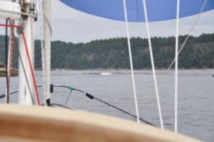
This morning I cast off from Pirates Cove at 0900hrs under a cloudy sky and light SE breeze. Careful navigation was required to get out of the narrow entrance on such a low, falling tide. Once out the mainsail was raise and the Genoa rolled out, sailing hard on the wind towards Ruxton Passage to the south. Of course, the SE wind eased considerably once I rounded the south end of DeCourcey Island and headed north towards Dodd Narrows, downwind. The spinnaker soon went up. There were plenty of boats powering past me from the slack current at Dodd Narrows towards the clearing skies to the south. I managed to sail under the spinnaker right up to the approach to the Narrows. The closer I got the fewer the boats coming through the Narrows, the current was increasing. Some boater called in a May-Day on the VHF, hitting a rock under a buoy somewhere on the west side of Saltspring Island, but he didn’t know exactly where he was! He had an interesting conversation with the Coast Guard and then I never heard from him again.
The wind stayed reasonably steady and the spinnaker continued to fly as I got close to the Narrows. Then, just as I was getting into the current flow, two large power boats approached from the North and decided to beat me through, against the current. Nice! And very nice standing waves left behind! I couldn’t avoid the curling crests that buried the bow under green water while rushing through on the five knot current. The green water reached right back to the forward hatch (which was closed, fortunately!). But the spinnaker didn’t collapse and I continued to sail.
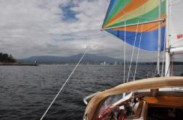
A couple of spinnaker gibes and I was at Jack Point, reaching towards the city and inner harbour as the noon cannon fired. It was pretty quiet on the approach and once in past the lighthouse the wind died completely and all the sails came down. I motored slowing over to the Nanaimo Yacht Club and found room at the reciprocal dock, tying up without any difficulty. It costs $5 to be here for the night on reciprocal, that’s for power, water, and access to the building. Not bad!
The city of Nanaimo has a vibrant waterfront that caters to the boating community. There are private marinas, public docks, yacht clubs and a marine park with docks, mooring buoys and room to anchor. Facilities of all sorts are within walking distance, everything from restaurants to marine chandleries to shopping malls.
After registering, my first task was to go and look for our old Islander Bahama 30 called “Dreamer”. I knew it to be at Stones Marina, within walking distance. It warmed up dramatically as I walked down to Stones Marina. Dreamer was gone! I walked all the way back and e-mailed Simon, thinking that he was probably out on the water somewhere. He e-mailed back saying “Dreamer” was on the hard having the engine rebuilt! I’ll have to go back there in the morning (when it’s cooler) to have a look at the yard.
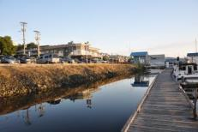
The afternoon wore on, me dozing in the cockpit with a book. Showers at the YC were cheap and felt good. The skies continued to clear as the afternoon turned into evening. I noticed Prairie Princess slowly drifting past in Newcastle Channel, also looking for moorage. Lorne & Val got a spot on the inside. I eventually walked over (different part of the marina, it’s a long way around) and visited. Nothing much has changed with them, this is as far north as they are going this year.

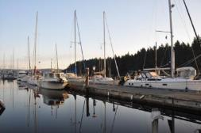

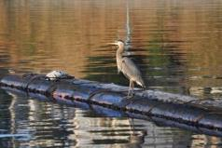

I’m headed across the Georgia Strait tomorrow, the prediction is for SE 10 -15 and the big flood starts at around noon. Hopefully it’s a good crossing. Time to be away from docks!
Saturday | July 26 |  | Pender Harbour | Point Atkinson
Chart 3 |  |  |  | 0501 | 4.0
 |  |  |  | 1209 | 1.0
 |  |  |  | 1925 | 4.3

Engine 2.5 Sailing 4 Distance 24
2130hrs Anchored just outside of Garden Bay in Pender Harbour, there are too many boats anchored inside. The sun has long since set and dusk is falling A single jet contrail overhead is still glowing across the sky. The wind, what little there was in here, has died and the water is flat, the boat drifting overtop of the anchor rode. The end to a near perfect day!
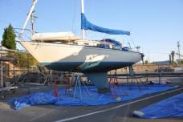
This morning I woke up to brilliant sun shining in through the windows! It was just after 0600hrs! Oh well, I was awake so I may as well get up. A glass of water and I was off to see if I could find Dreamer up on the hard at Stones. A short walk later in the cool of the morning and I was looking at the bottom of the old boat. The blister repair from years ago seems to have held up nicely. I took a few photos and then walked back to NYC. Coffee and honey cake followed as the sun warmed the air and dried the dew out of the cockpit. The marina slowly came to life and boats started to drift in and out. I got rid of the garbage and picked up two bags of cubed ice.
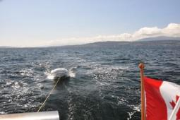
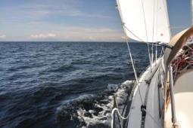
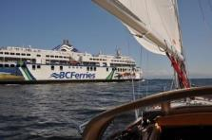
By 1000hrs there was a hint of a SE breeze rippling the water in Nanaimo Harbour. The smoke from Harmac was starting to lean over and the weather reports on VHF and iPhone were indicating a start to the predicted SE 10 – 15 this afternoon. I was motoring up Newcastle Channel by 1030hrs, all ready for a day of downwind sailing. Departure Bay was busy with float planes and BC Ferries. The main went up and by the time I got to Horsewell Rock the Genoa was rolled out and drawing. The tide was still falling and the current against, the water was quite choppy. But it was sailing and aimed in the right direction! WG was open to transit and the waypoint locked into the GPS was Cape Cockburn 29 miles away! As the day progressed the seas calmed with the change of tide and by 1245hrs the spinnaker was up on a beam reach in lightening wind. There weren’t a lot of boats visible although you would think that every moron with a boat was out there somewhere, the calls to the Coast Guard were non-stop!

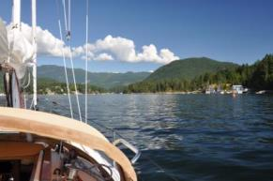
The wind continued to ease as I got closer to the south end of Texada and North Thormandy Island. Most of the sailboats that were visible were motoring. But I was being persistent, ghosting along at 3 – 3 ½ knots. The goal was still the Hardy Islands but I could see the writing on the wall. The temperature inside the boat was 30c and the wind was evaporating. At 1500hrs I finally gave up and turned the engine on, taking the spinnaker down. It had been a nice light airs run. I was still over 10 miles from Cape Cockburn so I aimed for Pender Harbour, only five miles away. Then as I got closer the wind picked up a bit and the spinnaker went back up, there is always hope! Didn’t last long though. At 3 knots it would have taken until about 1900hrs to reach Hardy Island and the heat was getting to me. I even had my shirt off for a while! So back under power and into Pender Harbour I motored.
I expected it to be busy, and it was. It’s a weekend, after all. I had the anchor down by 1700hrs in the outer bay. I cruised through Garden Bay first and found Amulet with Roy & Anne from our marina. They came over in the dinghy for a chat while I was getting the boat organized. Then it was a delicious ice cold beer and a nap in the cockpit, in that order! The barbeque didn’t get lit till 1945 hrs and I had a very tasty steak as the sun set!
Pender Harbour is a major boating center on the Sunshine Coast of the BC mainland. There is no “town”, just various collections of stores, pubs and boating facilities. Most activities happen on the water, tourist oriented. It’s a busy place.
I’ve been playing text mail with Carey, Trish & Wayne and then Ena for a while. I also had a FaceTime with Natasha for a bit. She can’t come over until the 1st of August because of an eye doctor appointment on the 31st. Oh well.
It’s off to Hardy Island tomorrow if the forecast NW winds show up. The tide doesn’t turn until after noon so there is no hurry to get out of here. And I noticed plenty of mosquitoes hovering around the keyboard. I’ll have to put the screens in tonight!
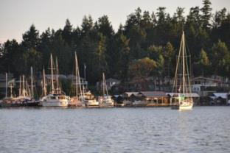

Sunday | July 27 | Hardy Island | Point Atkinson
Chart 4 |  |  | 0542 | 4.0
 |  |  | 1242 | 1.0
 |  |  | 1951 | 4.4

Engine 1.6 hrs Sail 4.5 hrs Distance 16 nm
0900hrs A beautiful morning, clear blue skies, and the sun is already warm. I even slept in until 0700hrs with nary a sound to be heard. By now lots of boats have already made their way out of Garden Bay, probably headed south in the big ebb. There’s no wind to speak of just yet. In anticipation of this being another hot day I filled the sun shower and water jug over at the docks at Maderia Park this morning. I’ll need a shower by tonight! It’s just about breakfast time!
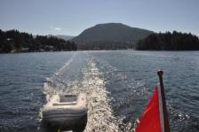
2300hrs Already that late! Just back from a pleasant (but hot) visit with Brian & Niki aboard Rasputin, the Islander 30 we met at Wallace Island just after the Islander Rendezvous. Small world. They are on their way back from Desolation, having to be home by Friday. Debating if they should go in to Princess Louisa or not. But back to this morning…
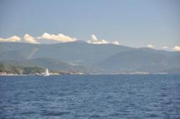
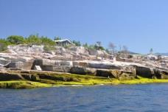
At around 1000hrs, after a filling late breakfast of pancakes, a light northwest breeze started to ripple the waters of Pender Harbour. The forecast was for 10 to 15 this afternoon from the NW, and the tide was going to turn to flood about 1300hrs, so if it was going to be 15 knots against the flood it would get ugly out there. By 1020hrs the anchor was hoisted and I was underway for the entrance. It was already warm out, no need for a sweater! Just outside Pender Harbour the wind became a faded memory, hardly a ripple on the water. I motored out to Amegammon Channel where a light ripple darkened the surface. Up and out went the sails and I was hard on the wind in behind all the rocks and small islands, out of the last of the ebbing current. I played the zephyrs close to shore in near glassy conditions with just enough way on to stay in control. At Quarry Bay the wind picked up a bit from the west and it looked good across the strait. Off I went on a long tack out, hoping to make Cape Cockburn in a long tack back in. I even thought about heading up to Sturt Bay on Texada Island if the wind remained steady. Alas, after a nice romp at hull speed half way across to the Texada side it ease considerably and nearly died. I worked my way back in towards the mainland side to find that the current had carried me back south, I couldn’t make the Cape. A whole series of tacks squeezed me by Cape Cockburn only to find no wind along the northwest shore. Lots of left over slop from a wind I could see blowing well to the north, but no wind at all where I was. It was like motoring on the west coast between Ucluelet and Tofino, very uncomfortable. It took me about 45 minutes to power the last 2.5 miles where I could get up on deck to lower the main. I coasted into the protection of Hardy Island to find only three power boats in here! Perfect. I had the anchor down and had a stern line ashore when the trawler behind me raised anchor and left. That’s the spot I wanted. So up came the anchor and now I could swing free of a stern line. This was all by 1500hrs so I had the rest of the afternoon “off”. With good forethought, I pulled a very cold beer from the icebox and relaxed in the cockpit. It was hot out and the shade of the dodger along with light breeze kept the temperature reasonable. I dozed off a few times while reading my book.
Although I call this location “Hardy Island”, it’s actually “Musket Island Provincial Marine Park” on the south side of Nelson Island in Blind Bay. A beautifully remote anchorage with three distinctive anchorage areas, this is the ideal safe harbour if the wind picks up in Malaspina Strait. There is no shore access as the lands surrounding these bays are privately owned.
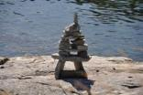
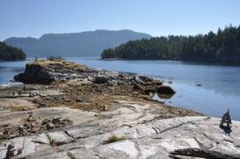
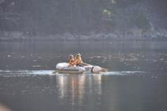
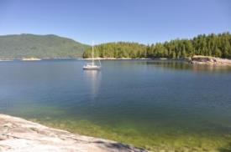
By 1830hrs I was ready for a shower. A few more boats had come in, all power with one sailboat. There was still lots of room! The shower was very refreshing and most welcome. It was after 1900hrs before that was all cleaned up and the barbeque lit for dinner. Just a chicken breast for dinner, no real appetite in all this heat. No hurry either! I was watching a guy on the other sailboat, a 37 ft Beneteau, working on what looked like a very kinked new anchor rode. He and his daughter(?) were trying to unkink it without much success. After dinner I finally rowed over and suggested the easiest way to straighten it out was to tow it at low speed. He liked the idea. He’s on his way around the Island with new anchor gear and the rode came out of a box all tangled. After chatting with him I rowed around a bit, watching a sailboat approaching from the Strait. There was an opportunity for a photo, the sailboat lit by the setting sun against the dark background of Texada Island. There was a power boat in the way so I rowed to clear that and just as I got into position the sailboat disappeared into shadow. Damn! Oh well, it was calm and peaceful so I just sort of stayed out there and then recognized the boat as Rasputin. Once they figured out who I was I helped them get their stern line on the rocks and then got invited aboard for a glass of boxed wine. I was there the entire evening as they had dinner and regaled me with stories of Desolation. It got dark and the mosquitoes invaded their boat. Candles and a bee swatter were soon at work. That didn’t help much and we soon moved into the cabin, a very warm cabin with no ventilation! And that’s what I’m back from now. It’s nice and cool in here. The netting is up and no mosquitoes that I’ve noted yet.

Monday | July 28 | Sturt Bay | Point Atkinson
Chart 5 |  |  | 0127 | 3.0
 |  |  | 0623 | 3.9
 |  |  | 1314 | 1.2
 |  |  | 2016 | 4.4

Engine 1 hr Sailing 4.5 hrs Distance 21nm
1920hrs It’s too hot to sit in the sun, and I’m not putting up the tent for the last hours of setting sun! So I may as well organize photos and update the log. I’m anchored in Sturt Bay at the north end of Texada Island, still a ways from Desolation Sound. But it’s only Monday and I still have lots of time before Campbell River on Friday.
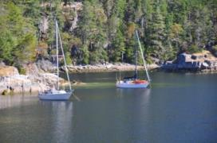
This morning started out perfectly with the sun reaching the dew on deck just after 0600hrs. I got up and rowed over to shore to take some morning photos. Very calm and very clear. Not a sound to be heard but the melodies of nature. A relaxing cup of coffee and an egg muffin for breakfast. There was no hurry to do anything as the tide was not turning to flood until after 1300hrs. Anchored boats drifted away, one after the other, as the tide fell. I rowed across the bay to the little house on the island. It’s for sale! But what a wreck! I had a look inside as the doors were not locked, probably because there’s nothing of any value inside or out. The renovation would start with a match! I rowed over to Rasputin and had a short chat. They’re heading up to Princess Louisa tomorrow, against the ebb all day. That will be fun! They’ve never been up there, so good for them.
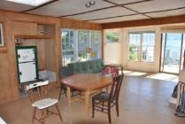
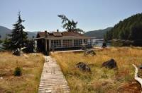
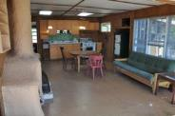

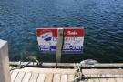

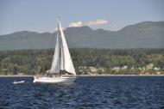
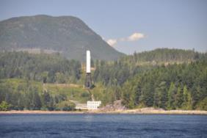
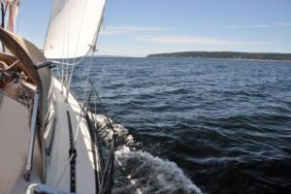
By noon the stern line was in and the anchor was up out of 50 ft of water (I need a windlass!!). There was a light, warm breeze just beginning through the anchorage. Gazing over the strait showed the water glassy smooth. The promise was for light NW winds until late in the afternoon when it was predicted to rise to 10 – 15 knots. I motored out of the group of island and then kept going for about an hour to get to a wind line just north of Jervis Inlet. The sails went up and a series of light-airs tacks along the shore followed. The light wind was warm and the sun brilliant in the blue sky. Like sailing in the Caribbean, only not as much wind! I put on my white sun shirt just to keep from getting too burned. The wind eased, the wind picked up, it shifted through 40 -50 degree on a regular basis. There seemed to be headers no matter which way I tacked. For a long time I couldn’t get close to 3 knots with a bit of a current still against. But eventually I made progress and got past the tall, white water tower that visible for miles in each direction in Malaspina Strait. There were a few sailboats in mid strait under spinnaker, headed south. There were also a few powering to windward along the shore. Generally, very few boats to be seen! But a near perfect day to be on the water!
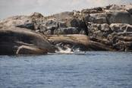

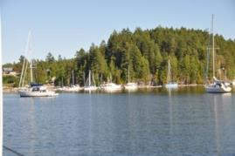
By 1640 I was close to Grief Point and deciding to tack around the corner and continue on to Lund, or head over to Sturt Bay and call it a day. It was still more than 15 miles to Lund and the wind ahead was showing signs of weakening. There were areas of glassy water developing. One long, last tack across the strait and I pulled into Sturt Bay at 1730hrs. The Texada Boating Club has quite the marina set-up, and there was room at the dock. But there was only one other boat at anchor, so I went to the head of the inlet and threw out the hook. A cold beer and some cheese and crackers was enjoyed in the cockpit! It was 31c (88f) in the cabin, quite a bit warmer in the sun. Hopefully the mosquitoes would stay away tonight and I could sleep with everything open! Dinner was still on, just later than usual.
Sturt Bay is one of the very few safe anchorage along the east side of Texada Island, a small indent in a very long and rugged shoreline. The bay is shaped like a “V” with a tidal lagoon at its’ head. There are the remnants of a rock/gravel quarry along the shore that has since found another loading dock further along the shore. A private marina is next to the Texada Island Boating Club marina, a substantial marina with room for visiting boats.
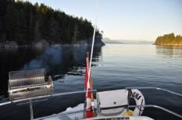
2200hrs It’s cooled off nicely, I’ve got into my jeans and a sweatshirt again! Dinner of barbequed chicken was at 2100hrs, a bit late but tasty none-the-less. I relaxed in the cockpit with soft music and a glass of wine as darkness fell over the anchorage. Still only two other boats in the anchorage tonight, a cutter rigged sloop with an all-female crew, and a C&C with an older guy who went ashore much earlier. It was very quiet. Perfect! The mainland shore was barely visible and the white tower disappeared into the gloom. Stars popped out all over the sky. No moon yet, it’s a new moon and will probably be visible tomorrow or Thursday. The wine and dark chocolate were perfect!

Tuesday | July 29 | Lund | Point Atkinson
Chart 6 |  | Supplies | 0204 | 2.9
 |  |  | 0704 | 3.9
 |  |  | 1344 | 1.3
 |  |  | 2040 | 4.4

Engine 3hrs Sail 0hrs Distance 15 nm
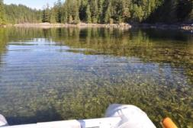
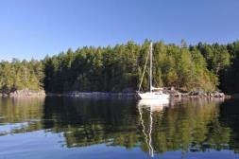
0900hrs A perfectly quiet night with nary a sound to be heard. And a perfect morning. Now all I need is a bit of wind, although there is none predicted. I’ll head to Lund today and probably have to motor most of the way, if not all. This morning I went for a short row into the rapidly emptying lagoon where, oh so many years ago, I took the photo of Nicky rowing the red dinghy. The tide was dropping this morning and I didn’t explore very far. The entrance is quite shallow and I didn’t want to get trapped. Then over to the Texada Boating Club to have a look at their docks. Quite nice and I’ll have to stop by again

2140hrs Sunset is now at 2100hrs, earlier every day! And right now the moon isn’t far behind, just a sliver over the mountains of Vancouver Island. There is still plenty of activity on the docks here at Lund this evening, the boats are like cars for those that live and vacation here. There is a bit of an off shore breeze blowing tonight, quite the change from the SE breeze that ruffled the water in here all afternoon. And it’s a good thing that breeze was here otherwise the heat would have been stifling. As it was, it was hot enough anyway, somewhere around 30c (80f) again today. Not that I’m complaining!
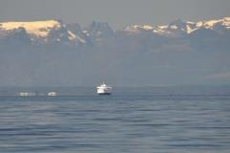
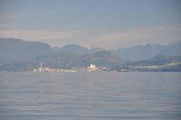
After breakfast of scrambled eggs I pulled up all 180 ft of rode at 1000hrs and motored out into the glassy waters of Malaspina Strait. There was no wind predicted today so I figured I may as well get on the road early. The tide was going to be dropping until about 1500hrs this afternoon so not much point in waiting. Powell River was clear in the morning sun, smoke from the stacks rising vertically against the hazy blue mountains. On the other side the Comox glacier was a backdrop to the Queen of Burnaby crossing from Courtenay to Westview, all on glassy water. Not many boats out and about as I motored around the

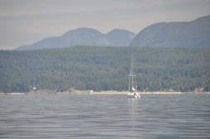

west side of Hernando Island in the hopes of getting a westerly wind. That didn’t work and I ended up motoring all three hours to get here, arriving at 1315hrs.

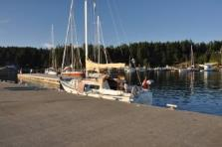
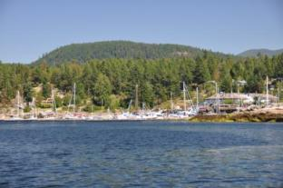
There was plenty of room on the inside of the floating breakwater, boats coming and going all afternoon. I paid my $20.70 moorage and then checked with the sweater shop to see if repairs could be made to the hole in my red sweater purchased here eight years ago. Evelyn, the lady at the counter, was minding the store for Nancy, the owner, and it’s Evelyn that actually knits the sweaters! An hour later, and for no charge, I can’t find the repair! Excellent! But was it ever hot! It was much nicer on the breakwater than tied up at the docks inside, at least there was a breeze! I had the small tarp up to get some shade as the sun drifted towards the western sky. I got two bags of ice from the store, had an ice cream bar and watched the traffic come and go.
The village of Lund is the northern end of the Sunshine Coast highway. It’s the jumping off point for many summertime visitors to the various local islands and cabins. There are a number of water taxi companies operating out of the public docks to accommodate these visitors. The marina itself is substantial and well maintained. The Lund Hotel is at the head of the dock along with various stores, a bakery and a pub and restaurant. There are shower and laundry facilities within easy walking distance. At one time Lund had a major boat repair facility but that has fallen by the wayside. Now it’s a good place to enjoy the sunsets from the hotel patio while enjoying drink, and a good resupply depot. The marina is protected by huge concrete floating breakwaters. My preference is to tie up on the inside of these breakwaters, the view is spectacular.
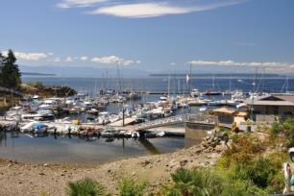
A relaxing afternoon with a couple of cold beer and a good book. Around 1600hrs I enjoyed a refreshing shower in very clean facilities ashore, debating if I should go to the pub for dinner or not. Eventually I decided not to, just too hot and no appetite for a big dinner. Crackers and cheese would have to do! There were people swimming off the docks (and still are now!) and setting up chairs for the sunset. And it was a brilliant sunset as the air started to cool off. Now with the off-shore breeze I’m back in my sweatshirt and jeans to keep warm while I write in the log. Perfect for a good nights sleep. There are mosquitoes around again tonight so the screens will be in and the coil is burning.
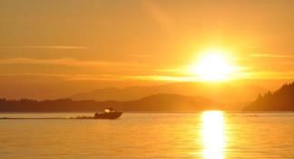
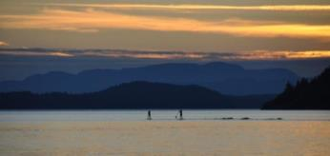

Wednesday | July 30 | Gorge Harbour | Campbell River
Chart 7 |  |  | 0137 | 2.8
 |  |  | 0703 | 3.5
 |  |  | 1325 | 1.6
 |  |  | 2038 | 4.0

Engine 1 hr Sail 5 hrs Distance 24 nm
2100hrs Anchored in a very quiet eastern end of Gorge Harbour. The marina/resort and popular anchorage is at the western end, and there are plenty of boats there. I’m the only one in the eastern end with ½ a mile of swinging room in 50 ft of water! There are oyster beds along the shore as well as a number of house, but its very quiet. There was a birthday party going on at one house astern, but it seems to have ended. The sun set a few minutes ago and the sliver of moon is hanging in the western sky. There is still a light, warm breeze drifting across the way from the west, but it’s most welcome! It’s been another hot day, 30c (80f) in the cabin again. It’s finally cooling off as evening descends.
Overnight was not the most restful of evenings at Lund. Shortly after I updated the log last night waves started to roll into the marina, through the floating breakwater. At first I thought it was the result of a power boat having gone by, but it went on and on. It was dark by this time and, with no apparent wind, I assumed the wind was blowing towards Campbell River and we were getting the left over waves. Although I slept well, the boat certainly rocked all night. Even this morning the waves continued. I rowed to the docks around 0815hrs, intending to get dinner for tonight and perhaps cinnamon buns for breakfast. The cinnamon buns I got from the bakery, then I had to wait for the grocery store to open for three small bacon wrapped tenderloins. The store had a very, very limited selection of meat! The cinnamon bun was delicious, even without frying!
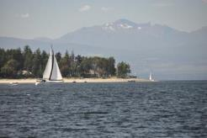
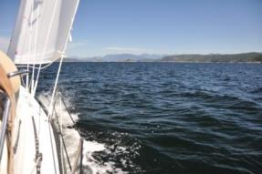
Boats were coming and going already, the water taxis already in full gear. A light westerly was starting up to accompany the seas still rocking the boat. By 0930 I had cast off the dock lines and powered just outside the marina to raise the sails. Off towards Savory Island hard on the wind towards Baker Passage. The plan was to go to Mason Landing for the day. Any currents were going to be against me most of the day with a big falling tide. I could certainly tell with a large tacking angles! Most sail boats were motoring in either direction. The usual comments on the VHF were directed at large power boat wakes, again. A Beneteau 45 motored past me and I guess I embarrassed him into rolling out his sails. I spent the rest of the day trying to catch up with him. I got close a few times until he quit at Middlenatch Island. He went powering off towards Gorge Harbour as I sailed in very light airs and shallow water in the same direction. There were a lot of anchored boats at Mason Landing so I opted to go to Gorge Harbour instead. We’ll end up at Mason Landing later in the trip anyway.
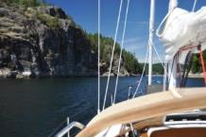
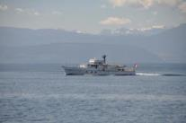

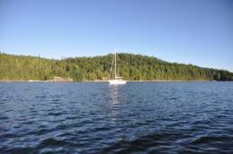
By 1430hrs I had the anchor down at the west end of Gorge Harbour after motoring the last 2.5 miles as the wind died completely. Gorge Harbour is a large protected harbour with aquaculture operations at the west end and private marinas at the east end. Unfortunately, it’s also quite deep, mostly 60 ft with a few shallow spots. The private marina is a resort that caters to visiting boats.
It was another hot afternoon. Lethargy was becoming a problem. I put up the sun tent and, after a cold beer, fell asleep in the cockpit again, but only for a short time. So hard to wake up after that! I did some repair to “Natasha’s Dinghy” name (superglue) and removed some of the tar from bumping against the dock last night. A few other minor things were corrected and I felt like I had done something today. There is no cell phone coverage in here. I did talk to Carey earlier as I knew that was going to be a problem. Nicole also called, concerned that Genevieve was connecting with the old wine club guys and selling cases of Rolly’s wine. She wanted to know what my wishes were. I told her I wanted 10 cases and that I would be back in late August to do some sampling. I also learned by e-mail that Avril will be going to Westshore RCMP as a CPIC clerk sometime this fall. That will shake things up a bit at CSPS! Tomorrow it’s off to Campbell River, probably Discovery Marina.
2245hrs A near perfect night so far. Although there is still a breeze ruffling the waters, it’s warm and feels a bit like the Caribbean. I have the anchor alarm set for 200 meters with a bit over 200 ft of rode out in 60 ft of water. The weather prediction is for wind tonight. We shall see. The stars are out and the last glow of daylight is on the western horizon. I have some soft music playing, port in hand with dark chocolate. It doesn’t get much better (other than the family isn’t here!).
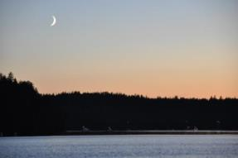
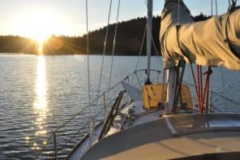

Thursday | July 31 |  | Campbell River | Campbell River |  | Seymour Narrows
Chart 8 |  |  |  | 0238 | 2.6 | 0341 | 0631 | +7.6
 |  |  |  | 0751 | 3.4 | 0940 | 1243 | -7.2
 |  |  |  | 1352 | 1.9 | 1536 | 1837 | +7.8
 |  |  |  | 2106 | 4.0 | 2143
Engine 3hrs Sail 0hrs Distance 17 nm
It’s already 2200hrs as I sit in the cockpit catching up to today’s activities. I’m tied up at the Coast Discovery Marina (not the more familiar Discovery Marina!), rocking in the wake of passing cruise ships and BC Ferries. Not the most comfortable of marinas, but any port in a storm…..
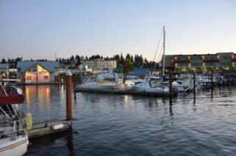
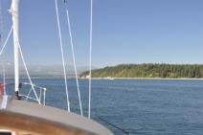
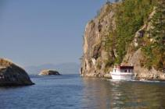
This morning was another stellar morning on the water. A gentle breeze was already ruffling the water, a breeze that had not died all night. I had about 250 ft of rode out and had the anchor alarm set for the night. When I woke up some time in the pitch black to use the head the breeze was warm enough that I didn’t bother closing the forward hatch. And no mosquitoes either! So after morning coffee and a cinnamon bun for breakfast I started to haul in all that rode. I need a windlass! By 0915 I was motoring out of the long harbor, past the vertical cliffs at the entrance and turning right to use Uganda Pass to access Sutil Channel. I figured the wind, if it was from the west as predicted, would be a close reach, not hard on the wind, for Cape Mudge. As it turned out, there was no wind, none at all! I motored the entire way, getting sucked into Discovery Passage by the start of the ebb, finding a 4 knot current with me. Of course, the wind then chose to start up, right on the nose. I called Discovery Marina on the VHF 66a to ask for moorage, only to find that they were full! Huh?! I’ve never heard them being full! This was not good! I got on the phone to confirm that they had no room for any of the three days, then onto the phone to Coast Discovery Marina looking for space. Fortunately, they had an opening. Not ever having been in here it was interesting driving in. First I had to drive sideways in Discover Passage just to make it to this side! The current would have swept me past the entrance! Once behind the breakwater there was no more current and the wind eased somewhat. I managed to tie up without great difficulty at exactly noon to find that the large aluminum commercial vessel beside me was creating a very nice windbreak, just when I needed a breeze. It got really hot, really quickly!
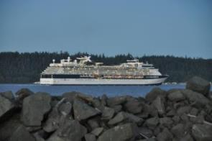
After paying for the moorage I started to do the shopping. I found the mall across the street is pretty well empty now. The IGA is gone, the only worthwhile store being Shopper’s. There was also a sports shop there so I bought a new set of trunks and goggles for swimming. I found the liquor store and purchased beer and Strongbow, then trucked that back to the boat. Off on another jaunt to the large mall to see what was there, picking up more stuff on the way back after a stop at the DQ for a Sundae, and identifying the car rental place (Budget) for tomorrow. I got that all back to the boat to find the temperature inside at 34c with the sun beaming in from the west, right into the cockpit. With a little measuring and rope work, I turned the boat around to get some shade in the cockpit! Impossible to sit in the cockpit otherwise. I did some organizing and then went for a walk into the park, sitting at a bench in the shade for a while. I also found the library and deposited my previous books and picked up a few new ones. For dinner I walked back to the pub at the Discovery Marina for a Caesar Salad with salmon and a cold beer. The place was quiet and even the waitress commented on the lack of customers. Then into Superstore to fill up more bags of stuff for the boat. I was getting tired of the walking and carrying! Once the boat was organized it was time for a shower at the marina facilities, and here it’s just like a regular household bathroom, small, but private. No meter on the water! The fish & chips place on the dock was still going strong as I came out, closing the order window at 2100hrs.
Interestingly, the wind just cooled down dramatically, still from the west, but now it’s time to move inside! Still a few things to do before I call it a night. I need to download more photos from the camera to make sure I have more than one copy. Then make sure I have everything set up for tomorrow.

Sunday | Aug 3rd |  | Cortes Bay | Campbell River |  | Seymour Narrows
Chart 9 |  |  |  | 0522 | 2.0 | 0513 | 0818 | +7.5
 |  |  |  | 1136 | 3.1 | 1141 | 1436 | -5.6
 |  |  |  | 1531 | 2.7 | 1649 | 1951 | +8.9
 |  |  |  | 2228 | 4.0
Engine: 1.3hrs Sail: 2.5 Distance: 17
2230hrs Relaxing in the cockpit with Tasha under a starry sky and warm NW wind gusting through Cortes Bay. It’s probably in the neighborhood of 12 – 18 knots and is certainly rustling through the trees on shore. All our flags are stored away and the halyards separated from the mast to eliminate that clanging sound. I can hear a few other boats in here with halyard slap. The half-moon is low to the western sky and the International Space Station went over a little while ago, just as Natasha was getting ready for bed. All is quite aboard now as I update the log over the past few days.
On Friday morning, July 31st the wind had been blowing lightly all night and the boat rocked in the low waves coming into the marina. It wasn’t really a problem but not all that comfortable. I cleaned up the boat a bit and then generally waited for 1130hrs to go to Budget for a car rental. Their data base showed that I was a consultant with the RCMP (it’s been a while) and they even gave me an upgrade from compact to midsize, I got a VW Tiguan. Not a bad riding car! Off to the boat to pick up laundry and hit the road. Three hours later I was at the office doing some maintenance in the PRIME system. A stop at the bank and I was home by 1545hrs, not bad! We went to the Yacht Club for dinner and, because showers were called for in the morning, the alarms clocks were set for 0500hrs!
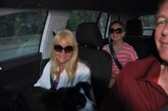
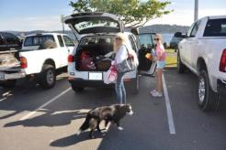
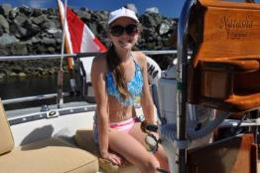
We were on the road the next morning by 0630hrs, all fresh and ready to go. It wasn’t until McKenzie Ave in Victoria that Carey remembered the block ice that we’d made, still in the freezer at home! Damn! No turning back for that through. We stopped in Duncan at Tim Hortons’ for some breakfast donuts and two hour later arrived at the Coast Discovery Marina by 1000hrs. No traffic to speak of all the way there! A quick jaunt to Thrifty’s groceries while we still had the car and $ 240 worth of groceries was loaded into the boat. I returned the car just before noon and it was time to get organized. It all fit again, the icebox full as well as the lockers.
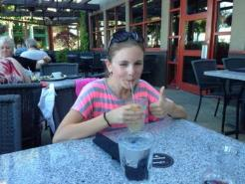
The rest of the afternoon was taken up with the girls shopping while I looked after Tasha. She and I spent some quality time on a grass field near the library, waiting for the girls to walk by (which they didn’t, took another route back to the boat!). Natasha found a new “stars & stripes” bikini along with some water shoes that fit. As evening approached we walked up to Moxies for dinner and then back to the boat as darkness fell. Carey was tired and went to bed early, but Natasha wanted to see any cruise ships that were going by. I checked Shipfinder on my phone and found two closing in on Seymour Narrows just north of here. There were bit later than the two the other night, but still quite spectacular as they glided by with all the lights shining.

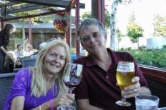

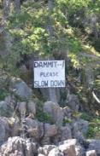
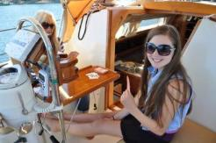
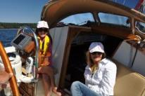
So it wasn’t a particularly restful night as waves from wind somewhere kept the boat bouncing against the docks. We were all awake at 0600hrs as we were taking some hard knocks. The flood tide was right for an early departure but we had to wait for the fuel dock to open at the Discovery Marina at 0900hrs. Natasha and I walked Tasha up to Tim Hortons’ for some cinnamon buns and croissants for breakfast. The warm wind was already blowing in Discovery Passage when we cast off to motored up to the fuel dock. 41 liters of fuel were taken onboard and by 0910 we were on our way out. A nice flood current boosted our speed over the bottom to almost 10 knots until we hit Cape Mudge where the huge countercurrent slowed us back down to 4.5. By 0930hrs there was enough wind to start sailing, which we did! A nice reach with main and Genoa and off towards Baker Passage we headed. Just around 1000hrs we heard Brent aboard Global Explorer calling someone on VHF 16. I called him and learned that they were just leaving Rebecca Spit and headed for Tenedos Bay, spending a couple of nights there. They should’ve been visible from where we were sailing, and they should have overtaken us eventually, but we never saw them. We did contact Henke aboard Aurora and learned that they were in Roscoe Bay and would meet up with us tomorrow at Elsworthy Island. Then I texted Don Cameron aboard Interlude as I understood they were up here as well. Don responded that they were at Refuge Cove and headed for Roscoe Bay today. We’ll probably meet them sometime up here as well. While all this was happening we were drifting through Baker Passage with a light westerly breeze over the beam and headed for the backside of Twin Islands. A bit of a gusty sail there but right to the entrance to Cortes Bay at noon, not bad for the first day with everyone on board.
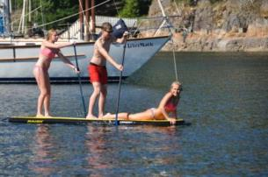
Cortes Bay is larger than I remember it. The Royal Vancouver YC and Seattle YC have large outstations at opposite ends of the bay. It looked like all those docks were full, or near to full. There were hardly any boats anchored out in the bay. We found a nice spot and dropped the hook in 35 ft of water with lots of room to swing. It was time to put up the sun tent with a helping hand from Natasha. The boat was sorted out and it was time to lay back and relax, watching the boats come and go. There were kids and adults swimming, paddle boarding and kayaking, there were boats coming and going, just a hub of activity. I took Tasha over to the dilapidated government dock that was filled with local boats, not somewhere you’d want to tie up to. Nowhere to walk once we were ashore either. And out of the light breeze it was very hot. Back to the boat!
I spun the boat on the anchor a few times, trying to get the breeze in the cockpit and keep the sun out. A Beneteau 50 that couldn’t get into the RVYC anchored quite close to us and eventually, as a breeze started to pick up from the west late in the afternoon, ended up being too close for comfort, right under our stern. Once the wind started to gust as evening fell he agreed to move further away to make the night a bit more comfortable. The smokies on buns for dinner were just right, filling when it was too hot to eat much else. We also cooked up some chicken for Tasha tomorrow. Tasha and I went ashore one more time and she surprised two small deer, and surprised her. She took off after them with no hope of a capture, but lots of fun. And that’s where we sit now. All on board are asleep, including Tasha beside me in the cockpit. It’s now 2315hrs and the wind is still rattling the rigging. Still not very cold although I do have a blanket over my legs. But I should be able to sleep well once I decide to hit the bed. Anchor watch for a while just yet.

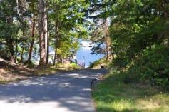
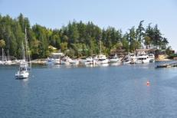

Monday | Aug-04 | Roscoe Bay | Campbell River
Chart 10 |  |  | 0524 | 1.8
 |  |  | 1308 | 3.3
 |  |  | 1630 | 3.0
 |  |  | 2309 | 4.0

Engine 3.3 Sail 1 hrs Distance 29 nm
2315hrs Natasha is back on board, the mosquito netting is in place and it’s almost bed time. It’s been an adventurous day! We’re not where we planned to be (Elsworthy Island) but rafted up with Aurora in Roscoe Bay. It’s still 22 c (74f) inside the cabin and the dew is just starting to drop after a blisteringly hot day. It should be a quite night with no wind to speak of. We can’t see the moon as it’s behind the mountain to the east. We had an early sunset (thankfully!) and will be one of the first boats to get the sun in the morning.
And speaking of mornings, this morning in Cortes Bay I found Tasha still sleeping outside in the cockpit, her head on the companion way sill, not a whisper of wind in the bay as the sun peaked over the low hills to the east. A lone mosquito and a full bladder forced me out of bed and Tasha and I rowed ashore to the community dock. No deer this morning as we walked along the deserted roadways. I noticed the rustle of wind in the trees and by the time we got back to the dock it was blowing a good 10 knots out of the NW, resuming the wind from last night. I made my coffee and had a few chocolate chip cookies while I read my book in the cockpit, waiting for the girls to wake up. That eventually occurred at about 0830hrs and I entertained them with “It’s a Beautiful Morning” by The Rascals, soon to be a morning ritual! We had bagels for our egg muffins and that proved not to be nearly as good as English Muffins.
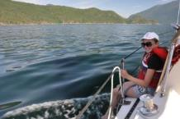
By 1000hrs we were sailing off the anchor (180 ft of rode!) and out of the bay through the narrow entrance. It was a pleasant sail to about Mary Point, the southern tip of Cortes Island, when the wind evaporated and the engine came on. Although the scenery was spectacular, the wind was notable by its absence and we motored all the way to our first destination, Elsworthy Island. It was busy! And Aurora wasn’t there! I called Henke on the VHF and learned that he was on his way from picking up supplies at Refuge Cove. I spoke to him about how busy it was and recommended Roscoe Bay instead. He was all for that as he had just come out of there this morning.
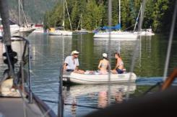
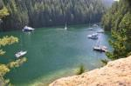
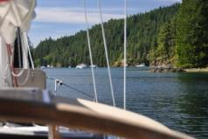
By 1400hrs we were motoring slowly over the shallow entrance into Roscoe Bay to find plenty of room to anchor and stern tie. Don Cameron and family were already here on Interlude as we set the anchor and tied ashore. Arora soon arrived and tied up alongside. It was hot! The sun tent went up and it was still hot! Not much of a breeze drifting through the anchorage. Henke took the girls up to Black Lake for a swim and I followed with Tasha for an afternoon walk. The lake water was warm and the girls had a great time. The Cameron’s were also there, also swimming with Tara. By the time we got back to the boat it was after five and the shadow of the steep hill was providing the first shade in the bay to the sterns of both Natasha and Arora. The girls jumped into the bay off the boat and I was forced to follow. After the first shock it wasn’t bad at all. Then it was showers all around and organize the boat a bit. What a disaster area! Henke took the girls for a dinghy ride while Carey & I prepared chicken wings for dinner and Kate made dinner for her crew. Once that was out of the way by 2000hrs I took the girls and Tasha ashore for a last walk. We climbed to the top of a steep hill overlooking the bay for some photos, then back to the boat to learn that Don and Karen were coming over with a bottle of wine.
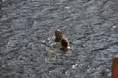
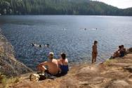
And that visit finished just before 2200hrs as darkness was falling. The girls were below on Aurora playing some sort of games. Carey went to bed and Kate, Henke & I talked about our boating past until just now. Natasha is probably already asleep as I hear nothing from up forward. Time to make my bed and get some shuteye before tomorrow dawns!

Tuesday | Aug-05 | Roscoe Bay | Campbell River
 |  |  | 0729 | 1.6
 |  |  | 1422 | 3.4
 |  |  | 1759 | 3.2
 |  |  | 2359 | 4.0

Engine 0 hrs Sail 0 hrs Distance 0 nm
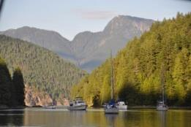
Midnight Another day already gone. The girls are just into the v-berth and the Tasha is asleep on the cabin sole. It’s not quite dark out yet as there is a ¾ moon just beyond the hill tops to the south east. Can’t see the moon, but can see the shadow. Henke and Kate were visiting in the cockpit while the Natasha and Helen were playing games and singing in Aurora, not wanting to quit even now.
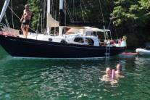
This morning started with a SE breeze rippling the waters of the bay. With the angle of our anchor and stern line we were getting pushed towards the shore, with Aurora being the closest. Once I’d taken Tasha ashore for her duties just before 0700hrs I cast off the stern line and pulled us into deeper water. All was well again even though no-one was awake yet. Then it was quiet time with a coffee and a good book. I was reading Randy Backman’s Tales from Beyond Vinyl Tap. Interesting look into the lives of the bands and individuals in the late 60s. By 0800hrs everyone was up and the anchorage was coming alive. We had a big breakfast of bacon, eggs and the hash browns. Very tasty and filling. Some enterprising souls had rigged a hose on a cliff, feeding fresh water from a stream into the salt water. I rowed over and filled up the empty shower bag for later in the day along with a 4 gallon water jug. A very neat set-up along the cliff where you don’t even have to get out of the dinghy (lots of oyster shells at low tide) and you just pick the hose out of the water and fill up whatever you want. I climbed back up the hill for a view of the anchorage in sunlight (photos and video) and Henke and the girls jumped off the bow of Aurora into the warm waters for a swim. The air temperature did not reach the stifling heat of yesterday and a little breeze continued throughout the day. The sun tarp did go up of course, and it was most welcome, but it wasn’t really, really hot. Lots of boats drifted out of the bay, new ones drifted in to replace them. Don and Karen left and one of the Stinky Boys, Rob on Cinnamon Girl came in. I took all the girls up to the lake for a swim and, yes, it was very nice in fresh water. We had steak for dinner although I suspect not everyone was that hungry. The afternoon and evening just seemed to wiz by and we didn’t really do anything, and suddenly the day was almost over. The girls went aboard Aurora for card games and music, Henke & Kate came aboard for some wine and chocolate. The space station came over again and all the stars came out. And that was it….
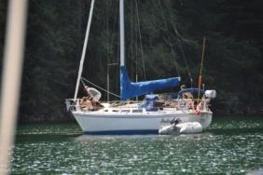

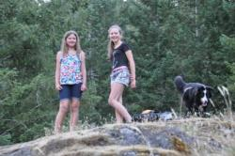

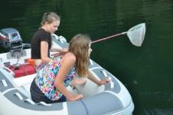
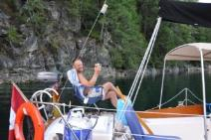

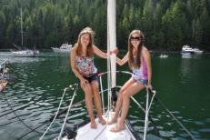

Wednesday | Aug-06 | Tenedos Bay | Campbell River
Chart 11 |  |  | 0827 | 1.3
 |  |  | 1519 | 3.6
 |  |  | 1919 | 3.3

Engine 3 hrs Sail 0 hrs Distance 11 nm

0730hrs There is a bit of cloud cover this morning as the tide continues to drop for another hour. We’re close to shore again with a SE breeze rippling the water, just like yesterday morning. I may have to cast off the stern line gain. Tasha and I have been ashore already, she’s getting good at in-out of the dinghy on shore, not so good at getting off the boat just yet. It’s a still-life aboard with everyone on both boats still asleep. I can hear a stream gurgling onto the rocks behind the boat and the occasional dog owner is rowing by to shore. We’re headed out of here today, Aurora starting the journey south and home, us going somewhere else, I haven’t decided yet. Probably over to Prideaux Haven which is only about 4 miles away, we’ll see how busy it is. Or we could go to Tenedos Bay, I just don’t know.
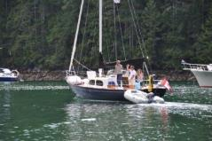
2200hrs The party next door is still rocking (old, drunk boaters from a three raft Comox Valley Yacht Club!). Not that there’s much music, but they have loud voices and its pretty quiet in Tenedos Bay at the moment. Carey has gone to bed and Natasha and I are having hot chocolate and chocolate chip cookies under the ¾ moon, waiting for the space station to glide silently across the sky. It should be soon.
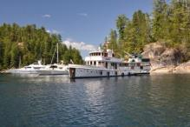
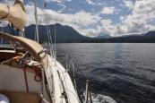
This morning was another partly cloudy start with a very light ripple on the water. We were in a better anchored position with the stern line and, although it was shallow on Aurora’s side, we still had water. The tides are getting lower in the morning every day! By about 1100hrs there was enough water over the bar to get out of the Bay and we cast Aurora off after our goodbyes. We raised the anchor and motored slowly after them, finding a minimum of 7 ft over the bar, lots of room. Then it was a very uneventful low speed motor over to Prideaux Haven, charging up the batteries and all the toys, checking all the e-mails and messages we couldn’t get in Roscoe. Lots of boats moving about but not enough wind to go sailing. At Prideaux it was like a white fiberglass jungle, huge power boats and lots of them. Into Melony Cove and we found Interlude anchored in the middle of even more boats. We tried to anchor way up at the head of the Cove but there wasn’t enough room to be comfortable. Off we went again, on our way to Tenedos and hopefully more space. We arrived just after 1400hrs to find enough space to throw a stern line ashore in about the same place we were all those years ago. And it was hot! Water temperature was 22.5c (74f) and that was good enough for Natasha & I, we were into the drink! Once over the initial shock (yikes!) the water wasn’t bad at all, very refreshing. We had lots of fun with contests that she came up with, mostly to do with her beating me to points around the boat! Fresh water showers followed on the foredeck, very warm and rinsing. Carey had a shower in the head. By that time it was cocktail hour, the day almost over! Time flies when you’re having all that fun!
Dinner was a plate of nachos under the small sun shelter. Natasha and I took Tasha for her last walk on accessible shore in the narrow passage between the small island and the main land. Natasha then powered us in a circumnavigation before returning to the boat. And that’s where we sit at the moment, waiting for the noise to subside next door. The last gensets have finally gurgled their last breaths for the evening and all should be quiet.

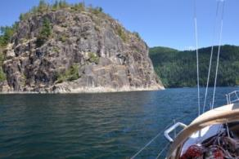
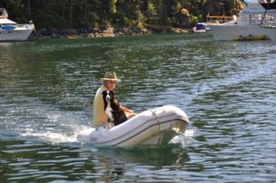

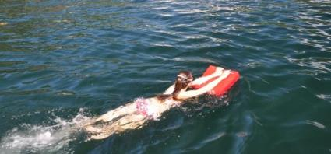

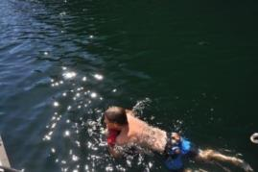

Thursday | Aug-07 | Tenedos Bay | Campbell River
 |  |  | 0102 | 4.0
 |  |  | 0919 | 1.1
 |  |  | 1607 | 3.8
 |  |  | 2017 | 3.3

Engine 0 hrs Sail 0 hrs Distance 0 nm

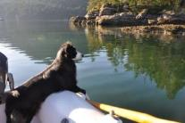
2330hrs Natasha just climbed into the v-berth on an absolutely perfect evening. No mosquito coil or netting tonight, open sky though the hatch. The ¾ full moon is reflecting off scattered clouds with not a ripple on the water. Every boat in here is dark and quiet. Natasha & I were sitting in the cockpit, her in my lap, watching the moon as the boat spun slowly at anchor. Stars popped out as darkness fell, the hot chocolate and chocolate chip cookies were perfect for the evening. We were again watching for the space station to slide by overhead, but she fell asleep twice before that happened! Tasha was asleep on the other side of the cockpit and Carey asleep up forward. It was magical just having her sleeping in my arms, watch the shore slowly revolve as zephyrs of warm wind teased the boat around. It’s too bad those moments don’t last forever!
This morning I got up to sunshine in the cabin and Tasha sleeping outside in the cockpit. I rowed her over to an accessible shore (lots of shells at this low a tide). She did her duty while I watered a tree in the dense forest. There were a few scattered clouds around and it was already warm. Back onboard I noticed a very large, flat rock close alongside to starboard! It was too close for comfort and with the tide still dropping, a real danger! A light breeze was drifting in from port, pushing us closer. Really no choice, I waited for a lull in the breeze and then cast off the stern line, pulling us out of danger with the anchor rode. The interesting thing is that the rock is not listed on the charts and there is a stern line eye on shore close to it! A bit strange that it’s not shown on the chart, and Provincial Parks put an eye there. Then it was coffee time.
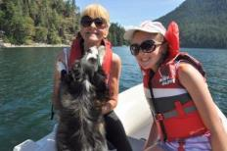
The girls eventually got up (something about somebody trampling on the cabin top) and we worked our way through a scrambled egg breakfast (eggs, peppers, onion, back bacon!). As we weren’t going anywhere and I wanted to wait for a rising tide to go to Unwin Lake, I got into a book and the girls got into doing their hair. This is, of course, after organizing the boat and trying to remove as much dog fur as possible, an everyday event! During that time we also moved the boat. A good number of anchored boats left for other destinations and before the next set arrived, we anchored out in the middle, no stern line. Perfect spot!
By 1300hrs we were all in the dinghy headed for the other end of Tenedos Bay and the trail to the lake. The little Yamaha started overheating as we arrived, an ominous problem for the return trip. But I’d worry about that later. Up to the lake we went, the trail being easy enough although a bit mucky. The lake was as spectacular as always with not many people in the water. We found the ponds on the way back and I took some photos of Natasha and Tasha at the pond where Carey and Nicky were photographed all those years ago. Back to the dinghy and sure enough, the Yamaha wasn’t pumping any water! I rowed all the way back to the boat, about as far as I’ve ever rowed that little boat with a full load! At least the water wasn’t too choppy.
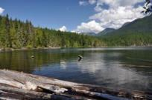
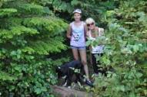
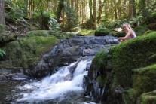

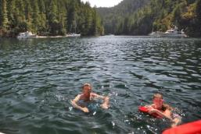
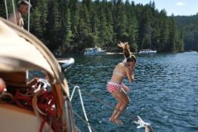
We were back by 1600hrs and it was time for a swim again. The water seemed colder this time and the initial shock was as tough as it always is. But once in, it was great with more water games around the boat. Showers on deck were most welcome and by then it was cocktail hour. A game of Cribbage in the cockpit with chips and drinks, and it doesn’t get much better! Natasha & I calculated our time to Lund for tomorrow, using the old fashion charts, dividers and a bit of math. She picked up the principles very quickly! The barbeque was lit about 1830hrs and the ribs and salad were great, more than filling enough. Natasha & I took Tasha for her last walk and then it was relaxing time (not that we hadn’t been relaxing!)
And now it’s after midnight on a perfect evening and it’s time for bed. Good night Mary Ellen!
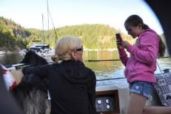

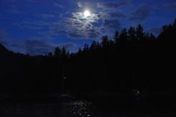

Friday | Aug-08 | Lund | Campbell River
Chart 12 |  | Supplies | 0209 | 4.1
 |  |  | 1007 | 0.9
 |  |  | 1650 | 3.9
 |  |  | 2108 | 3.2

Engine 3.7 hrs Sail 0 hrs Distance 13 nm
1600hrs The girls are just back from showers, smelling like clean hair. We’re tied up at Lund with a Yamaha 30 rafted up alongside. Apparently it’s going to get busy this evening so they’re rafting boats up early! All the groceries have been purchased, the large bag of garbage has been taken ashore. The laundry is all fresh again and the boat has been washed. We’re ready to go again! Oh, yeah, we have dinner reservations at the Lund Hotel. We’re here for the night!
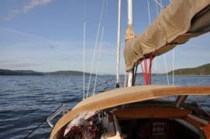
This morning we were going to get up early to catch the tide in Thulin Passage to Lund. Arrival had to be before noon, preferably by 1100hrs. Tasha and I went shore just after 0700hrs and did our duties again, a very quiet morning. Back to the boat and the girls were already up. We were out of tea so Carey had to have a coffee with me (she prefers tea, especially after my coffee!). I started the cinnamon buns in the oven and then got ready to haul the anchor. It was stuck under something! I had to use the engine quite
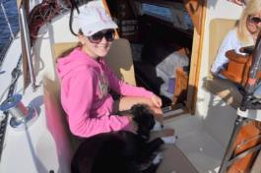

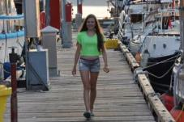
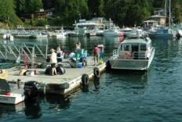
a bit, with lots of power, to get the bow to finally spring up as the anchor let go. Good thing it did. No damage done. Then it was simply powering for 2.5 hrs to get us here. There was a bit of a breeze from the west, right on the nose, but I just powered on through. We arrive just before 1100hrs and tied up on C Dock, the commercial dock. Then the work began! The girls went shopping with Tasha while I washed two weeks of salt off the decks and cleaned up the dinghy. Vacuumed the dog hair out of the interior and did some organizing. The afternoon seemed to hurry by as we watched boats come and go, water taxi’s running over to Savery Island, and a Beneteau 30 get rafted alongside. I guess they were anticipating a busy night. The couple next door were very quiet and kept to books, keeping to themselves.
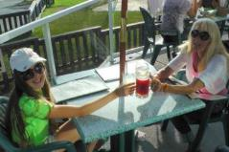
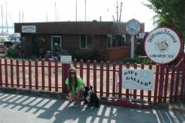
We ended up at the hotel on the deck for dinner, a bit of a lack-luster affair with poor service and mediocre food. Next time we’ll the restaurant on the board walk!

2200hrs Inside, zapping mosquitos! Quite the number made it into the cabin during the evening and I’ve been zapping them since! Carey is in bed (complaining) and Natasha is soon to follow. It’s about as cool outside as it’s been the entire trip, not that it’s cold. The docks are quiet tonight, the people next door are below. The full moon (or close to it) is hanging in the eastern sky, but hidden by the large power boat next door. The sunset, which promised to be spectacular, never lived up to its promise. The dinner at the Lund Hotel was over-spiced and underserved. Oh well. Not every night can be perfect.
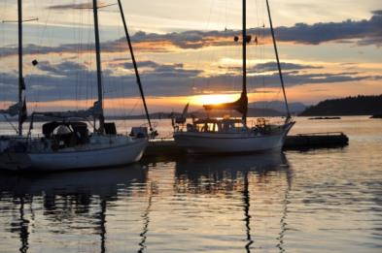

Saturday | Aug-09 | Squirrel Cove | Campbell River
Chart 13 |  |  | 0312 | 4.1
 |  |  | 1050 | 0.7
 |  |  | 1729 | 4.0
 |  |  | 2159 | 3.0

Engine 2.2 hrs Sail 1 hrs Distance 13 nm
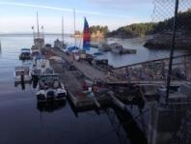
2330hrs Another extraordinary day! Natasha and I are just in from the cockpit, Tasha is sleeping out there tonight. It’s perfectly calm and quiet in Squirrel Cove with a full moon beaming down through high, wispy clouds. The human noises have all quieted down and nothing disturbs the silence. A near perfect night!
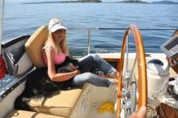
This morning I took Tasha for a walk at 0700yrs through the “village” of Lund (actually just the Hotel and the now defunct boat yard). She got to run and I got to see a sad state of repair of most of the buildings. Obviously this place needs an influx of money. Although the bakery was open there were no customers as yet, and no boats were moving in the marina. That changed soon enough as the commercial guys came down the dock and started the clang & bang around in their aluminum boats. And then at 0730 some guy in a 30 ft Bayliner starts up his big diesel and just sits there, doesn’t go anywhere, lets the rumble continue for about half an hour and then turns them off! Nice! The girls were up by 0815hrs and, after organizing the boat a bit, Natasha & I were off to the bakery to pick up a loaf of bread and some cinnamon buns for breakfast. Very filling and very tasty! Our “rafters” were soon on their way, headed for Refuge Cove (sounds like they go dock to dock all summer!) and we got the boat ready for the trip up to Squirrel Cove. The big ebb finished about 1100hrs and we started north through Thulin Passage on the start of the flood. No wind of course, so it was power against a long line of large, high speed power boats with enormous wakes! Tasha would just get comfortable in the cabin when we had to crash through another series of wakes, causing her to scramble into the cockpit again. I even made a comment on the VHF about their lack of boating educate, not that it would make much difference! But there were enough comments that it was obvious I wasn’t the only one dismayed.
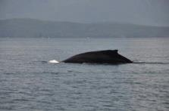
By about 1300hrs we were approaching Squirrel Cove, still under power, when we heard the very distinctive sound of a whale spouting! And close by! It took a few moments to look around and there, not more than a 100 yards off the starboard beam, was an enormous whale right on the surface. I immediately stopped the engine and we drifted in for a closer look. Natasha and I were debating if it was a Humpback or Grey and settled on the Humpback. For the next hour we sailing around under jib,
taking video and still photos as “Mr White” (as we called him) fed on the bottom 450 ft down. And we had him all to ourselves, which was quite nice. There were many boats passing by in the sound, but other than a small aluminum skiff that stayed well away, no other boats came close. Carey had Natasha send iPhone video to Cathy, Ena and Trisha, the video turning out not bad at all.
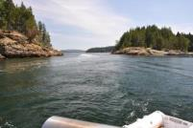
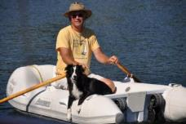
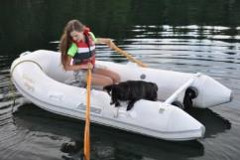
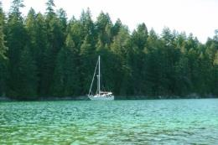
Eventually we drifted into Squirrel Cove and set the anchor in the small channel behind the island in the center. Although it was warm out, it didn’t get overly hot with a nice SE breeze ruffling the water. The small sun tent went up and Natasha played hairdresser again while I dozed in the cockpit. Didn’t feel like a long time but I was out for 45 minutes! Natasha & I rowed over to the flooding lagoon, not risking a row in! We took Tasha over to the island for some running time, and then it was cocktail and appies in the cockpit. That, of course, led to bacon wrapped steak with fresh salad for dinner. Delicious, in a perfect setting. When the dishes were all cleaned up Natasha & I rowed Tasha over to the island for the last run. Then it was a comedy of errors trying to get back into the dinghy! I had Tasha get in, then Natasha, then I climbed in. But the tide had dropped a bit and we were hung up on a rock. While I was trying to get us free Tasha casually stepped back out of the dinghy onto the rocks! We told her to get back in, which she did, as I continued to try and push us off the rock. She climbed out again! By this time we were both laughing hysterically! I finally got us clear and all three of us made it back to the boat. By the time that was all done the evening was over except to the full moon with hot chocolate and chocolate chip cookies. And, of course, the space station cruising by overhead. And we’re just done that and now it’s off to bed. I’m leaving everything open tonight, no mosquitoes, no wind, a perfect evening.

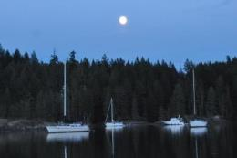

Sunday | Aug-10 | Teakern Arm | Campbell River
Chart 14 |  |  | 0409 | 4.2
 |  |  | 1129 | 0.7
 |  |  | 1807 | 4.1
 |  |  | 2252 | 2.9

Engine 1.1 hrs Sail 2 hrs Distance 10 nm
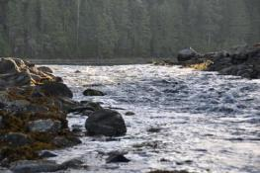
0800hrs All are still sleep as I update the log in the sunny cockpit. Tasha is stretched out on the cockpit sole in the shade, already asleep again. Yes, it was a perfect night with the full moon shining into my eyes whenever I cracked them open. Tasha spent the entire night outside, sleeping on a small cushion I left out there for her. The sun is already hot this morning with a light NW breeze just starting to ruffle the water. Tasha and I have been ashore and even rowed over to the lagoon for a look at the full ebb. The coffee is made and the anchorage is just coming to life. There is an American Bayliner 4577 called Obsession with a very annoying genset that he ran late last night and now early this morning. It’s time to get the girls up!
2300hrs The full moon is hanging in the clear eastern sky over the mirrored waters of Teakern Arm. It’s very quiet now, all activity has ceased. The girls are in bed up forward, Tasha is asleep in the cockpit beside me. Other than the incredible heat of the mid-afternoon, the day was near perfect.
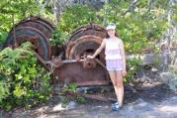
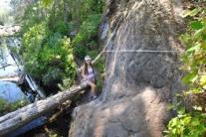
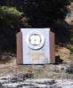
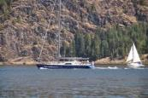
We raised the anchor in Squirrel Cove at about 1100hrs with a light western breeze ruffling the cove waters. We powered slowly to the entrance and once outside raised the sails and cruised out on a very broad reach into Lewis Channel. The westerly was coming down the channel and so we tacked against the wind and tide along with a few other sailboats. Lots of power boats around again as well, lots of big wake. We sailed most of the way to Joyce Point and then reached up Teakern Arm towards Castle Falls. The very limited anchorage was busy, but we managed to get a spot not too far from the (new to us) dinghy dock. The anchor went down in 50 ft of water and we backed up to the beach with a stern line ashore. The sun tent went up immediately! It was already 1400hrs by then and after a short moment of relaxing (and a game of Uno), Natasha and I went ashore with Tasha. The “dinghy” dock was busy with lots of dinghies and, of course, a 20ft runabout! A bit crowded! Anyway, up the trail we went. I’d forgotten just how tough this trail was! It was vertical and a challenge! Natasha didn’t seem to have any problem, and neither did Tasha. She ran forward and back more than once! The view on the ledge at the top of the falls was spectacular, and the lake was pretty with only a few people there. We weren’t planning on swimming today, just having a look. And it was hot for the return hike. Back to the dinghy then, and a row to the foot of the falls where people were having showers!
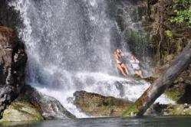
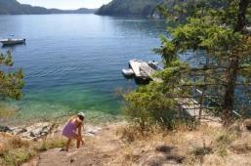

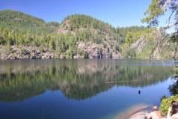
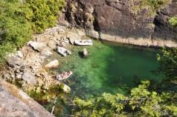

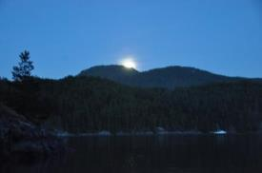
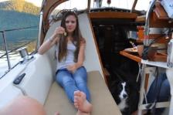
Eventually we rowed back to the boat for cold drinks. The temperature inside the cabin was 33.5c with not a whisper of a breeze. Hot! We waited for the sun to dip behind the trees and then, once the sun tent was down, took refreshing showers! Felt so much better. The temperature didn’t drop much and none of us was hungry enough for the steaks we were planning. I made up a plate of cheeses and crackers and that was dinner! Tasha was taken to a nearby beach for a brief walk and that was it. Oh, and the Canadian navy showed up in the form of two Coastal Patrol Vessels (59 & 60) who stern tied near the falls. We’re very fortunate where we are anchored as we have a tall headland between them and us. Once around the corner of the headland in the dinghy we can hear generators and see their radars still on. It will be a noisy night for the boats anchored nearby. And they will probably leave early in the morning, pulling up hundreds of feet of heavy chain. In the meantime, the sun finally set and the full moon climbed over the eastern hills as the sky darkened. Natasha & I rowed over to the navy vessels in the dark, checking them out under the full moon and perfect rowing conditions. There was even a meteor that blazed right over the patrol vessels. We both saw it, and thought it was a flare shot off by the navy boats! Now it’s time for bed.
Monday | Aug-11 | Refuge Cove | Campbell River
Chart 15 |  |  | 0503 | 4.2
 |  |  | 1204 | 0.8
 |  |  | 1845 | 4.2
 |  |  | 2353 | 2.6

Engine 2.1 hrs Sail 0 hrs Distance 10 nm
2140hrs Tied to the dock at Refuge Cove with an overcast sky and a threat of rain. Thunderstorms, actually, but I doubt that they will develop into them. The air is still and sultry with a few rain drops reaching the water. It was a very hot day and the inside of the boat is still very warm. The temperature hit 35c today with no wind to speak of, much too hot to be tied to a dock in the blazing sun, but this is where we are. The girls are getting ready for bed and I’m not all that far behind.
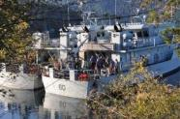
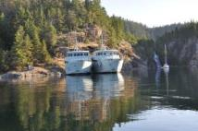
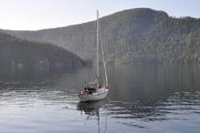
This morning I woke at the usual 0700hrs with no sun in the boat. Curious, I found that the steep hill and trees to the east of us were blocking sunrise. Everyone else already had sun in the cockpit! Off to shore I went with Tasha to the rocky beach just to the west of us. After doing our duties I rowed over to where the Navy was gearing up to cast off their stern lines and raise their anchors. Tasha and I went ashore at the dinghy dock and climbed up to where their stern lines hit the shore, watching their preparation. That was taking forever so I rowed back to where we were anchored and climbed the hill behind the boat, capturing some nice photos of the still water and boat. Eventually the Navy vessels slowly made their way out of Teakern Arm and I rowed back to the boat. It was 0900hrs by then and the girls were just stirring in the v-berth. Eventually breakfast of egg muffins was enjoyed in the sunshine of the cockpit and we got ready to cast off our stern line and raise the anchor. Fortunately, no drama of a stuck anchor and, after motoring over to the falls, we departed on our course for Refuge Cove.
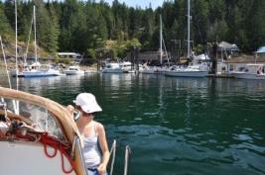
Absolutely no wind to speak of and we motored the entire way, only an hour and ¾ s from anchor up to arriving on an ebbing tide. Refuge was busy as always, and we ran into Tom Forest on Capi anchored out in the bay. We managed to find dock space and tied up next to a Catalina 355 called Koowabunga, a young family from Seattle. Natasha and Kay got along well and went out paddle-boarding for a while. The afternoon heat enveloped the boat under the sun tent. The girls went shopping, Natasha and I got ice cream (tasty) and boats came and went. Clouds began to roll in from the west and finally covered the blazing orb and we could take the sun tent down. Dinner of steaks and a fresh, green salad was very tasty as darkness fell. No watching the sunset tonight, no space station drifting by, no full moon rising in the east. The skies are completely clouded. So it’s off to bed. The girls are now tucked away and I’m just about to do the same.
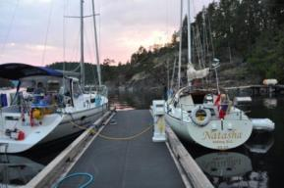
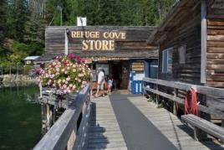

Tuesday | Aug-12 | Gorge Harbour | Campbell River
Chart 16 |  |  | 0558 | 4.1
 |  |  | 1238 | 1.1
 |  |  | 1923 | 4.3

1720hrs Anchored in Gorge Harbour, east of the marina and all the other anchored boat. Lots of room around us, the anchor is down on a small hump on the bottom, 40 ft instead of the usual 60 ft in the rest of the harbour. We were hoping to get a spot at the marina and called, but they’re full again tonight. Good thing we have reservations for tomorrow night! And it rained today! After all that sun and heat over the past few days the cooler temperatures are a bit of a surprise. We’re dressed in jeans and sweaters today after trying to avoid clothes all together yesterday, looking for shade! Quite the change.
Last night was one hot night, the temperature never did drop and the inside of the boat hardly cooled off. The 0700hr shower this morning was most welcome to get some of the damp off the skin. Not much was moving at the docks at that time. The girls got up and to the showers just after 0800hrs, just before the major influx of sail and power boats coming into the docks from wherever. Talk about getting busy early! The majority would be here just for laundry (long line-up by 0830hrs) and supplies, guys having ice cream at 0900hrs in the morning! I organized the boat a bit, swept up another dog in fur on the sole, while the girls were up showering. After that it was simply casting off and powering over to the garbage barge ($5.00 for the bag) and then out of Refuge Cove.
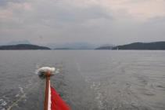
There was a bit of a westerly wind in Desolation Sound and I raised the main in the hopes of getting some sailing towards Manson Landing. The wind stayed light and we powered on while I made breakfast underway. Down around the south end of Cortes Island and then north towards Manson Landing, the tide behind us all the way, but flat all the way as well. The clouds moved in as well with the weather report now indicating the potential for thundershowers in the afternoon.
Arrival at Manson Landing was a bit of a disappointment. A collection of near derelict boats occupied the public dock and as luck would have it, Pallas Athena was rafted to a boat already tied up and we rafted to her. Daniella was aboard and getting ready to hike up to the store. We just wanted to have a look around the park as the anchorage and docks are completely exposed to the south west, the direction the wake of every boat going into Gorge Harbour would come from. That, and the promise a south-east wind with the showers, convinced me to have a look around the park and then go to Gorge Harbour for the night. So we did, clambering over two rafted boats to the dock (I took Tasha by dinghy) and then walking over to the lagoon. The tide was very low and still falling so it didn’t look very pretty. There were many people around as the clouds started to sprinkle lightly. Time to go.
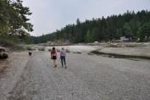
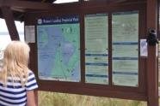
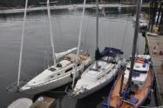

We motored the half hour over to Gorge Harbour and dropped the anchor. The skies have lightened a bit and it’s not raining anymore. The tarp is up and we’re dry underneath.
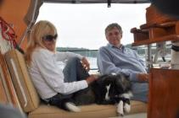
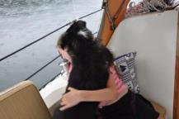
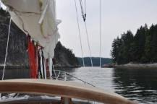

Wednesday | Aug-13 | Gorge Harbour | Campbell River
 |  | Supplies | 0227 | 2.4
 |  |  | 0656 | 3.9
 |  |  | 1316 | 1.4
 |  |  | 2001 | 4.3

Engine 0 hrs Sail 0 hrs Distance 0 nm
0730hrs Just back from our morning walk, in a wet grass playground and sand volleyball court. Tasha was somewhat covered with sand after I threw the ball more than a few times! The girls are still asleep and a few boats have already left the marina. It’s still cloudy out but there are large patches of blue sky around and the sun will eventually make an appearance.
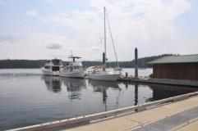
Last night the sprinkles stopped and it ended up being a pleasant evening under the tarp. Dinner was barbequed chicken (half for Tasha!) with pasta and a fresh salad. Very good. Then Natasha & I took Tasha for a walk from the community dock, a dock where there was literally no room to tie up a dinghy! Up the road we went, past the community hall and small park, to the cross road and then down the long driveway to the resort. I’d forgotten about the RV park, and it was packed. The RVs were so close together who would want to stay there to “enjoy the great outdoors”! We had a quick look around, not much has changed, and then all the way back, up and down the hills. We were both tired after that, the dog wasn’t of course. And then this morning with Tasha’s walk I find the shortcut through the small park. In fact, I’m sure the small park is part of the marina resort! Oh well, we needed the exercise anyway! Later in the evening, after Carey had gone to bed, Natasha and I were relaxing in the cockpit, lamenting that the moon would not be visible tonight because of the cloud cover, when the orange globe peered up over the low mountains to the east, under the clouds! Very nice. There were even a few stars out, between the dissipating clouds. Eventually, once the chocolate chip cookies were enjoyed, we too were tied enough to climb into bed.
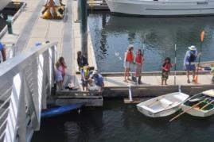
This morning we’ll wait till about 1000hrs to see if our space is available at the docks. We saw Kookaburra come in last night and so I’m sure Kate and Natasha want to meet up again. There is a pool here as well so it should be a good day. The holidays are drawing to a close soon. Tomorrow Rebecca Spit and then it’s the drive home from Campbell River on Friday, already!

2200hrs Not a whole lot happened today, as predicted. I called the marina and by noon we were tied up just inside the fuel dock. Very good service, friendly and certainly knew what they were doing. Cost $53.00 for the night, not bad for a resort in the middle of summer. The rest of the day was spent hanging around the resort and the boat. Natasha ended up not swimming because of her period, so the pool wasn’t used at all. We made reservations for dinner at the much ballyhooed restaurant, and yes, it was good. The weather was warm enough that the sun tent stayed up most of the day, only coming down when the girls went for a shower and the wind picked up a bit. Lots of boats came in (full again) with a number of power boats from SNSYC. Of course, they were all large and none of them even acknowledged that we existed, even the one parked right next door. It’s quiet out now with the exception of the small kids on the boat in front of us, who are arguing with their mother, who is shushing them to be quiet but not too successfully. Time for bed.
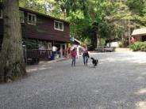
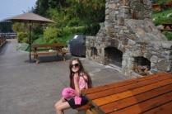
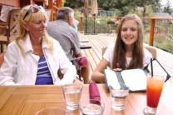

Thursday | Aug-14 | Rebecca Spit | Campbell River
Chart 17 |  |  | 0322 | 2.1
 |  |  | 0759 | 3.7
 |  |  | 1358 | 1.8
 |  |  | 2042 | 4.3

Engine 2 hrs Sail 0 hrs Distance 9 nm
0700hrs Tasha and I have already been for our walk, the last full day of the girls’ vacation. Its part cloudy this morning with not a breeze rippling the water. Other than dog walkers, no one is up yet. We’ll take our time heading out of here this morning and make our way to Rebecca Spit for the last day on the water. Marc is not coming out next week for the return trip so I can start making plans for taking stuff off the boat. I may have to get a bigger car!
2330hrs It’s flat out now with zephyrs of a breeze drifting in from every direction. The glow of Campbell River is obvious in the western sky with no moon visible through the trees of Rebecca Spit. Natasha and I are just in after watching the stars come out, catching the occasional flash of a lightning storm somewhere over the strait to the east of us. We both managed to see the streaking meteor as well. Earlier there was a commotion on the water, like rain or small waves, quite distinctive. I got a flashlight out and found it to be thousands of small fish going after even smaller fish near the surface, splashing as they rocketed out and fell back in. Quite fascinating. Natasha was thrilled to see it, visible even with the flashlight off. The girls are now girl talking up in the v-berth, Tasha has her head hanging in the companion way, watching me type. A near perfect evening, contrary to the forecast.
This morning, after everyone was up and breakfast was out of the way, we found (in a smelly way!) that the holding tank was full! Yikes! At 0900hrs we were away from the dock and running for the entrance to Gorge Harbour. Just outside we pumped the holding tank empty. I’ll have to replace the vent filter now, but it was due anyway. There was no wind as we powered through Uganda Passage and into Sutil Passage, headed for Rebecca Spit 7 miles away. But the sun was shining and it was getting warm again, contrary to the forecast. While powering across I could see Canadian Warship 710 (Frigate) coming up from the south at speed, crossing behind us. He called up an opposing trawler by name, switched to VHF 68 and then questioned him regards to flag, last port, destination, etc. before letting him carry on. Interesting.
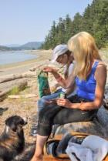
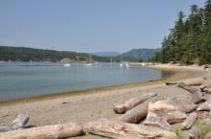
We rounded the corner of the Spit around 1100hrs to find quite a few boats at anchor, more than I expected. The anchor was soon down about half way along from the point and, with a very low tide, the beach was very wide. We all climbed into the dinghy for the short ride to shore and a hike along the trails of the park. Tasha, I’m sure, enjoyed them the most! Natasha wanted to make mud pies on the beach so she, by herself, she went back to the boat to get the bucket, some cans of pop and a bag of chips. We spent some time on the beach, sitting on the logs in the shade.
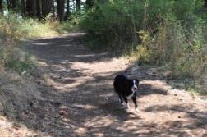
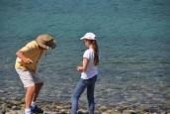

Once back to the boat it was nap time and eventually prep for dinner, salmon and pasta, which was very tasty. A double bus load of summer campers showed up at the park just before dinner, and as a group of kids, were as loud as they get. At least they were gone by sundown, a very pretty sunset.

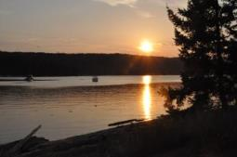
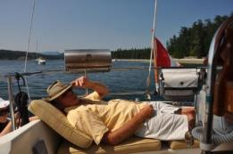

2340hrs We have a SE wind whipping up big time as I was writing this. I guess I’ll be up for a while! Time to go on deck to see what’s happening.
0400hrs It’s been an eventful night! First the strong wind whipping up with some worry about pulling the anchor loose., I let out another 60 ft of rode and, as we’re somewhat close to shore, I set the depth alarm for 10 ft. Then, at 0130hrs the wind died. Into bed I crawled, fully dressed. There was a thunderstorm rumbling by to the south east, probably right over Desolation Sound. A short time later, and a bit uncomfortable, I got up and stripped down, back into bed, dead calm outside. A bit later the depth alarm went off. It still showed over 10 ft (13 ft trigger) deep. That kept repeating and I got tired of getting up to check so I turned it off. Still no wind and pitch black outside. A little while later, still a dark grey sky but I couldn’t read the clock, I head a crunching sound in my sleep and the boat gave a jolt. Aground?! Up I got (again) and noted a light breeze from the SW pushing us onto the beach. Not good! Got dressed (sweatshirt on backwards) and pulled in a bunch of rode and turned the sounder back on. Pulled us back into 14ft of water. The tide has dropped a lot and the beach is close and very wide. It’s been a great night so far. Back to bed.

Friday | Aug-15 | Campbell River | Campbell River |  | Seymour Narrows
Chart 18 |  | By noon | 0415 | 1.9 | 0314 | 0614 | +11.4
 |  | Car Rental | 0913 | 3.5 | 0930 | 1232 | -10.5
 |  |  | 1446 | 2.2 | 1531 | 1828 | +9.5
 |  |  | 2124 | 4.2 | 2132

Engine 2.6 hrs Sail 0 hrs Distance 14 nm
1100hrs All packed and ready to go. The rental car (Toyota Camry) is in the lot and loaded up. At least there was a break in the rain and everything got to the car still dry.
The rest of the early part of the morning was peaceful, although short. I woke up at 0600hrs to the sound of rain falling on the roof. My bladder was also ready to burst! So up I got again, get dressed, and take Tasha ashore. She’s getting good and doing her duty right away. I pick my tree, she picks hers. Not that she liked the rain at all, she was happy to get back to the boat. The girls were up and getting organized. I climbed into full rain gear after getting coffee ready and muffins into the oven. The anchor was soon up and by 0700hrs we were underway. It was 13 miles to get around Cape Mudge and into Campbell River with a medium size ebb helping us around the corner. No wind at all but there was a left-over swell from the SE that we had to work against. It wasn’t all that bad, the weather channel reporting 15 knots further south in the strait. The coffee was hot and the chocolate muffins tasty as we motored south. The buss heater also worked inside the boat, keeping the girls warm. We had some communication trouble getting into Coast Discovery Marina. Apparently the dock manager’s return calls were going direct to voice mail. Anyway, we got into a good slip and now we’re ready to go.
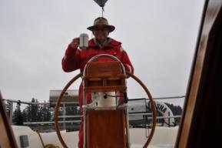

Saturday | Aug-16 | Campbell River | Campbell River |  | Seymour Narrows
 |  | Supplies | 0510 | 1.7 | 0403 | 0708 | +10.6
 |  |  | 1036 | 3.4 | 1029 | 1328 | -9.0
 |  |  | 1542 | 2.6 | 1629 | 1922 | +8.3
 |  |  | 2208 | 4.1
2100hrs The sun has long since set behind a few clouds in the western sky as I sit at the marina in Campbell Rive. It’s been a long but pleasant day.
Yesterday we were home after a long, wet drive by 1430hrs. Natasha was soon asleep in the back seat and I really wanted to be asleep in the front seat! It rained until about Nanaimo and then dried. The laundry got done and organized, we had showers, and the car was loaded up for the return trip in the morning. Then we went to the Club for Friday night dinner, all in a bit of a zombie state. Not enough sleep the night before! The alarm went off at 0500hrs this morning and I took Tasha around the block. Goodbyes were said and I was off by 0530hrs. I had to get the car back up there by 1100hrs as that was when we rented it yesterday. Not much traffic and I was flying along under cloudy skies. By Nanaimo it was beginning to clear and by Courteney the sun was up behind me. I pulled into the Thrifty’s lot in Campbell River at 0830hrs, not bad timing! Pick up groceries for the boat, drop them off at the boat, load up the ice and pack the icebox. Then drop off the car at 0945hrs and, on the return walk, drop by the library and pick up a fresh load of books. Then it was clean-up time. That took most of the rest of the day! I brought up the small shop vacuum and used it to try and remove as much dog fur as possible! Make the bed, clean the cockpit cushions, wash out the cockpit and the rest of the deck, let alone the dinghy, and it was after 1600hrs before I was finished. I also replaced the holding tank vent filter and had to walk over to Ocean Pacific Marine to replace a small section of hose. The sun was hot again with temperatures inside the boat reaching 30c again! It was beer time and into a couple of magazines from home as the sun started to slide to the western horizon. Dinner was at Dick’s Fish & Chips at the dock here, took forever to get one piece of halibut for takeout! Now it’s almost dark already and the air is cooling down rapidly. It will be an early night tonight!
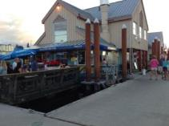
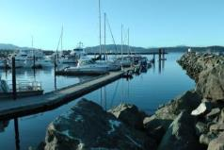
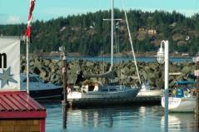

Sunday | Aug-17 | Sturt Bay | Campbell River
Chart 19 |  |  | 0609 | 1.6
 |  |  | 1204 | 3.4
 |  |  | 1649 | 3.0
 |  |  | 2255 | 3.9

Engine 2.5 hrs Sail 5.5 hrs Distance 36 nm
2030hrs The sun has fallen behind Texada Island and I’m tied to the docks at the Sturt Bay Boating Club. The cool air has finally forced me back into jeans and a shirt. It was another hot day today, reaching 30 c in the cabin late this afternoon. Certainly can’t complain about the weather this year!
This morning it was a shower just after 0600hrs, before the rush of other boaters who were also up early. Then off to the bank for some cash and breakfast at the Whitespot. Would you believe, the only customer in the place for the entire hour I was there, reading a Province newspaper. The tide was flooding all morning so there was no hurry to leave the marina. By 0810hrs I had cast off and headed for the fuel dock. 31 liters of fuel and two bags of ice and I was ready to start heading south. The flood certainly helped in that direction. It was in full force and boosted my speed by about 5 knots over glassy water, no wind to speak of. There was a Beneteau 50 coming up behind me, also headed for Cape Mudge, obviously overtaking at almost double my speed. He stayed close to Cape Mudge and encountered the big back eddy slowing him down. I saw where the tidal stream was running out in the middle of Discovery Passage and passed him! He worked his way back in my direction and then motored by me in the current. I saw the disturbed water off to port and crossed behind him, headed in the direction of Savory Island. Sure enough, I almost passed him again as the flood just kept going into the strait. Absolutely flat 12 c water. Then the strait water line appeared. Although a bit of current remained, suddenly the water changed to a greener hue and the temperature began to rise, eventually reaching 21.7c as I neared Texada Island.
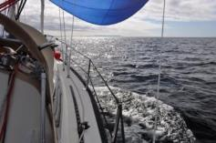
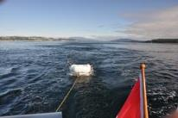

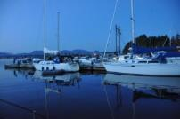
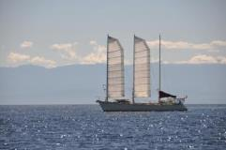
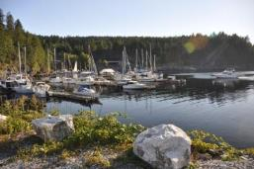
The NW wind finally showed up as well and the spinnaker went up. For a while there I was going 5+ knots on a very broad reach, headed straight for Sturt Bay according to GPS, 27 miles away. But the wind eventually lightened and I had to harden up to maintain any kind of speed. It was a pleasant drifter all the way to the north side of Harwood Island where I gibed and headed back towards Texada. The wind really died then with glassy smooth water and 9 miles to go at about 1400hrs. Time to motor a bit. Once I turned the western corner of Harwood Island the wind came back up a bit. I was too hot and tired to bother with the spinnaker again so the jib was rolled out to sail slowly right to the entrance to Sturt Bay. Nice little sail. The weather forecast for 1600hrs indicated a strong wind warning for later tonight and tomorrow morning, wind from the west at 15 – 20 knots, easing tomorrow afternoon. That got me to contemplating tying up at the boat club instead of anchoring. There was enough space at the club so the fenders went out and the mooring lines prepared. Once secure it was already after 1600hrs and hot! And I hadn’t put any beer in the cooler! A cold rum & coke solved that while other boats pulled into the docks, almost all sailboats. The boat next to me, a Dana24 with a young couple on board are on their way back from four months aboard, to Alaska and back! They went up the outside of Vancouver Island and have been on the road since early May! Yikes! She is a lightkeeper at Cape Beal of all places!
The rest of the afternoon was snacking and reading after the sailing cleanup. It’s an alright little marina, nothing here with not much to go to, but it’s in the right place. And at $0.70 per foot, a good deal. It’s now already 2130hrs and the mosquitoes have chased me inside. I can’t recall this many two weeks ago when I was last here!
Monday | Aug-18 | Smuggler's Cove | Point Atkinson
Chart 20 |  |  | 0650 | 1.5
 |  |  | 1412 | 3.9
 |  |  | 1907 | 3.2

Engine 0.9 hrs Sail 5.5 hrs Distance 31 nm
2030hrs Full cloud cover tonight with just a hint of the remaining breeze, warm as it is. Dinner of steak and Caesar salad was very tasty and the clean-up is done. Soft music and a relaxing evening, a perfect ending to the day. I’m anchored in the furthest bay at Smuggler’s Cove with four other classic sailboats and one aluminum catamaran from Seattle. The crew on that one left with a dog in a canoe when they arrived and haven’t been seen since.
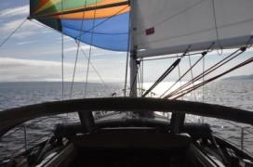
This morning came to light with the sun beaming through the portholes, it was already after 0700hrs! The predicted strong NW winds never developed on this side of Texada, there was just a whisper rippling the waters in the bay. The morning coffee and honey cake was perfect as the rest of the world came awake. Harbour Air arrived with a Beaver, looking for passengers and a place to dock. That all worked out and he was soon away again. The real breakfast of egg muffin was prepared and cleaned up. A wind was developing out in Malaspina Strait and the prediction was for 10 – 15 in the morning with the winds easing in the afternoon and then strengthening again in the evening. The tide was ebbing till about 1100hrs so I figured an early start was called for.
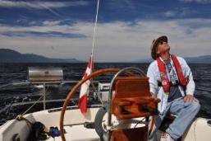
By 0830hrs I had cast off and was slowly motoring out of the bay. The mainsail was soon up and by 0900hrs the spinnaker was up as well. A light NW wind was aiming me down Malaspina Strait towards the white water tower on a very broad reach. Perfect! I was planning on the Hardy Islands or, better yet, Pender Harbour before the winds died in the afternoon. The weather reports indicated 15+ knots in Georgia Strait from Cape Mudge down to Entrance Island. The morning progressed nicely, the wind picked up and at one point I was sailing along at over 6 knots most of the time, managed 7.2 at one point. Then it came time to consider a gibe. By this time the wind was a consistent 15 knots with about a 2 ft chop, a bit of a risk in the gibe. Not to worry, I can do this. It was 1030 and we were abeam of the water tower, lots of room to shore just yet. Everything was set up for the gibe. I have my life jacket on with the portable VHF in the harness. I went forward with auto doing the driving. I grabbed the spinnaker sheet, undid the mast end of the pole and clipped in the sheet. Then undid the old sheet to move it to the mast. Then found that the new guy was loose! I guess it wasn’t set in properly! No choice now but to drop the pole and take down the spinnaker. Easier said than done! It was an epic struggle to take the spinnaker down, it was wrapped around the forestay at both top and bottom! That must have taken the better part of 20 minutes and for a while I was afraid that it wasn’t going to come down! All’s well that ends well however, and into the cabin it went. I rolled out the Genoa and reached off towards Cape Cockburn, mentally reviewing what had gone wrong.
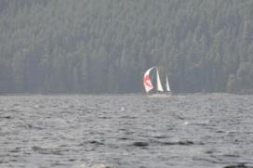
About 45 minutes later the wind had eased somewhat and the spinnaker went back up. With just as much trouble! I had packed the spinnaker properly (I thought!) and yet there were two hourglasses when I pulled it out of the bag! Yikes. That took a bit of work to sort out! Not a good spinnaker day! Off towards Texada Island on a broad reach past Jervis Inlet and the Hardy Islands. Three sailboats came out of Blind Bay, all heading in the same direction, the lead ketch with a bright red and white spinnaker up. We were on converging courses, I was reaching deeper than he was. When we got to the Texada side of Malaspina Strait the lighting was right and I took a series of photos. I called him on the VHF and he responded. Went to 68 and I got his e-mail address so I can send him the photos. Then it was a gibe away from the shore (no issues this time!) and back towards Welcome Passage, the destination now being Smugglers Cover. The wind started to lighten and by 1415hrs I was off Secret Cove with hardly any wind. The engine came on and I powered the last 1.5 miles into a very busy Smuggler’s Cove. But surprisingly, only one boat in the inner bay. The anchor went down near 1500hrs and it was time to clean up and kick back.
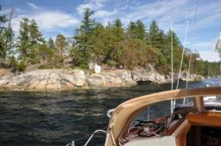
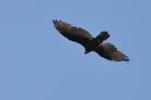

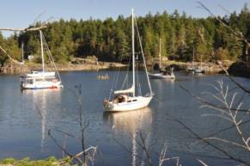

A few more boats have come in since then, a couple of C&Cs, a Fisher 30 and about a 40 ft custom built boat. The skies have gone from almost clear to completely cloudy, but still warm. I had a shower late in the evening to get the sticky sweat off. Then dinner and now just easing back. During all that sailing today I also answered a bunch of e-mails and made phone calls. The iBook system isn’t working so I called the office and spoke to Rick. He will send out an e-mail. Then, during the take down fiasco Wendy called from the Tribal Police and left a message. I called her back. They want me to continue with the Ops part of the policy manual this fall. Good news! I also called Steve to see if the air conditioning part had finally come in from Japan. It had and it will be in his hands late this week. Also good news.
Now that I’ve been chased in my mosquitos with the coil burning inside (and I’ll probably have to kill a few in here) it’s almost time for sleep. It’s been a long, hard working day!

Tuesday | Aug-19 | Newcastle Island | Point Atkinson
Chart 21 |  |  | 0019 | 4.0
 |  |  | 0751 | 1.4
 |  |  | 1529 | 4.0
 |  |  | 2034 | 3.3

Engine 2.8 hrs Sail 3 hrs Distance 22 nm

2000hs The smokies are on the barbeque as the last of the sun touches the tall buildings along the waterfront of Nanaimo. What little wind there was today has evaporated and the water is smooth. I’m tied to a mooring buoy at Newcastle Island in Nanaimo, the end of another day on vacation. Not exactly the day I was hoping for, but about what I was expecting.
This morning dawned clear and bright after a somewhat restful night. It blew fairly hard last night but I had a really good set in the mud (90 ft in 15 ft of water!) and the stern line was lead to the bow so the boat could feather into the wind. I heard the occasional gust but wasn’t worried. I was up before the sun hit the deck, a good cup of coffee in hand, a couple of cookies, and the continuing chapters of James Peterson’s “The Quicky” to read. The sun came over the trees and started to heat the boat up already. The anchorage was coming to life as it should. I made myself some scrambled eggs and English muffins and then went for a row to have a look at Malaspina Strait. It looked a bit lumpy but not much in the way of wind. The forecast called for 15 to 20 from the west this morning, easing to 10 to 15 this afternoon and then increasing to 25 tonight, showers in the morning. The current lighthouse reports indicated very little wind on this side but 17 with gusts to 23 at Entrance Island. There was a big flood tide all day, right to about 1700hrs, so it would be a bit lumpy going across. The weather for tomorrow was showers in the morning and then light NW winds for the rest of the week. I didn’t want to motor all the way across against the flood so decided to get under way, take a chance today.
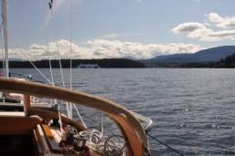
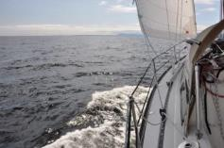
By 1145hrs I was motoring out of Smugglers’ Cove and into Welcome Channel. Out the south end of that and there was a wind line ahead. The sails were already up and, as I cleared South Thormandy Island, the NW wind picked up and I was off on a glorious reach straight for Horsewell Rk. The sky was blue, I had the stereo cranked up, and we were at hull speed! The further across I got the lighter the wind became, contrary to what the weather office had predicted. By the time I was half way across the sails were slapping and it was time to turn the engine on! A bit of a rolly sea and, although I got another 45 minutes of sailing in near Nanaimo, it was motor most of the rest of the way. In through Departure Bay where the sails came down and into Newcastle Channel. I could see Dreamer still up in the yard so there was no point in staying at the Nanaimo YC, so on to Newcastle I went. There was nothing but power boats at the docks, and two very large ones at that, so I drifted over to the mooring buoys and grabbed one at about 1600hrs. Time to clean up and have a cold one!
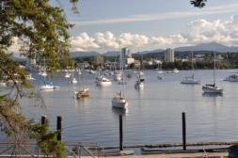

The docks are quiet tonight and there are mooring buoys still empty. I happened to come across Swan, Doug Dyer’s Islander 36 as I was coming in. I have yet to speak to the occupants, but it certainly doesn’t look like Doug. Other than that, it’s been a very quiet afternoon and evening. I’ve just finished two smokies and the rest of the Caesar salad, very tasty and filling. The sun has now set (it’s 2030hrs!) and darkness is approaching from the east. I don’t know yet if I’m staying tomorrow or not, we’ll see what the weather is like in the morning. Right now there isn’t a threatening cloud in the sky!

Wednesday | Aug-20 |  | Nanaimo | Point Atkinson
 |  |  |  | 0120 | 3.9
 |  |  |  | 0851 | 1.4
 |  |  |  | 1627 | 4.1
 |  |  |  | 2144 | 3.3

Engine 0 hrs Sail 0 hrs Distance 0 nm
0600hrs Not quite a clear morning, but it’s not raining either. The forecast was for showers and that’s now gone, and it’s still warm out with the promise of sun later today. The sky is already breaking to the east with clear spot where the sun will rise. After last night’s entry I worked on an e-mail to Wendy Parker at STPS outlining the proposal for policy review. I tried sending it through my cell phone hot spot using Shaw, but it wouldn’t go. So I used my g-mail account and it went. We’ll see if she responds today. By then it was close to 2200hrs and, just as I went to bed at 2230hrs, a northwest wind started up, just like the weather office called for. I had to double the bow line so it wouldn’t creak all night, tie off the halyards so they wouldn’t slap, and put the wheel on, just in case. After that, it was a good sleep although I did wake up in the big gusts. This morning there are boats already moving, probably headed for slack tide at Dodd Narrows at 0700hrs. And, of course, the dog owners are rowing to the docks. I don’t know what I’ll do just yet, stay here at Newcastle or take the boat downtown. I’m leaning towards downtown. Get some supplies and hit the library for some replacement books.
2030hrs The sun set behind the trees long ago, fall must be approaching! I’m back at Newcastle, just a different view from a different mooring buoy. The sky has cleared up nicely and a dying SE breeze is rippling the water. I can see through the gap between Protection & Newcastle Islands and there is obviously more wind out there.
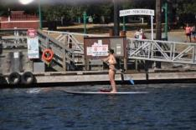
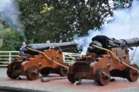
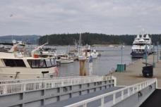
After this mornings’ entry I did a bit of clean-up and then moved the fire extinguisher in the head from the cabinet to behind the toilet. Should have done that years ago and I don’t know why I didn’t think of it so much earlier. Now it’s totally out of the way! I started into another book as the morning progressed, eventually calling up the Nanaimo Port Authority on the cell phone to see if there was room at the dock yet. I was planning on spending the day downtown, getting some ice, lunch and a shower. They did have room around 1000hrs so I cast of and motored all the way over to be placed on C dock, where the really big boats go on Cameron Island. That’s a long walk to town! Oh well, off to the library with my finished books in exchange for a new set. I had lunch at the floating Mexican restaurant and then a shower before picking up ice at Thrifty’s. I didn’t really want to be out on Cameron Island, it’s a long walk to anywhere with not another sailboat in sight. The docks don’t have ice any more, it’s either the fuel dock (an even longer walk) or Thrifty’s. And the showers are as poorly designed as they have ever been. I got back to the boat around 1400hrs to find that I’d literally been surrounded by white fiberglass walls. And not all the dock space had been taken yet! The options were to stay (paid for anyway) or go elsewhere. There was a nice SE breeze blowing in the harbour, and the current was ebbing at Dodd Narrows, but I simply wasn’t in the mood to go anywhere far. So it was back to Newcastle for the afternoon, a very relaxing afternoon. I didn’t do anything except get into a new book (The Eagles – Heaven & Hell, by Don Felder, its good) and watch life go by. The NYC had its’ Wednesday night races through the anchored boats again, fun to watch. Now darkness is falling as the city lights come on. Tide change at Dodds is at 0745 tomorrow so I want to be out of here by 0630 at the latest.
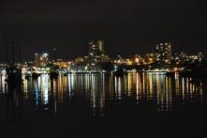
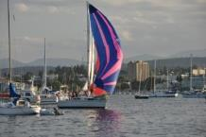

Thursday | Aug-21 |  | Montague Harbour | Point Atkinson
Chart 22 |  |  |  | 0224 | 3.8
 |  |  |  | 0944 | 1.3
 |  |  |  | 1712 | 4.2
 |  |  |  | 2236 | 3.2

Engine 2.0 hrs Sail 7 hrs Distance 46 nm

1945hrs Tied to a mooring in Montague Harbour, the end of another invigorating day of sailing. The SE wind is finally easing at bit and the sun has set behind the trees. I’ve never got out of the sweat shirt during the day, probably the first time this vacation! Not bad for the fourth week on the water!
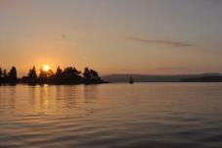
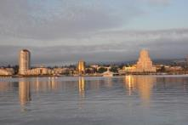
This morning my internal alarm clock clicked at 0600hrs and by 0610 I was motoring slowly through all the anchored boats as the sun rose over Protection Island. There wasn’t a ripple in the water with only a

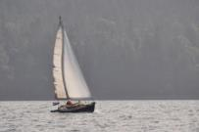
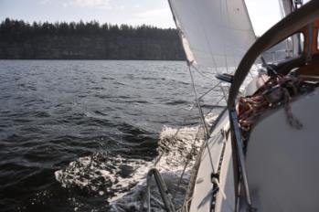
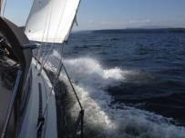
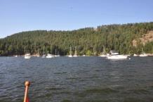
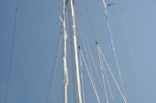
few other boats moving already, probably also headed for the 0730 slack at Dodd Narrows. I had a cup of coffee and some cookies as I powered up Northumberland Channel. The weather promise was for 10 -15 knots from the southeast, easing to 10 in the afternoon before turning to NW tonight. There was also a promise of showers! At least the big flood would keep the waves manageable, if the wind did indeed come in as promised. I was one of the first through the narrows with a long line of boats coming up behind me. Dodds was still ebbing when I arrived and once through, I powered towards DeCorcey Island to have breakfast. There wasn’t a ripple to be seen yet and I didn’t want to power all the way south, I was prepared to wait for the wind. Close to DeCourcey I simply turned off the engine and drifted with the current, making the usual egg muffin and orange juice. As luck would have it, a light SE breeze developed as I finished. A 30ft C&C raising sail out in the channel. I followed suit and was soon drifting along at 2 – 3 knots, still with hardly a ripple on the water. That soon changed and in two long tacks I was aimed at Ruxton Passage, racing the C&C. The wind built nicely and I was soon at hull speed, catching up to the C&C until he lowered his sails and powered into Herring Bay. So much for a sailing partner! Into DeCourcey Channel and over to Valdez Island. The morning developed nicely, the wind steady and warm, the waves very manageable due to the flood against. Tacking angles were horrible, but I wasn’t in any hurry to go anywhere. The goal I had set was Montague, but there was any number of options if the wind proved too much or not enough. I crossed paths with a few boats, none of them sailing south. It was disappointing to see that many sailboats powering north and south, ignoring the wind. Around Poulier Pass the wind picked up to 18 – 20 across the deck, whitecaps everywhere and a reef in the main. I noticed a small flap of material loose on the leach of the genoa, figured it was the sacrificial cloth suffering stitching failure. Not much to do about it at this point. On I sailed, crashing through the waves and tacking from one shore to another, salt spray all over the boat. Tacks were hard, taking a lot of effort, so I went shore to shore in Trincommalli Channel to the south end of Wallace Island and then one long tack over to Saltspring Island before coming back to Galliano Island to get out of the still strong flood current. The small flap of material on the leach of the genoa was now a large flap, but the sail was still together. By 1530hrs I was getting close to the north entrance of Montague Harbour and getting a bit tired! There were quite a few boats anchored off the north beach and I figured that if there were that many out here, the harbour must be packed. I tacked through the entrance and into the harbour to find two buoys still open! I furled the genoa and sailed to the buoy I wanted and picked up the ring without turning the motor on. The main came down and I was here! With the wind still blowing at 12 -1 5 knots it took a bit to organize and clean-up. The salt on deck (and everywhere else) will have to wait till I get home. I finally got some water into and out of me, then made a sandwich with cedar cheese. Relaxing for about an hour with the book as the wind slowly eased. By 1900hrs it had eased enough that I could lower the genoa and undertake some repairs on the foredeck. I had just enough repair tape to put the leech back together for the rest of the trip. It obviously needs to go back to Letch & McBride for some stitching! And that’s where it’s a now. The wind has almost completely evaporated now and the boat has almost stopped rocking. We’ll see what the wind will do tomorrow, the tides will still be against me most of the day. I should sleep soundly tonight!

Friday | Aug-22 | Portland Island | Point Atkinson
Chart 23 |  |  | 0323 | 3.9
 |  |  | 1030 | 1.3
 |  |  | 1747 | 4.2
 |  |  | 2316 | 3.1

Engine 1 hrs Sail 3.5 hrs Distance 15 nm
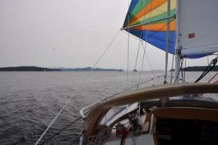
1945hrs Stern tied in Princess Bay at Portland Island. I think it’s been a couple of years since I’ve been here! So close, yet so seemingly far. It’s not particularly busy in here tonight, a Friday night. There is still room for more if more came. I have the stern line to a shore ring just to the north of the dock and there is no-one around me. The ferries keep rumbling by with not a ripple on the water. It is, however, cooling off quite a bit tonight. The sun set in an orange haze and the afternoon warmth is rapidly dissipating with a zephyr of breeze.
After a good night’s sleep I awoke at about 0700hrs to a partially cloudy sky. Coffee and cookies with a good book as the harbor woke up. I made a couple of slices of French toast for breakfast and then rowed ashore for a walk around the campground. Busy, but not full. The camp host was out walking his dog with a cigarette in his fingers, past the sign that said “No Smoking” due to the fire hazard. Back to the boat and I got ready to sail away as a light ad gusty NW breeze had sprung up. By 1030 the main was up and the mooring buoy line retrieved. A nice quiet sail out of the harbour and into Trincomalli Channel. Lots of boats out, many already sailing, and I was off on a broad reach for Captain’s Passage. By the time I got to Nose Point on Saltspring Island the spinnaker was going up. A nice reach towards Ganges to a gibe along the shore, then a long reach towards Otter Bay across Swanson Channel. The flood was against me but the wind, light but steady, kept the boat moving. There was a Beneteau under plain sail going the same way and, although I probably sailed twice as far, I ended up ahead of him coming out of Captain’s Passage. The wind backed a bit and I ended up at Thieves Bay before having to gibe back towards Portland Island. The wind got lighter and lighter till it evaporated completely just outside Morsby Pass. I pulled it down, lowered the main and powered into the anchorage at about 1400hrs. A night, light sail after yesterday’s marathon.
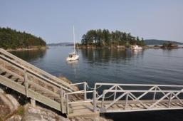
The rest of the afternoon was relaxing in the cockpit, having a shower and change of clothes, and a couple of smokies for dinner. Hans texted that they were finally out for two weeks, headed for Chemanus for a jazz festival, wondering where I was. They ended up going to Tent Island. Brian and Cathy also texted, saying they would drop by on their way to Annette Inlet. A smattering of text messages later and they decided not to come here because of the forecast SE winds (!?). I listened to the forecast and there is no mention of any wind tonight, later in the day tomorrow.
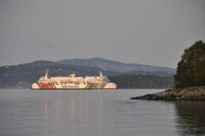
So, the last evening of the 2014 vacation. Not a bad trip at all. Lots of sailing for me, lots of hot weather for the girls. For me, 31 days on the boat covering 466 nm. The engine was on for 49.8 hrs with 62.5 of sailing time. If I subtract .5 hrs of engine time each day the engine was used (for getting in and out of harbors, etc.), then the engine was used for 38.8 hrs of motoring from point “A” to “B”. Not bad considering a trip to the windless Desolation Sound area.

Saturday | Aug-23 | Home | Fulford Harbour
Chart 24 |  |  | 0308 | 2.8
 |  |  | 1025 | 0.9
 |  |  | 1808 | 3.0
 |  |  | 2320 | 2.4

Engine 1 hrs Sail 0 hrs Distance 5 nm

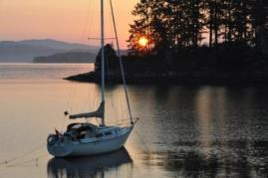
1500hrs Up just after 0600hrs to catch the sunrise, not bad photos! Then back to the boat to make a cup of coffee, cast off the stern line and haul the anchor, on the way home. I had an Erickson 35 following me, obviously the same intentions, beat the current change to flood (against) in John Pass. I was at the marina by 0800hrs and walking home by 0810hrs. The rest of the day was taken up by clean-up and hanging around the house. Another vacation has come & gone.
